How to not blow yourself (or your portfolio) up

“There are old traders, and bold traders, but there are very few old bold traders.”
This means that younger investors are a) prone to boldness and b) these same aggressive traders have short careers. In trading jargon, young bold traders (who, as I’ll get to in a moment, are almost always men) tend to “blow up,” or have catastrophic losses, before they reach their fifth decade.
Rogue traders – investors who place huge, disastrous bets with their firms’ money – are the ultimate bold traders. We’ve chronicled three of the most notorious rogues: Nick Leeson, Jerome Kerviel and Liu Qibing. Below is a list of the worst – that is, the ones that lost the most money – rogue traders in recent history.
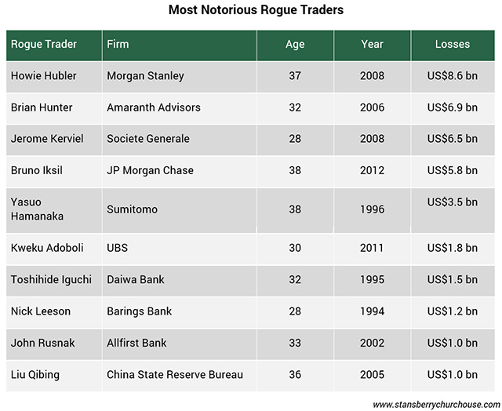
Two things jump out from this list: 1) the perpetrators are all male; 2) they were all under 40 when they destroyed billions of dollars in value.
Point 1 isn’t a shock, as women are underrepresented in the financial world. And they’re especially underrepresented on the trading floors of investment banks.
According to financial employment website eFinancial Careers, only 15 percent of investment bank traders are women. So, it’s not surprising there are no famous women rogue traders. A search for even small-scale rogue traders yields only a small handful of women.
Men like to trade – and women generally prefer to invest
Most traders and money managers are men. But studies have shown that women are actually better investors.
In one study, investment fund company Vanguard analysed the trading decisions made by the owners of 2.7 million retirement accounts from early 2007 through October 2009 – during the worst of the financial crisis. The study showed that men were 10 percent more likely to abandon their positions than women – so they ended up locking in losses and missing the eventual mean reversion rally.
In a 2001 study titled, “Boys Will Be Boys: Gender, Overconfidence and Common Stock Investment,” researchers analysed the investing behaviour of more than 35,000 households that were clients of a large discount brokerage firm. They found that men traded stocks 45 percent more often than women. Extra trading reduced the performance of both men and women, but as a result male investors’ net returns were 2.65 percent lower – and the women’s returns 1.72 percent less.
Too much trading is a major cause of poor investment performance. Not only do fees and other trading costs add up, but traders have a tendency to sell when prices are falling (or have already fallen) and buy after prices have gone up – called the dumb money effect.
Also, studies have shown that men are more likely to deviate from a trading plan. In a simulation run by Financial Skills, a trader profiling company, male traders broke specified trading rules 2.5 times more than women. Men are more prone to overconfidence, believing that they “have the game figured out” and they trade more often.
It’s all about testosterone
As with most ingrained investor shortcomings, biology is to blame. As we’ve pointed out, humans are hard-wired by evolution to make impulsive, unprofitable decisions.
The basic problem is that while modern life is vastly different than it was 100,000 years ago, our primitive instincts are the same. The involuntary adrenaline rush and other chemical responses that kept our ancient ancestors out of danger now occur when we invest. But now, instead of saving our lives, biochemistry can sabotage our investing.
One hormone in particular hurts investment decisions: testosterone. And of course men have more testosterone than women – about 7-8 times more.
Too much testosterone can lead to overconfidence. Very confident cavemen, with lots of testosterone, were good at beating back attacking sabre-tooth tigers. But on the modern trading floor, all that testosterone, and the overconfidence it breeds, can lead to serious problems.
In a test, John Coates, author of The Hour Between Dog and Wolf, took saliva samples from 17 male traders on eight consecutive days, in the morning and the afternoon. Coates discovered that testosterone levels were significantly higher on the days that a trader earned more than his daily average income.
Coates suggests that traders become addicted to the feeling of euphoria, or the “winners effect.” Early success makes young male traders, whose testosterone levels are the highest they will ever be anyway, more aggressive, less rational and more dogmatic. And this continues until the day they stop winning and a big stock position turns disastrously against them.
Older traders are less aggressive
But after age 35, testosterone levels start to decline. By the time the average man reaches age 60, he has 30 percent less testosterone than a 30-something male. As a result, older male traders’ decisions are less influenced by testosterone. Instead of getting a thrill out of a risky trade, he has a different motto: Live to fight another day.
Besides the biochemical change, the older, less bold, trader also has more experience to draw from. The surviving veteran may have taken a bad loss or two due to overconfidence when younger, but survived. These “near death” experiences left the trader humbled, realising that under slightly different circumstances he or she too could have blown up.
After living through a few black swan events – unpredictable, adverse events that come out of nowhere – the veteran trader realises that overconfidence, and a lack of discipline, can have catastrophic consequences.
The lesson for all investors
Whether young or old, male or female, the lesson is this: Don’t get overconfident and confuse skill with luck. It’s easy to underestimate risk and think we can trade our way to profits.
So, like the trading firms that failed to rein in their rogue traders, investors need rules in place to prevent disastrous investments. They need an investment strategy and the discipline to stick to it. This would include rules to prevent position sizes from getting too big, avoid too much trading and to cut losses before they become disastrous.

