The #1 secret to keeping your wealth
December 14, 2015 | Kim Iskyan
Finding great stocks to buy doesn’t do you any good if you don’t have any money to invest. And the best way to ensure that you have money is to not lose the money that you already have.
Every investor has bought a share that’s gone down – an idea that seemed good at the time but is now down 10%, 30%, 50% or more. You might tell yourself a loss isn’t a loss until you sell. And (you tell yourself), if you sell now, you’ll miss the rebound that will make up for everything.
No one likes to admit defeat. But in investing, it’s important to have a disciplined approach to selling your bad positions and losing the battle. Otherwise, you risk losing the war when a few bad stocks wipe you out altogether.
The secret to keeping your wealth is simple. As legendary investor Warren Buffett put it, “Rule No.1: Never lose money. Rule No.2: Never forget rule No.1.”
The math of selling your losers before they turn into big losers shows why.
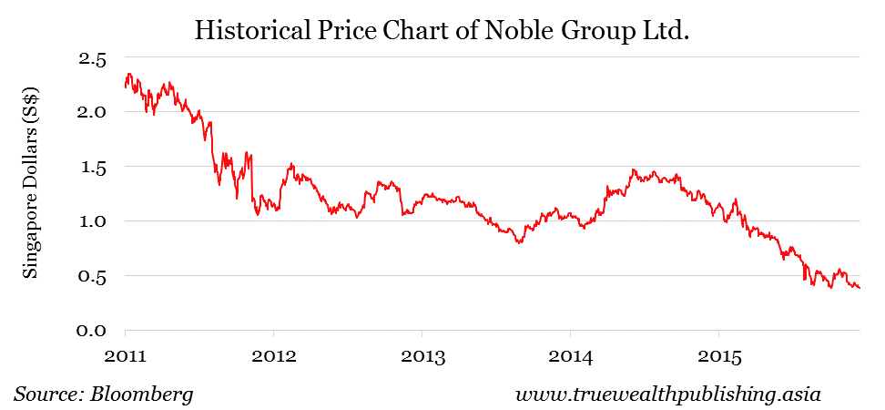
Let’s say you bought shares of Singapore Exchange-listed Noble Group (NOBL). The shares have traded as high as S$2.34 within the past five years but now trade at around S$0.39.
If you bought shares at, say S$2.00, you’re now sitting on an 80% loss. But that doesn’t mean the shares would have to move up 80% for you to break even. NOBL shares would have to move up over 400% just to get back to the S$2.00 level. That’s a very big move. And counting on a big move just to break even is a bad idea.
Even less severe share price drops still make it difficult to get back to break even. A 50% decline in your NOBL shares to the $1.00 level would mean that the share price would have to double just for you to make your money back. How often have you bought a stock that’s doubled?
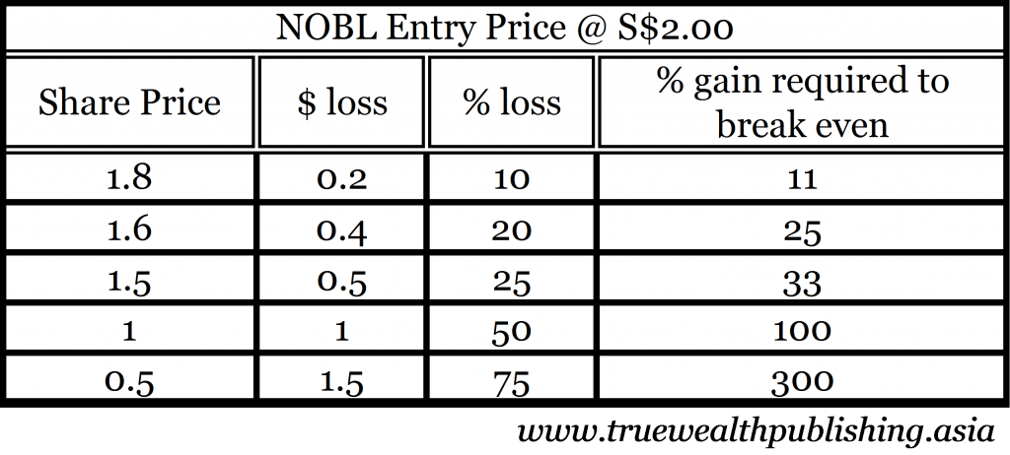
The key to not losing money isn’t to wait for the rebound. The key to not losing money is to sell before you feel any need to wait for a rebound.
The best way to do this is to use a trailing stop.
A trailing stop means that you sell your shares at a pre-determined level below the present market price. This price level is adjusted if the share price moves up. That way, you know exactly how much you stand to gain (or lose) as long as you sell at your trailing stop level.
For example, if you bought shares of NOBL at S$2.00, you might set your trailing stop at 20% below that level, or S$1.60. In this case, as long as you stick to your trailing stop, you’ll protect yourself against far greater losses.
On the other hand, let’s say that NOBL shares rose to S$2.20. As the shares rose, you would continually adjust your trailing loss level to 20% below the market price. At S$2.20, your sell level would be S$1.76. If the shares rose to S$3.00, your trailing stop would stand at S$2.40.
One important point: make sure you don’t put a standing market order in at your trailing stop level. You don’t want to tell your broker when you’re going to sell. Make sure that you make it a mental level – not one that you tell your broker.
The key thing is to follow through. If your trailing stop is hit, you must sell – no ifs, ands or buts. You might lose the battle, but at least you won’t lose the war. And you’ll still have capital to trade another day.

