Template 1 – Develop or improve a hazard

Earthquakes  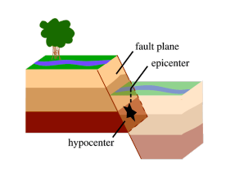 | Definition  An earthquake is the sudden movement or trembling of the Earth's tectonic plates, which creates the  ground’s shakes. An earthquake happens when two blocks of the earth suddenly slip past one another. The surface where they slip is called the fault or fault plane. The location below the earth’s surface where the earthquake  starts is called the hypocentre, and the location directly above it on the surface of the earth is called the  epicentre. | Evolution over time  Data compiled by the US Government’s National Oceanic and Atmospheric administration shows that even though the number of earthquakes have increased in frequency, the proportion of high intensity earthquakes has been decreasing over the years.
Spatial dimension / Vulnerability  The world's greatest earthquake belt, the circum-Pacific seismic belt or “Ring of Fire”, is found along the rim of the Pacific Ocean, where about 81 percent of our planet's largest earthquakes occur.  In recent decades earthquake disaster risks have increased in urban centers of both developed and developing countries. | Annual Average Loss  On average 3.5 million people are affected by earthquakes every year.  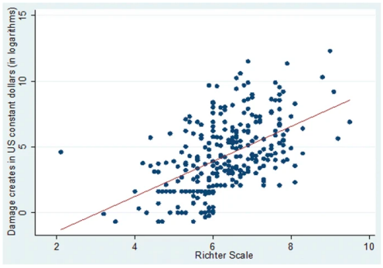 | Top Occurrences  - Valdivia, Chile (1960) - 9.5  - Prince William Sound, Alaska (1964) - 9.2  - Sumatra, Indonesia (2004) - 9.1  - Sendai, Japan (2011) - 9.0  - Kamchatka, Russia (1952) - 9.0  - Bio-bio, Chile (2010) - 8.8  - Ecuador coast (1906) - 8.8  - Rat Islands, Alaska (1965) - 8.7  - Sumatra, Indonesia (2005) - 8.6  - Assam, Tibet (1950) - 8.6
Maps & Charts

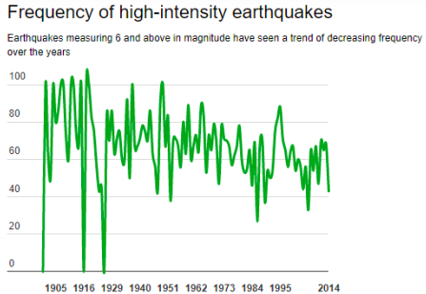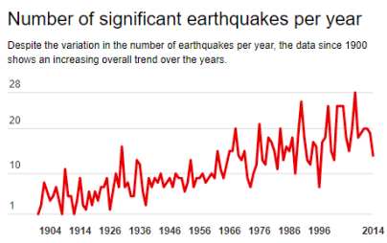

Template 2 – Case study
Name of hazard | Place and date | Intensity and frequency  Do we know the intensity of the event (if measurable)  And its frequency? How many times per year or 1/100 year?
Spatial dimension / Vulnerability  How big is the impacted area?  How are the most at risk group of people | Impact  Human impact  Economic impact  Social impact | Your comments  Why did you choose this event?  Write 2-3 things you found interesting about this case study?
Maps & Charts

Optional

