CHAPTER 5
THE COVID CRISIS AND A NEW INDUSTRIAL STRATEGY FOR EUROPE
Riccardo Cappellin

ABSTRACT

This essay has aimed to indicate some new important emerging policy problems, which have characterised the Covid crisis in the European economy during 2020 and then the bounce-back in 2021. The paper has illustrated an economic theoretical framework focused on innovation and structural changes, according to a Schumpeterian and evolutionary or neo-institutional approach, which seems more appropriate than the traditional neoclassical and macroeconomic models, as the basis for a “new industrial strategy” in the European Union. The mainstream economic models are static and point-like, as they do not consider the role of time and of space, such as the existence of asymmetric information and external economies and also the interdependence between the companies and the other “stakeholders” in the process of economic development. On the contrary, the theoretical framework of this paper considers the factors that act on the structural changes according to four different and interdependent dimensions: the final demand, the intermediate productions and also the supply of labour and the endowment of natural resources. Finally, some preliminary indications on the organisation of a new industrial strategy at the European scale are discussed, different from the focus on just the digital and green technologies, as indicated by the NGEU program by the European Commission.
Keywords: European integration; employment creation; industrial policy; innovation policy; urban and regional planning; macroeconomic policies; export-led growth; EU internal market; Covid-19 crisis

1. Introduction
The increase of the economic and political competition between the largest world powers and between the large industrial and financial international companies is stimulating internal social and economic divides and also military civil conflicts within many countries. Armed conflicts within and between countries in Europe and in the world (Ukraine, Afghanistan, Iraq, Syria, Israel, Central Afrika, Kosovo, etc) may have been stimulated by economic, commercial and financial factors. However, I believe that the most important factors are not the economic factors, but rather political factors such as the will of political hegemony and the defence of the individual cultural identity of specific groups of people. On the contrary, economic growth may be the most important factor leading to international cooperation and to prevent military conflicts, as the experience of the European Union has demonstrated in the case of the European continent.
Recently, the fragmentation of the global economy has been increased by the global pandemics, which has led to tighter immigration restrictions, to greater national self-reliance, by reshoring of strategic productions, constraints on import and on foreign investments in the case of strategic goods and resources. The disruptions of the supply chains and the emergence of sectoral bottlenecks have led to price increases in the industrial but also in the service sectors. Moreover, the large increase of income and wealth inequality have led to social and political discontent. That is driving to an increase of State intervention in the economy and to a change of the neoliberal paradigm widely diffused in economic policies since the Reagan’s and Thatcher’s years in favour of a greater State interventionism leading to the call for an explicit national industrial strategy (Aiginger & Rodrik 2020, Bellandi & De Propris 2017, Bianchi, Ruiz Durán C. & Labory 2019, Cappellin 2020a and 2020b, Rodrik, 2020).
Thus, there is the need to reconsider the economic development strategy also in the most developed countries, such as Europe and the USA. The theoretical framework illustrated in this contribution is different from that of the neoclassical and of the Keynesian economic models and it could be the basis for the design of a “new industrial strategy” appropriate to the actual and specific context of national and regional economies in Europe. In particular, this contribution first considers development models indicated in the economic literature and which focus on external trade, such as the export-led and the globalisation model. Then, it considers the endogenous growth models focused on the relationships between the internal demand and supply. Moreover, this contribution aims to illustrate the factors that act on the structural changes, in a medium-term perspective, on four different and interdependent dimensions: not only the final demand and the intermediate productions, but also the supply of labour and the endowment of natural resources. Finally, this contribution presents some preliminary indications on the organisation at the European scale of a new industrial strategy, which should represent the institutional framework for business decisions

2.The Mercantilism Export-Led Model
According to the traditional export-led growth model (Thirlwall 1979 and 2011), which is similar to the mercantilist development strategy, the internal productions are oriented to the foreign demand and their level is determined by the international competitiveness of the companies. In fact, according to a Keynesian model (Cappellin, 2011, 2012, 2016a, 2016b), the GDP is determined by the exports and imports and not only by the internal demand:
Y = (C + I + G ) + X - M
That growth strategy implies that companies should aim to lower costs, higher productivity and also to lower wage and to industrial restructuring in order to increase their competitiveness and that is leading to employment decrease within the firms and often to low employment increases and high unemployment in the overall national economy.
The “export led” growth model is leading to an excess of supply on the internal demand and to a trade balance surplus. It also implies a lower internal demand and an excess of national savings on domestic investments, as indicated by the following national accounting identity:
I = S - (X - M)
In particular, the export led model implies that economic policy focuses on exports and not on internal private and public investments and that the high national saving pushes the internal financial funds to finance investment abroad. Thus, the export led model implies a continuous outflow of financial funds and that is hindering a larger increase of the production capacity in the net exporting country.
This model has an unbalanced nature and leads to extending the economic, political and often also military hegemony of largest countries on smaller countries. In fact, the increase of the trade surplus in few net exporting countries, accompanied by fast growth and a re-evaluation of the currency, is attracting foreign financial funds and that leads to an increase of the foreign debt in the net-importing countries. Moreover, the export led model of growth is tightly related to an increase of the imports of mineral resources in the exporting countries, required by their industrial productions, and also to the immigration of skilled and unskilled labour and also to the attraction of foreign saving due to lower fiscal rates on capital incomes and to the revaluation of the currency.
Therefore, the “export led” growth policy has led to an increase in international political tensions, as it implies an increase in the financial assets of exporting countries with a surplus of the balance of payments. That impoverishes the importing countries, which are forced to finance their imports not with exports, but with an increase of foreign debt and with the sale of financial assets (public securities) or real assets (sale of companies and of properties), as it has occurred in the Greece vs Germany case after the great 2008-209 financial crisis.
The export led model increases tensions within the European Union. On the contrary, the growth of the overall European economy can be promoted by an increasing orientation of the European productions to the European internal market. That policy does not imply a decrease of exports, as it can also favour a new long term competitive advantage in international markets, as the demand by consumers in the emerging countries may in the future be increasingly oriented towards the European high quality services and goods, which are typically linked to the higher standards of living of European citizens, with respect to the more traditional goods locally produced in Asia and in low wage countries.

3.The Neoliberal Globalisation Model
Starting from the 1980s, the traditional export led growth model in the most developed countries evolved into the neo-liberal model of globalisation, that characterised the period up to the great financial crisis of 2008-09 and it entered into a final crisis with the recession due to Covid in 2020 (Cyert & March 1963, Alchian & Demsetz 1972, World Economic Forum 1973 and 2019, Garofoli & Holland 2017, Holland 2016, Pisani-Ferry 2021a and 2021b, Business Roundtable 2019, Murray 2019, Blackrock 2022).
Large multinational industrial and financial companies conquered foreign markets not only with the exports of products and services, but also with their investments abroad, the M&A of local companies, the export of profits in tax havens, the lobbying of national and also European institutions in order to change the national rules (so called “structural reforms”) and to increase their economic advantage and the influence on the public opinion.
Even in leading countries, such as the USA and Europe, the neo-liberal model of globalisation has had negative effects, leading to an increase in income and wealth disparities, a decrease in social mobility, a low growth of consumer demand, a decrease of fixed corporate investments and in research investments due to the focus on financial investments, the decrease of public spending in social services and these effects have led to a decrease of the political support for the ruling conservative political parties, which have supported this model. In smaller less developed countries the neo-liberal model has led to forms of economic-financial neo-colonization (“crony capitalism”), with the political support of the privileged social classes in these countries, such as the private economic elites and the public technocracies.
Where that was not possible, “democracy” has been exported with military invasions and the destruction of the same political-institutional organisation of small and weak states, such as Iraq, Libya and Afghanistan. These invasions lead to civil or internal wars in the small invaded countries, as well to military tensions with the other more powerful neighbouring countries, such as Turkey, Iran, Russia, etc..
The globalisation process and the establishment of foreign subsidiaries of multinational companies have been the instrument for the adoption of the traditional export-led policies in many smaller intermediate-development countries in Eastern Europe, Asia and Latin America, and that have succeeded in increasing their economic growth. However, these countries found themselves in a “middle income trap”, being specialised in traditional manufacturing sectors, while the more advanced service sectors and activities are increasingly concentrated in the larger countries, as the small size of the local market in these countries prevents the development of modern service productions.

4.The “Endogenous Model of Growth” Model and the Changes of Internal Demand and Supply
The globalisation model and the export led model have been criticised by many economists and also by various governments. An alternative model may be called the endogenous model of growth, since the drivers of growth are not represented by the international demand, but by internal structural changes which are determined by the interaction between the internal demand and the internal supply in the various sectors of the national or regional economy.
In particular, according to the endogenous development model, it is important to ensure a simultaneous growth of the aggregate demand and of the aggregate supply, which in the long term should evolve together:
Δ YS = Δ YD
Both demand and supply are determined by the growth of the production in the various sectors (i), as:
Δ YS = Σi Δ Yi S
Δ YD = Σi Δ Yi D
and the supply and demand in the individual sectors should be balanced in the long term:
Δ Yi S = Δ Yi D
The interdependence between the growth of supply and of demand within the individual productions may be illustrated by the “barriers to entry” model, which indicates that the level of production in each individual sector must ensure the condition of non-negative profits or the condition that the price is higher than the average cost: p> CM, in order to insure the financial feasibility of the individual firms. This condition of financial feasibility of a specific production implies a comparative static perspective, but it does not explain the evolution or growth of the various productions in a medium term perspective. That required the analysis of the various internal and external factors which affect the demand and the supply of the various productions.

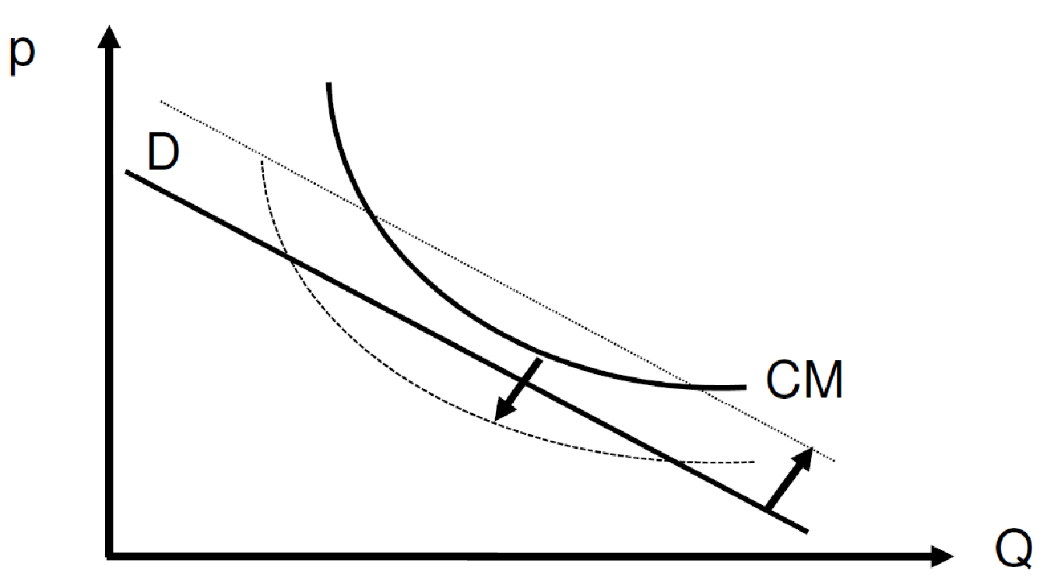
Fig. 1. The Model of the Barriers to Entry and the Evolution of the Demand and Cost Schedules
When the price that the consumers are willing to pay is lower than the production costs, companies in order to survive should either increase the productivity of the used resources and lower the costs or should shift to new products, which are more evaluated by the consumers. The financial viability of a production is not insured by the “invisible hand of the market” and the automatic changes in prices, but by the explicit choices of the producers.
It must be underlined that, when a disequilibrium arises between the demand and the supply of a product, the key role is not played by the price but rather by the quantity adjustments. In fact, when supply is greater than demand, that determines in the short term an increase of the stocks. Thus firms are later constrained to the disposal of these stocks because of the costs of their conservation and deterioration and that leads to a decrease in the excess supply. On the other hand, when demand is greater than supply, that leads immediately to a scarcity and to the appearance of queues, thus the customers are induced to save the previously bought goods by decreasing their needs of the product considered to shift their needs to other products. These quantity changes may occur almost immediately, while the price adjustment, which is indicated in a neoclassical model of equilibrium, implies the effect of the price change on the demand and supply. That change may be very slow and uncertain, since both demand and supply are constrained by organisational costs and institutional norms.
In fact, the changes in demand and supply in the medium term do not depend only on the price, but rather on the changes in the geographical and “cognitive” proximity and on the existence of external economies between the companies of the same sectors and in the relations between customers and suppliers. These adjustment processes occur over time, as companies learn from each other and from the contacts with their respective customers and suppliers. In particular, the changes in the supply depend on the investments made in previous periods, on the technology in use, on the skills of the workers and suppliers and gradually evolve over time on the basis of the relationships between the company and the surrounding environment or territory. On the other hand, the changes in demand depend on the compatibility of the technical characteristics of the products and services sold by the company with the needs of the users and on the gradual evolution of the latter over time. Therefore, the growth of demand and supply is connected with the territorial proximity of current and potential users and producers and it develops over time due to interactive learning processes between the various users and producers.
It must be noted that any imbalances between the internal demand and the internal supply within an individual country can be compensated by imports or by exports. However, the model described in the above equations is valid at a global level, since it is inevitable that there is a balance between supply and demand for each individual production at the global level, as the value of exports or the supply of a specific product by a single country necessarily corresponds to that of the imports or the demand by all other countries.
According to an endogenous growth model, the national industrial strategy should aim to avoid excessive dependence in specific strategic productions, which may represent a bottleneck in the productions of other goods, due to the importance of intersectoral linkages, as the case of the microchips or of energy productions has recently indicated.
Quantity adjustments are important especially in the specific case of “collective goods”, since the individual private demand may not be sufficient to stimulate the production for these goods. Thus, due to the existence of “externalities in consumption, the emerging needs of these goods may remain latent or unsatisfied for a long time, as these goods must be produced jointly and require the aggregation of the demand by a rather large group of local/regional or contiguous users. Thus, the demand by individual users must be replaced by public demand and by public action financed through the public budget, as the increase of the supply requires new production structures, which can’t be built in the absence of public intervention, public investments and social and institutional innovation.
The endogenous model of growth does not hinder a partial or temporary disequilibrium between the internal supply and the demand, while it aims to focus the attention by the policymakers on the need of specific measures of industrial policy insuring a long term balance of the growth of internal demand and supply in the various sectors of the economy in order to avoid structural imbalances between the various countries.
A crucial role in this re-equilibrium process may be played by the industrial policy, which may directly increase the demand of the new productions through fiscal incentives to the users or through direct public purchase by the institutions and that leads to an increase of the demand curve. On the other hand, looking to the supply side, industrial policy measures may be oriented to finance the investments needed to create new production capacity in new sectors or they may increase the productivity of the companies and that leads to a decrease of the cost curve and will insure the condition for non negative profits which allow (but does automatically determine) the entry. Therefore, the policies aiming to the expansion of the production capacities in the individual productions must be accompanied or even be anticipated by policies of expansion of the internal demand towards the same productions.

Fig. 2. The Growth of Investment Determines a Shift of the Sectoral Demand and Supply
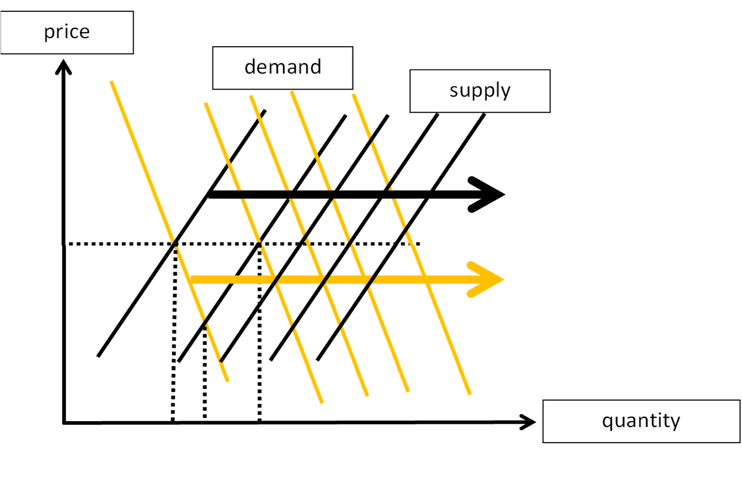
In this respect traditional macroeconomic policies are not sufficient and the European Union must use not only monetary policy or public budget policy, but also a third and tightly complementary instrument of

economic policy, which may be called a “new European industrial strategy”, which is aimed to orient the investments of private companies, with loans and grants and also with public equity participations and public investments, towards those new strategic productions, which can diversify the European economy and respond to the new societal needs.

5.The Co-Evolution of the Demand Patterns and of the Supply Structure
The changes in the sectoral structure of the European economy largely correspond to the changes in private consumption patterns in the euro area. In particular, the needs and priorities by the citizens have profoundly changed, as indicated by the increasing role of the demand for services.
A new industrial strategy in Europe should respond to the emerging basic needs of the European citizens, such as the needs of:
- good nutrition,
- good mobility,
- good cities,
- good free time, culture and entertainment,
- good health and training,
- good environmental quality and fewer natural disasters.

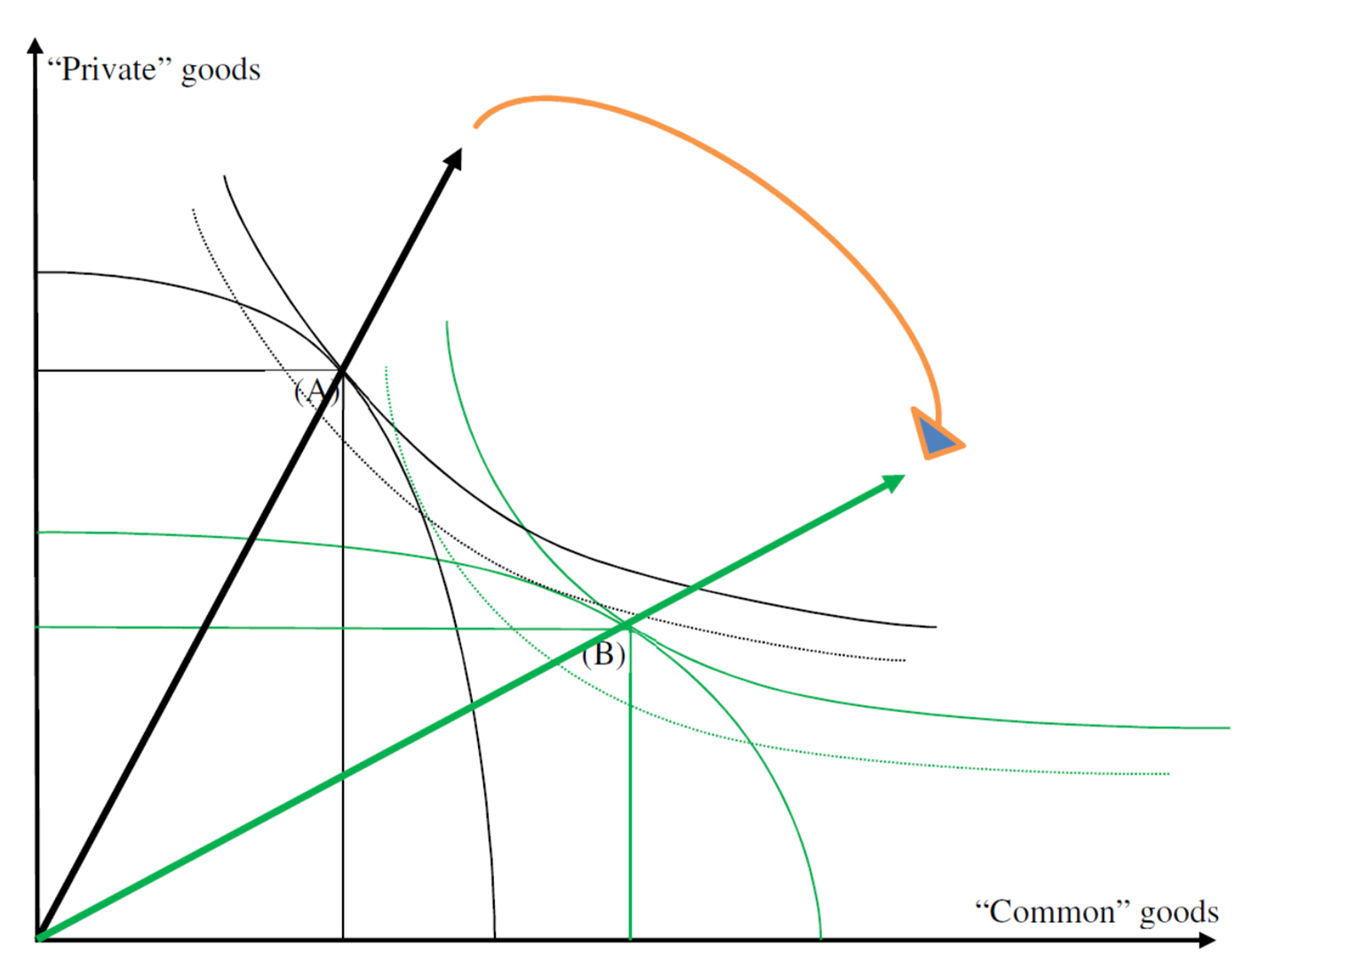
Fig. 3. “Private” Goods and “Common” Goods
In this perspective, the growth of the “demand” (determined by the citizens) should clearly be confronted with the constraints of the “supply” (determined by the companies). This latter is represented by the “frontier of possibilities” between the various productions and it depends on the financial resources available for the investments by the State and the private companies, as also by the capabilities and quantity of the labour force and the new available technologies.
In the current post-Covid situation, a new European industrial strategy should reorient both the production supply by the companies and the demand by the users (i.e. citizens and businesses) from the traditional goods/services, that are addressed to the demand by the individual consumers, towards new goods and services, that have a collective character (i.e. “common goods” or “collective services”, as indicated in Figure 3).
Thus, the changes of the demand are tightly linked to the restructuring of the supply side of the economy towards new innovative productions and that enhances an increase of the aggregate productivity and of the citizen’s wellbeing (Aiginger & Rodrik 2020, Rodrik 2014 and 2020, Cappellin & Wink 2009, Cappellin 2010).
The selective stimulus of demand guides industrial strategy, public spending and taxation, private finance and the intangible and material investments of companies towards ESG - Environment-Social-Governance objectives of sustainable development.

6.The Interdependence Between Emerging Changes in the Demand of Products and in the Labour Force
Social preferences are segmented and widely different between the various social groups, and some groups represent “lead” users, who may anticipate the behaviour of the other more traditional consumers. These “lead users” are especially important in determining new segments of the demand, which drive the birth of “innovative” firms, and in some cases may even anticipate the changes in the supply when the users may self-produce the required goods (Cappellin 2011, 2012).
Companies and also consumers within the same production sector differ one from the other and are not equal between them, as the neoclassical hypothesis of the “representative agent” assumes. Thus, the aggregate demand and supply are highly internally differentiated. In particular, businesses and consumers in each period differ from those in the previous periods in that they can be divided into three categories: new or innovative businesses (and consumers), traditional businesses and consumers, and businesses and consumers in crisis or that disappear. The focus on these structural changes are typical of an economic approach which may be defined as a Schumpeterian or evolutionary, as it focuses on the diffusion of innovation, differently from traditional macroeconomic and microeconomic theory, which do not consider changes in time and space of production technologies and consumer needs.
Therefore, it is clear that the growth of production in the various sectors depends primarily on the birth of new users and new producers and therefore on the learning processes that develop over time between companies on the one hand, between consumers on the other hand and between the companies and the consumers.

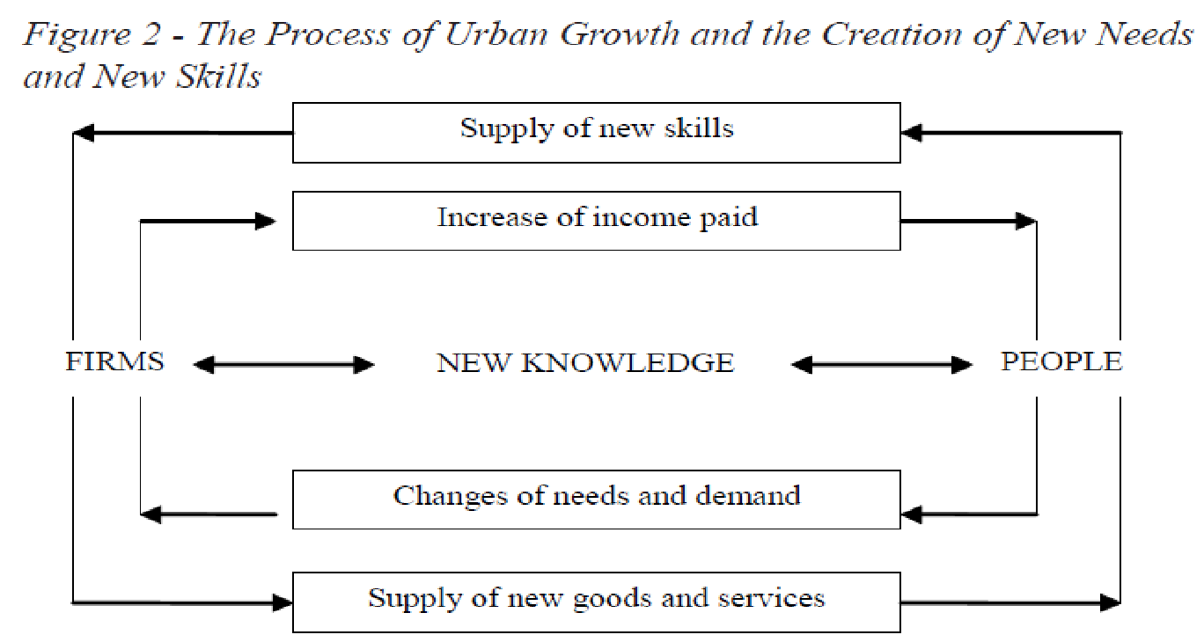
Fig. 4. The Differentiation of the Product and Labour Markets and the Emerging New Needs and New Skills
The interaction between the people and the companies is occurring both in the product market and in the labour markets and it is explained by the well-known circular relations of income flows between companies and households. Figure 4 indicates the relationships between businesses and households in the real flows of goods and labour services and in the monetary flows of factor income and good purchase. In fact, on the one hand, the demand for products depends on the income levels of citizens and, on the other hand, the supply of companies depends on the skills of the workers. In particular, the relationship of innovative firms with the more experienced consumers on the production side and of the innovative firms with the higher skilled workers on the labour market side is very close.
Therefore, any excesses of the demand over the supply in the case of new productions may be determined by the fact that the users have adopted international modern consumption patterns while the local companies are too little innovative and constrained by their rather traditional competences or there is shortage of workers with adequate skills. On the other hand, an excess of the demand over supply in the case of the most skilled workers may depend on the scarce investment in training by the households and on the too low wages paid by the companies.
Similarly, an excess of supply over the demand for new products may depend on the too limited spending capacity of the consumers and workers and the too low wages distributed by the companies. Furthermore, an excess of the supply of skilled workers on the respective demand by the companies and an excess of the demand of new products on the respective supply by the companies may depend on the limited innovation capabilities by the companies.
Therefore, the markets of new goods and the markets of highly skilled labour first involve a minority of advanced consumers and of highly skilled workers and only later they increase as the companies learn to produce more advanced goods and to employ more skilled workers. The current policy debate usually focuses on the opposite case, when the companies are introducing too advanced products for the more traditional consumers and they demand too qualified labour with respect to the limited skills of the majority of workers.
Figure 4 illustrates also that the relationship between people and companies does not only develop in the markets of goods and factors considered by the traditional accounting model, which is used in the calculation of the Gross National Product. In fact, knowledge interactions between the demand by the users and the supply by the producers implies the existence of knowledge spillovers or that some innovations may be anticipated by the users (user innovations), which may proceed to initially self-produce goods or services still not available in the market (such mountain bikes and other sport items or new surgical instruments), or that new goods may be anticipated by the producers (such as telephone hardware and software) and later the users adapt their behaviours and skills and demand these goods.
A perverse cycle may be occurring both in the labour market and in the market of goods/services when:
- the demand of labour is characterised by:
- corporate survival strategies focused on cost reduction,
- concentration of investment in technological process innovation, increase of demand for less qualified labour,
- relocation of traditional companies to other countries with low cost labour.
- the supply of labour is characterised by:
- high youth unemployment,
- emigration of the young qualified labour.
- the supply of goods and services is characterised by:
- lack of innovation,
- decrease of the supply of qualified products by the national companies,
- increase of the imports of qualified products from abroad.
- the demand of goods and services is characterised by:
- reorientation of the demand by national consumers to more innovative foreign productions,
- decrease of the internal demand of traditional productions,
- lower revenues for the local firms.

On the contrary, a virtuous model of development is occurring both in the market of goods/services and in the labour market when:
- the demand of goods and services is characterised by:
- higher knowledge by the users/consumers of new product/services,
- more qualified needs and higher incomes and also more free time,
- users/consumers willing to pay higher prices for new products/services.
- the supply of goods and services is characterised by:
- higher knowledge, higher material investments in technology and equipment,
- immaterial investments in continuous education and R&D and technical design,
- production processes with higher speed of execution and improved quality of the productions,
- increase of the selling prices of products/services.
- the supply of labour is characterised by:
- young people having higher education,
- workers involved in intense interactive learning processes (e.g. social networks),
- young people demanding higher wages and being more expert and educated.
- the demand of labour is characterised by:
- innovative companies specialised in new advanced productions demand new competencies,
- companies willing to invest in hiring new more qualified workers,
- companies willing to pay higher wages to qualified workers.
In fact, the interaction between the demand and the supply may lead to higher wage and income levels, to an increase of the internal demand, to shifts in the demand towards more qualified expensive goods or services, to the adoption of more modern technologies and to an increase of investment in public infrastructures and public services. That would promote a change in the economic structure of the regional and national economy towards new productions with higher productivity and requiring more qualified labour.

7.The Role of Environment and Territory in a Circular Model of Development
The development of new productions is strictly connected with the development of more qualified occupations in the labour market, but it is also connected with an improvement in environmental quality, according to the various “ESG - Environment-Social-Governance” indicators. These indicators are increasingly adopted in the financial evaluation of debt securities and of equity funds and are tightly related to the growing importance of the new logic of “stakeholder capitalism”, which is opposed to the traditional logic of both “shareholder capitalism” or that of “state planning”.
In fact, the role of natural resources and of the quality of life by the citizens have an increasing importance in the evolution of the demand patterns both by the households and the companies and also promote the creation of new goods and services, on the supply side.
A better environment will imply less damages and lower risks of natural disasters such as the recurrent floods, will create greater security, a greater trust in the institutions and sense of common belonging and cooperative behaviours, which would lead to lower rivalry or transaction costs between actors which are obstacles in the innovation processes. In fact, the investment in “common goods”, such as the environment, which create benefits to all European citizens will increase the “external economies” both in production and in consumption, as it is typical of the concept or “relational goods” and of the model of the “sharing economy” or “circular economy”.
Therefore, a modern industrial strategy must take into account the negative or positive impact that the development of productions will have on the natural environment and on the territory and also the positive and negative effects that the natural environment may have on the demand, the consumption and the investments by the citizens and the companies, as the existence of an adequate demand is the condition for the growth of the supply (Bourden & Torre 2020, Wink 2021).
The territory is crucial from three different perspectives:
- demand / needs side: the definition of new needs, their quantification and their “hierarchical organisation” on the territory are necessarily different from place and therefore require different projects,
- supply side / companies: the satisfaction of new needs, the birth and development of new companies for the production and supply of new goods and services that can find their natural habitat in the territory according to the model of “endogenous development”, which implies a synergy effect between supply and demand;
- social governance / innovation side: according to the “quadruple helix” model, a fundamental role is played by citizens-consumers, who collaborate with local governments, companies and universities in defining projects. In fact, the promotion, coordination and verification of the projects associated with the various macro-areas of intervention would imply a multilevel governance in which local and regional institutions, the territorial system of training, schools, research and universities are involved and have an explicit role together with businesses and social partners.
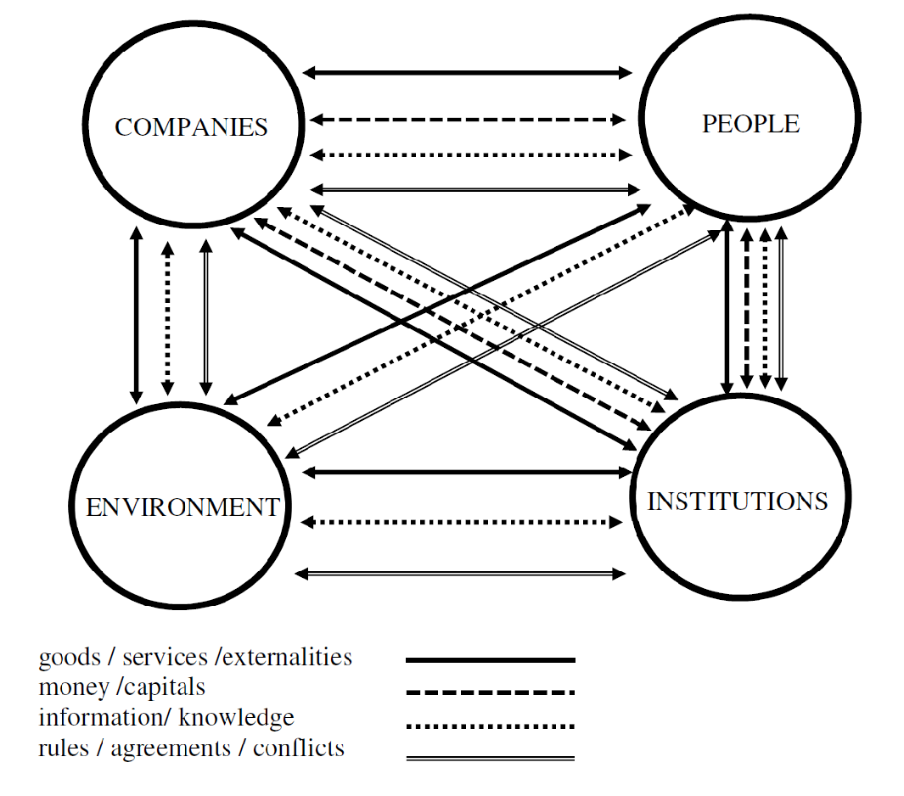
Fig. 5. Stakeholders and Flows in an Environment -Social -Governance Framework
Therefore, a fourth dimension of the process of aggregate growth is represented by the close interdependence between the development of new productions and of more qualified occupations, on the one hand, and the quality of the natural environment and the working of institutions on the other. In a “circular development” model, each of the four “stakeholders”: production of goods/services, labour resources, environment resources and supply of public services, interact between themselves, as indicated by Figure 5.
Figure 5 indicates the stakeholders and the flows among them in the conceptual framework adopted in this contribution. The national-local system is highly internally integrated but also open to the external world. All stakeholders are interdependent. All flows between the stakeholders have a bidirectional orientation and have a multidimensional nature: real, financial, cognitive or legal nature. Companies sell goods and services to the people and institutions, determine and receive positive and negative externalities on the environment, employ people and use public services. They receive the prices of goods and services sold and pay the salaries to the workers and taxes to the institutions, exchange information and knowledge with the other actors and also the environment. Also people interact with the environment and the institutions, receiving public services and positive or negative externalities. The environment interacts with companies and people and it also receives public investments and creates positive or negative effects on the working of the institutions. Finally, public institutions determine norms, which regulate the relationships or the conflicts between the various actors. However, also companies and people may determine norms and agreements or conflicts between each other and jointly regulate the interdependent relationship with the environment.
No actor is dominating all other actors, but their respective power is different. In fact, in a democratic and modern society, the rights of people and of the environment are becoming more powerful and companies and institutions should withdraw their power. Structural change and innovation have not only technological, but also social and institutional character. The evolution of the system may follow various paths, as each actor is internally changing on the base of the stimulus received from the other actors and also the intensity and the nature of the flows between them are changing.
In particular, the environmental benefits will determine a greater well-being for the citizens and that will stimulate the demand, both by the households and by the companies, for new economic goods and services. Therefore, changes in the demand patterns and changes in the national and regional sectoral production structures and also changes in the environment and in the territorial structure are closely linked between themselves. In fact, the evolution of scarcity of natural resources and of the quality of life of the citizens are tightly related to the evolution of both the production structures and of the demand patterns.

8. A New European Industrial Strategy as the Institutional Framework for Business Decisions
The Covid crisis in 2020 determined a sharp decrease of the final demand, of prices, of productions and of employment. The impact of the crisis has been very different between sectors, professional profiles, ages, genders and also territorial areas. Thus, it has determined an increase of disparities in income, wealth and wellbeing between the citizens. The crisis has stimulated technological advances in specific sectors, such as modern information technologies, and led to a major effort in energy saving technologies. Also the transport flows, the territorial settlements such as large metropolis, suburban areas, small urban centres and rural areas have been differently affected and it has increased the awareness of the importance of environmental quality by the citizens.
The economic recovery in 2021 has implied a bounce back to almost the same GDP level of 2019, before the Covid crisis, but the supply side has not been capable of swiftly adjusting to the increase of the demand and that has led to bottlenecks, disruptions in the supply chains and inflationary increase in the various markets. Therefore, macroeconomic policies should be adjusted from an un-discriminated expansionary fiscal and monetary policy, due to the strong inflation push at the end of 2021. However, it is not appropriate they return to the restrictive monetary and fiscal policy, which were inspired by an “ordo-liberal” model and have led the decade of slow growth after the great financial crisis of 2008-09 (Marelli 2021, Della Posta 2020, Garofoli 2017 and 2021).
On the contrary, in order to achieve a medium and long term economic growth pattern, there is the need of new European industrial strategy aimed at a transformation of the European productive and institutional system, in order to overcome the so called “middle income trap” and to be able to compete with the new productions developed in USA and China.
The starting point is the role of demand and innovation, according to indications of modern neo-Keynesian and neo-Schumpeterian economic theories. Structural change requires the interdependent growth of various productions, as indicated by Nurkse’s “balanced growth” theory (1961), Hirschman’s “trickling down or polarisation effects” (1958) and the “big push model” by Rosenstein-Rodan (1943).
Therefore, “structural reforms” are needed that promote economic and social innovation and not only technological innovation, similar to those already indicated by first economic planning in Europe during the 1960s and different from the so-called “structural reforms” based on the “neoliberal” approach and followed after the 2008/09 crisis.
Citizens require economic policies, which directly address the negative impacts, determined by the Covid crisis, on increasingly important basic needs (“foundational economics”: Morgan 2021), such as: nutrition, housing, mobility, leisure, entertainment, tourism, health, education, environment quality, energy saving and also new jobs allowing a better work-life balance. Clearly, economic policies should tackle specific recent economic problems, such as: the critical situation of specific productions, such automobile, computer chips and energy, and also the increasing role of finance in the success of private companies and the increasing indebtedness of the governments. Thus, it is not enough to return to the situation existing before the crisis and there is the need for a major reorientation of the aims and instruments of economic policies and governments at the various levels: European, national and local, should direct.
The pricing system may offer a reliable guidance for marginal decisions but it is not good for handling major structural transformations such as the shift away from agriculture to manufacturing and from manufacturing to services. We cannot conceive that market forces always act in the right direction and with an appropriate speed. The “free market” does not work perfectly even in a static efficiency context and certainly it does not work when there are “market failures” and when a dynamic perspective is relevant. In fact, usually the market alone is not able to promote those innovations, which require the coordination of “no price” relationships or synergies between many different actors within a national or regional innovation system. These relationships are essential to ensure the creation and circulation of tacit and codified knowledge, which promote innovation and productivity growth in the long term, without which there cannot be economic growth.
Therefore, a new industrial strategy should anticipate the structural changes in the final and the intermediate demand and intervene in order to promote, on the one hand, the change in the consumption patterns by the European citizens towards new innovative products and services and, on the other hand, to promote the tangible and intangible investment by European companies in new productions.
The theoretical framework indicated in this paper indicates the feasibility to quantitatively estimate the coherence between changes in the demand and in the supply in the various productions, the parallel evolution in time of the demand and supply structures, the interdependence between changes in the product market and in the labour market and the existence of negative or positive dynamic circuits and finally the impact of the new productions and living styles on the territorial and the environmental quality and the feedbacks of these latter on the demand by the users and the production by the companies.
On the contrary, the current industrial policy in the European Union has focused on the adoption of specific modern technologies such as digital and green technologies. However, this too narrow focus implies the risk of “greenwashing” and of missing the strategic importance of different technologies in various industrial ecosystems and there is the need to promote the development of new productions and employment opportunities.
In an economy that is increasingly complex and also fragmented and subject to unforeseen exogenous shocks, the task of the State is not that to directly produce products and services but rather that to promote the speed of restructuring processes with the strategic coordination (“governance”) of the various companies distributed throughout the territory and also of the evolution over time of the different phases of development.
Industrial policy in Europe should not focus only on the large international companies but also on medium and small sized companies, which should increase their size through M&A or internal growth, as also promote spin-offs of new strategic activities. Moreover, innovations can’t be based only on internal R&D within the individual companies, while a modern industrial system requires to sustain the innovation networks between the various companies, as indicated by the model of the “quadruple helix”, which underline the cooperation between the different stakeholders of the “national or local production systems”: companies, unions, financial institutions, universities, public institutions and associations of citizens. In particular, the role of the State (Holland 2021) is fundamental in promoting the consolidation or the creation and the development of innovative strategic industrial supply chains, such as those indicated in Figure 6.

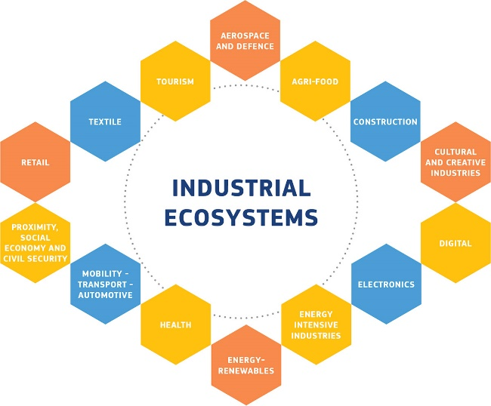
Fig. 6. The Ecosystems of a New European Industrial Strategy
(source: https://commission.europa.eu/strategy-and-policy/priorities-2019-2024/europe-fit-digital-age/european-industrial-strategy_en)
Moreover, it does not seem useful to only aim at a decrease of global CO2 emissions or to promote the labelling of financial securities with an Environment-Social-Governance (ESG) score, while it is more important to explicitly promote a sustainable development in the territory and in the living environment of the citizens. That requires to adopt also a territorial-regional-local perspective, and not only a “tech” or “green” perspective. In particular, cities or the territory (Goddard 2021, Ciciotti 2017 and 2020) have not been explicitly considered in the design of the NGEU – Next Generation Europe program of the EU Commission, while they often represent a policy framework or a constituency having a greater strategic importance, for promoting national economic development, than the individual companies or technologies.
In fact, in an economic and social and also environmental perspective, the most relevant units for the development of a country are neither manufacturing specialised SMEs nor large diversified companies, but rather medium and large cities, which represent self-sustaining economic systems, since they have a strong collective identity, are able to continuously diversify their productions, interact with other near and distant cities, are resilient over time by overcoming crises and are able to ensure employment for young qualified people and to provide high quality collective services for the citizens.

9.The Role of the State in Promoting Long Term Investments and Their Coherence in Time and Space
A modern knowledge oriented economy requires a new industrial strategy, which is different from the old fashioned dirigisme model of public price controls or from the extensive State productions of commercial goods and services or also from the distribution of un-discriminated financial public aid to private companies. On the other hand, a modern industrial strategy does not consist only in the traditional liberal model of free competition complemented by antitrust regulations or the only funding of basic research and higher education. Thus, industrial strategy is a public policy aiming to promote innovation, investments and the increase of the aggregate productivity and of the internal demand of the economy. A new industrial strategy must enhance the creation of new productions, through infrastructures, business investments and the training of specialised human resources and it should also enhance the demand of these new productions through fiscal incentives addressed to the consumers or directly to the companies.
Moreover, in the case of specific innovative products and services having a social or cultural value (such as: sport, health, arts, music, historic monuments, environment, etc.), the State should support the required initial investments, by creating the infrastructures, which will make feasible various related complementary private investments and it should facilitate the growth of the internal national demand for these products or services, for example, through appropriate programs capable of diffusing the knowledge by citizens of the usefulness of these new products and services. Thus, industrial and development policy should work on both the demand and the supply side and ensure their respective consistency.
- First, the State should regulate mergers and acquisitions, vertical integrations or strategic alliances between the large national and multinational companies, in order to promote greater investments and the creation and development of modern strategic productions (so called “national champions”).
- Second, it is up to the national government to ensure the coordination between monetary and the public budget policies, on one hand, and industrial and regional policy, on the other hand. Particular attention must be addressed to the role of banks in financing companies and to the relationship between private companies investments and public expenditure and taxation.
- Third, rather than to promote the competitiveness of supply and exports in the global markets by decreasing internal costs, it is necessary to relaunch private and public consumption and internal demand. It is up to the national government to take the initiative of large national investment projects in new markets, in new production chains and in different areas of the country.
- Fourth, it is up to the national government the multi-level governance process between the various institutions: municipalities, regions, national and EU institutions, in the planning and implementation of so called “public or common goods”.

10. The Organisation of the European Industrial Strategy
The design, approval and implementation of operative investment projects requires the coordination between the European Commission, the National Parliaments and Governments and finally the various local public constituencies and private companies (i.e. “multilevel governance” approach).
The problem is not just the adoption of modern technologies and the availability of public and financial funds, but to promote institutional and organisational changes in the coordination (“structural reform” according to the EU Commission) between various public institutions and private organisations (European Commission 2021a, 2021b, 2021c, 2021d, 2021e). In fact, a deterministic, bureaucratic and technocratic vision leads to the adoption of traditional instruments, which are inadequate, such as: budget allocations, tenders, selection and the distribution of funds to investments. A long and plethoric catalogue of the existing and not yet implemented projects is inadequate and measures that did not work in the past cannot become a priority for the future NGEU program. A profound productive transformation and re-orientation of the economic-industrial-social system can’t be achieved through the “government” or “top-down” dirigisme model, which inevitably leads to chronic delays and conflicts at the European, national and local levels between institutions and with private companies.
Modern regional and industrial economics indicates the need to adopt a modern “governance” method, which is more flexible and allows for real-time response in the implementation phase of the programs and projects. There is the need to facilitate the “bottom-up” participation by the various “stakeholders” at the local, sectoral and national level (included: citizens, universities, economic and social actors and public institutions closest to the territory) and to share a common vision in the design and implementation of operational projects. In fact, the premises for innovation are political solidarity between the various “stakeholders” or the existence of a “common will” and also the sharing of knowledge, skills and creative capabilities between them. The “participation” by the various economic and social stakeholders requires the creation of “policy networks” between the local and national actors. This “bottom up approach” based on structural innovation is similar to a “Schumpeterian creative destruction” process, which aims to substitute traditional companies and productions by new companies and productions.
Rather than the traditional planning method based on public tenders and subsidies distribution to private companies, a more innovative, interactive and operational model should be based on “program agreements” between the various public and private actors involved. The identification of the needs by the various local territories should be the prerequisite for the agreement on a limited number of strategic, intersectoral and multilevel programs. These latter should aim to the original design and the creation of new infrastructures and production structures, capable to lead to precise or measurable economic and financial results, measured also according to ESG criteria, such as: an increase of GDP and of employment, and adequate to compensate for the costs incurred by the national and EU budgets.

11.Conclusions
A new industrial strategy for the European economy should be based on the following principles:
- a new industrial strategy in the period of the Covid crisis does not require only public transfers to private companies, but also to relaunch the private demand in those sectors which have been most affected by the crisis, for example through a decrease of the indirect taxes and other incentives to the consumers;
- new production must be driven by the internal demand for investment and consumption, both private and public, and not only by exports, given an increasingly fragmented and declining global market. Moreover, there is the need to create new employment to compensate the decline of employment especially between women and young people in the traditional activities and to promote creation of new companies or new productions responding to the new needs of the market;
- the reconversion from traditional productions to new productions, where the demand increases, requires a greater effort not only in technological innovations, such as the diffusion of digital technologies and greater scientific R&D, but also in organisational, social and institutional innovation, based on improved education of the workers and on networks of collaborations between the companies, universities, public administration and the communities of citizens;
- both industrial policies and the companies should be tightly embedded within the various regions and cities of the European territory and aim to respond to the emerging and still latent needs of the citizens, such as a better natural environment and better quality life in urban centres;
- Finally, there is the need to create new employment in the public sector, in order to respond to the new demand for “common goods” and to improve the efficiency of the public administration through the hiring of qualified young people.

REFERENCES

Alchian, A. & Demsetz, H. (1972). Production, information costs, and economic organisation. The American Economic Review, 62(5): 777–795.
Arnkil, R. et al (2010). Exploring the Quadruple Helix. Report of Quadruple Helix research for the CLIQ Project, Work Research Centre. Tampere: University of Tampere.
Aiginger K. & Rodrik, D. (2020). Rebirth of Industrial Policy and an Agenda for the Twenty-First Century, Journal of Industry, Competition and Trade, 20:189–207.
Bellandi M. & De Propris, L. (2017). New forms of industrial districts, in economia e politica industriale. Journal of Industrial and Business Economics, 44, 4, pp. 411-427.
Bellandi, M. & Labory, S. (2020). Some notes on the impacts of Covid-19 on Italian SME productive systems, in Brondoni, S., Cappellin R. & Ciciotti, E. eds, The New European Industrial Strategy: Companies and Territories, Symphonya - Emerging issues in management, 2020 Issue 2, 63-72, https://symphonya.unicusano.it/index.php/sym/issue/view/834
Blackrock (2022). Larry Fink’s 2022 Letter to CEOs: The Power of Capitalism. https://www.blackrock.com/corporate/investor-relations/larry-fink-ceo-letter
Bianchi P., Ruiz Durán C. & Labory S. (2019) (Eds.). Transforming Industrial Policy for the Digital Age: Production, Territories and Structural Change. Cheltenham, Edward Elgar.
Bourdin, S. & Torre, A. (2020). The Circular Economy as a Means of Territorialisation of the EU Industry, in Brondoni, S., Cappellin R. & Ciciotti, E., eds, The New European Industrial Strategy: Companies and Territories, Symphonya - Emerging Issues in Management, 2020 Issue 2, 33-40, https://symphonya.unicusano.it/index.php/sym/issue/view/834
Business Roundtable (2019). Corporate Governance - Business Roundtable Redefines the Purpose of a Corporation to Promote ‘An Economy That Serves All Americans’, August 19, 2019.
Cappellin, R. (2003). Networks and Technological Change in Regional Clusters in Bröcker, J., Dohse, D. and Soltwedel, R. (eds.), Innovation Clusters and Interregional Competition, Springer Verlag, Heidelberg (ISBN 3-540-00999-X): 52-78.
Cappellin, R. (2009). La governance dell’innovazione: libero mercato e concertazione nell’economia della conoscenza, Rivista di Politica Economica, 99, 4-6: 221-282.
Cappellin, R. (2010). The governance of regional knowledge networks. Scienze Regionali, 9, 3, 5-42.
Cappellin, R. (2011a). Growth, consumption and knowledge cities, in Symphonya. Emerging Issues in Management, n. 2, 6-22.
Cappellin, R. (2011b). The governance of conflicts and partnerships in knowledge and innovation networks, in M. Chatterji, D. Gopal and S. Singh (eds.), Governance, Development and Conflict, Emerald Group Publishing Lmt, Bingley UK, ISBN 978-0-85724-895-4; 1572-8323 (Series), 31-70.
Cappellin, R. (2012a). Growth in post-industrial cities: an endogenous model, in Cappellin, R., Ferlaino, F e Rizzi, P. (eds.), La città nell’economia della conoscenza, Milano, Franco Angeli, 29-49.
Cappellin, R. (2012b). Knowledge creation and innovation in medium technology clusters, in Bo C., Chatterji M., Chaoyan, H. (ed.), Cooperation for a Peaceful and Sustainable World Part 1 , Emerald Group Publishing Limited, 185 – 216.
Cappellin, R. (2016). Investments, balance of payment equilibrium and industrial and regional policies in Europe, in Mazzola F. & Nisticò R. (2016), eds., Le regioni europee: politiche per la coesione e strategie per la competitività. Milano: Franco Angeli, reprinted in Capello R. & Resmini L. (eds.), (2019), Teorie, modelli e metodi nelle Scienze Regionali italiane, volume 1, Milano: Franco Angeli.
Cappellin, R. (2020a). The needs of the citizens as the drivers of a “New European Industrial Strategy”, presentation at the congress of the European Regional Science Association, 25-28 August 2020, session PS26, webconference, www.academia.edu.
Cappellin, R. (2020a). The new European industrial strategy and the company’s organisation models, in Brondoni, S., Cappellin R. & Ciciotti, E., eds, The New European Industrial Strategy: Companies and Territories, Symphonya - Emerging Issues in Management, 2020 Issue 2, 7-24, https://symphonya.unicusano.it/index.php/sym/issue/view/834
Cappellin R. (2020b). The needs of the citizens as the drivers of a “New European Industrial Strategy”, presentation at the congress of the European Regional Science Association, webconference, 25-28 August 2020, session PS26.
Cappellin, R. & Wink, R. (2009a). International Knowledge and Innovation Networks: Knowledge Creation and Innovation in Medium Technology Clusters. Edward Elgar Publishing, Cheltenham.
https://www.academia.edu/6851184/Cappellin_R_and_Wink_R_2009_International_Knowledge_and_Innovation_Networks_Knowledge_Creation_and_Innovation_in_Medium_Technology_Clusters_Edward_Elgar_Publishing_Cheltenham
Cappellin, R., Marelli E., Rullani, E. & Sterlacchini, A. (2014). (Eds.), Crescita, investimenti e territorio: il ruolo delle politiche industriali e regionali, Website “Scienze Regionali” (www.rivistasr.it), eBook 2014.1
Cappellin, R., Baravelli, M., Bellandi, M., Camagni, R., Ciciotti E. & Marelli E. (2015), (Eds.), Investimenti, innovazione e città: una nuova politica industriale per la crescita. Milano: Egea.
Cappellin, R., Baravelli, M., Bellandi, M., Camagni, R., Capasso, S., Ciciotti, E. & Marelli E. (2017). (Eds), Investimenti, innovazione e nuove strategie di impresa. Quale ruolo per la nuova politica industriale e regionale? Milano, Egea.
Cappellin, R., Baravelli, M., M. Bellandi, Ciciotti E. & Marelli, E. (2017). The role of investment and innovation in a program of economic recovery in the EU and in Italy, in Cappellin R., Baravelli M., Bellandi M., Camagni R., Capasso S., Ciciotti E. & Marelli E. (2017) (Eds.), Investimenti, innovazione e nuove strategie di impresa. Quale ruolo per la nuova politica industriale e regionale? Milano, Egea.
Cappellin, R., Becchetti, L., & Bellandi (2019). The guidelines of a new industrial strategy oriented to the citizens and the territory, paper presented at the Conference of the Rectors of the Italian Universities - CRUI, “Universities for sustainable development”, Udine, May 2019.
Ciciotti, E. (2017). Una politica di sviluppo basata sulle città: aspetti teorici e indicazioni operative, in Cappellin R., Baravelli M., Bellandi M., Camagni R., Capasso S., Ciciotti E. & Marelli E. (Eds.), Investimenti, innovazione e nuove strategie di impresa. Quale ruolo per la nuova politica industriale e regionale? Milano, Egea.
Ciciotti, E. (2020). A New Territorial-Industrial Policy after the Covid 19 Crisis, in Brondoni, S., Cappellin R. & Ciciotti, E. (Eds.), The New European Industrial Strategy: Companies and Territories, Symphonya - Emerging issues in management, 2020 Issue 2, 25-32, https://symphonya.unicusano.it/index.php/sym/issue/view/834
Cyert, R.M. & March, J.G. (1963). A behavioural theory of the firm. Englewood Cliffs, NJ, Prentice- Hall.
Della Posta, P., Marelli, E., & Signorelli, M. (2020). Market-financed and growth-enhancing investment plan for the Euro area, Metroeconomica, 00: 1–29. DOI: 10.1111/meca.12294
Etzkowitz, H. (2003). Innovation in innovation: The triple Helix of university-industry-government relations. Social Science Information, 42 (3): 293 – 337.
European Commission (2021a). Communication “Updating the 2020 New Industrial Strategy: Building a stronger Single Market for Europe’s recovery”, 5 May 2021. https://ec.europa.eu/info/files/communication-updating-2020-new-industrial-strategy-building-stronger-single-market-europes-recovery_en
European Commission (2021b). Staff working document - Annual Single Market Report 2021, 5 May 2021. https://ec.europa.eu/info/files/staff-working-document-annual-single-market-report-2021_en
European Commission (2021c). The EU’s 2021-2027 long-term budget & NextGenerationEU: facts and figures, Publications Office. https://data.europa.eu/doi/10.2761/808559
European Commission (2021d). The performance framework for the EU budget, under the 2021-2027 multiannual financial framework. Volume I, Communication, Publications Office. https://data.europa.eu/doi/10.2761/573102
European Commission (2021e), Recovery plan for Europe. ttps://ec.europa.eu/info/strategy/recovery-plan-europe_en
Garofoli, G., & Holland, S. (2017). Alternative Economic Policies in Europe: An Introduction. European Journal of Comparative Economics, vol. 14, no. 1.
Garofoli, G. (2021). Investment, Employment and Aggregate Demand: A New European Industrial and Regional Strategy, in Brondoni, S., Garofoli, G. & Rizzi, P., eds., The new European Industrial Strategy: institutions and governance, Symphonya - Emerging issues in management, 2021 Issue 1, 40-49, https://symphonya.unicusano.it/index.php/sym/issue/view/835
Goddard, J. (2021). Covid-19. Civic Universities, Societal Innovation and the Recovery of Local Communities, in Brondoni, S., Garofoli, G. & Rizzi, P., eds., The new European Industrial Strategy: institutions and governance, Symphonya - Emerging issues in management, 2021 Issue 1, 56-63, https://symphonya.unicusano.it/index.php/sym/issue/view/835
Group “Growth, Investments and Territory” (2019). A New European Industrial Strategy” oriented to the citizens and the territory for a reform towards post-neoliberal economic policies, proceedings of the Forum organised in partnership with the EESC, 4th December 2019, Bruxelles, www.academia.edu, e-book preliminary draft.
Hirschman, Albert O. (1969). “The Strategy of Economic Development,” in Agarwal, A.N. and Singh, S.P.(eds), Accelerating Investment in Developing Economies, London Oxford Press.
Holland, S. (2021). Not ‘Rolling Back the State’, in Brondoni, S., Garofoli, G. & Rizzi, P. (Eds.), The New European Industrial Strategy: Institutions and Governance, Symphonya - Emerging Issues in Management, 2021 Issue 1, 23-39. https://symphonya.unicusano.it/index.php/sym/issue/view/835
Holland, S. (2016). Beyond Austerity; Democratic Alternatives for Europe, Spokesman Press, Nottingham.
Marelli, E. (2021). Macroeconomic Policies for Recovery in Europe and in Italy, in Brondoni, S., Garofoli, G. & Rizzi, P. (Eds.), The new European Industrial Strategy: institutions and governance, Symphonya - Emerging issues in management, 2021 Issue 1, 64-75. https://symphonya.unicusano.it/index.php/sym/issue/view/835
Morgan, K. (2021). After the Pandemic: Experimental Governance and the Foundational Economy, in Brondoni, S., Garofoli, G. & Rizzi, P. (Eds.), The New European Industrial Strategy: Institutions and Governance, Symphonya - Emerging Issues in Management, 2021 Issue 1, 50-55, https://symphonya.unicusano.it/index.php/sym/issue/view/835
Murray, A. (2019). America’s CEOs seek a new purpose for the corporation, Fortune, August 19.
Nurkse, R. (1961). Problems of Capital Formation in Underdeveloped Countries. New York: Oxford University Press.
Pisani-Ferry, J. (2021a). The End of Globalisation as We Know It. Project Syndicate, Jun 28, 2021.
Pisani-Ferry, J. (2021b). Global asymmetries strike back, Bruegel essay and lecture series, ISBN 978-9-078910-52-7.
Rodrik, D. (2004). Industrial policy for the twenty-first century. CEPR Discussion Paper No. 4767.
Rodrik, D., (2020). New firms for a new era. Social Europe, 19th February 2020.
Rosenstein-Rodan, P. (1943). Problems of industrialization of Eastern and South- Eastern Europe. Economic Journal, v 53, No. 210/211, pp. 202–11.
Thirlwall, A.P. (1979). The balance of payments constraint as an explanation of international growth rate differences. BNL Quarterly Review, March.
Thirlwall, A.P. (2011). Balance of payments constrained growth models: history and overview. PSL Quarterly Review, 64, 259, 307-351.
Wink, G (2021). Place-based Transformation Policies for Decarbonization. The Art of Timing, in Brondoni, S., Garofoli, G. & Rizzi, P., eds., The New European Industrial Strategy: Institutions and Governance, Symphonya - Emerging Issues in Management, Issue 1, 100-110, https://symphonya.unicusano.it/index.php/sym/issue/view/835
World Economic Forum. (1973). Davos Manifesto 1973: A Code of Ethics for Business Leaders, https://www.weforum.org/agenda/2019/12/davos-manifesto-1973-a-code-of-ethics-for-business-leaders/
World Economic Forum. (2019). Davos Manifesto 2020: The Universal Purpose of a Company in the Fourth Industrial Revolution, 02 Dec 2019, https://www.weforum.org/the-davos-manifest

I thank Professor Manas Chatterij and the Graduate Institute of Geneva, for having organised this large interdisciplinary conference on the economic, social and demographic problems after the Covid crisis.

