The Economist explains

Thomas Piketty’s “Capital”, summarised in four paragraphs
May 4th 2014, 23:50 BY R.A.

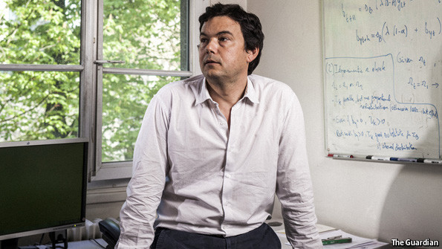
IT IS the economics book taking the world by storm. "Capital in the Twenty-First Century", written by the French economist Thomas Piketty, was published in French last year and in English in March of this year. The English version quickly became an unlikely bestseller, and it has prompted a broad and energetic debate on the book’s subject: the outlook for global inequality. Some reckon it heralds or may itself cause a pronounced shift in the focus of economic policy, toward distributional questions. This newspaper has hailed Mr Piketty as "the modern Marx" (Karl, that is). But what’s it all about?
"Capital" is built on more than a decade of research by Mr Piketty and a handful of other economists, detailing historical changes in the concentration of income and wealth. This pile of data allows Mr Piketty to sketch out the evolution of inequality since the beginning of the industrial revolution. In the 18th and 19th centuries western European society was highly unequal. Private wealth dwarfed national income and was concentrated in the hands of the rich families who sat atop a relatively rigid class structure. This system persisted even as industrialisation slowly contributed to rising wages for workers. Only the chaos of the first and second world wars and the Depression disrupted this pattern. High taxes, inflation, bankruptcies, and the growth of sprawling welfare states caused wealth to shrink dramatically, and ushered in a period in which both income and wealth were distributed in relatively egalitarian fashion. But the shocks of the early 20th century have faded and wealth is now reasserting itself. On many measures, Mr Piketty reckons, the importance of wealth in modern economies is approaching levels last seen before the first world war.
From this history, Mr Piketty derives a grand theory of capital and inequality. As a general rule wealth grows faster than economic output, he explains, a concept he captures in the expression r > g (where r is the rate of return to wealth and g is the economic growth rate). Other things being equal, faster economic growth will diminish the importance of wealth in a society, whereas slower growth will increase it (and demographic change that slows global growth will make capital more dominant). But there are no natural forces pushing against the steady concentration of wealth. Only a burst of rapid growth (from technological progress or rising population) or government intervention can be counted on to keep economies from returning to the “patrimonial capitalism” that worried Karl Marx. Mr Piketty closes the book by recommending that governments step in now, by adopting a global tax on wealth, to prevent soaring inequality contributing to economic or political instability down the road.
The book has unsurprisingly attracted plenty of criticism. Some wonder whether Mr Piketty is right to think the future will look like the past. Theory argues that it should become ever harder to earn a good return on wealth the more there is of it. And today’s super-rich mostly come by their wealth through work, rather than via inheritance. Others argue that Mr Piketty’s policy recommendations are more ideologically than economically driven and could do more harm than good. But many of the sceptics nonetheless have kind words for the book’s contributions, in terms of data and analysis. Whether or not Mr Piketty succeeds in changing policy, he will have influenced the way thousands of readers and plenty of economists think about these issues.
Dig deeper:
"Capital" is a great piece of scholarship, but a poor guide to policy (May 2014)
Why did the French version of "Capital" not make the same splash? (April 2014)
Revisiting an old argument about the impact of capitalism (January 2014)

