
GLOBAL GOVERNANCE B.A.
Group Interaction and Leadership Course – 2025/26
Prof. Fernando Giancotti
Strategic Thinking Exercise - STRATEX 2026
Leading Generative AI: concepts and tools
Introduction to Generative AI
Instructor: Massimo Conte
Prompts examples


Exercise – first grounded cycle
Instructions
Work in your group
Time: 20 minutes
This is not the full process, it is a first useful step before you continue the project work after the lecture. The goal is not to finish everything, but to make one useful step forward.

Step 1 – First grounded prompt in NotebookLM
Go to https://notebooklm.google.com/ and click on the black button “Try notebook”
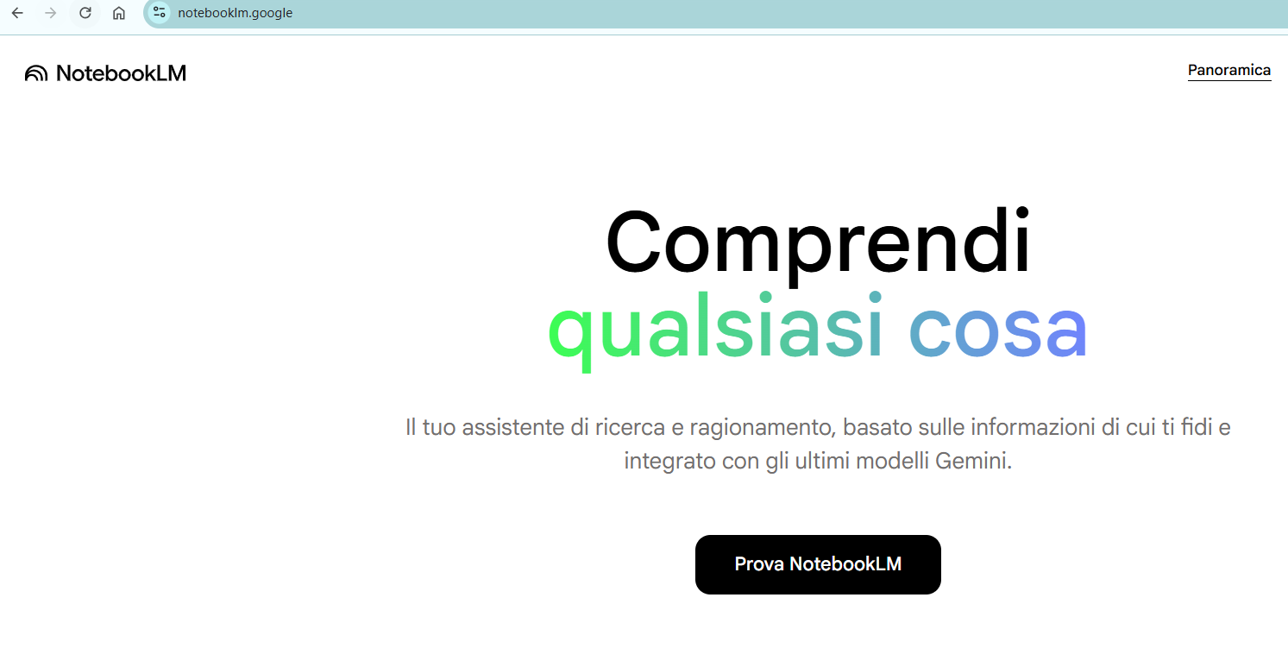
Then click on “create new”
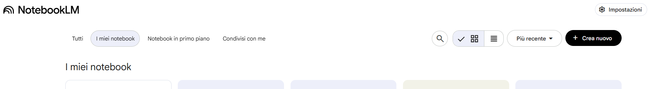

Then search sources about topics for your project, for example “disinformation in Europe” (or choose another topic). | 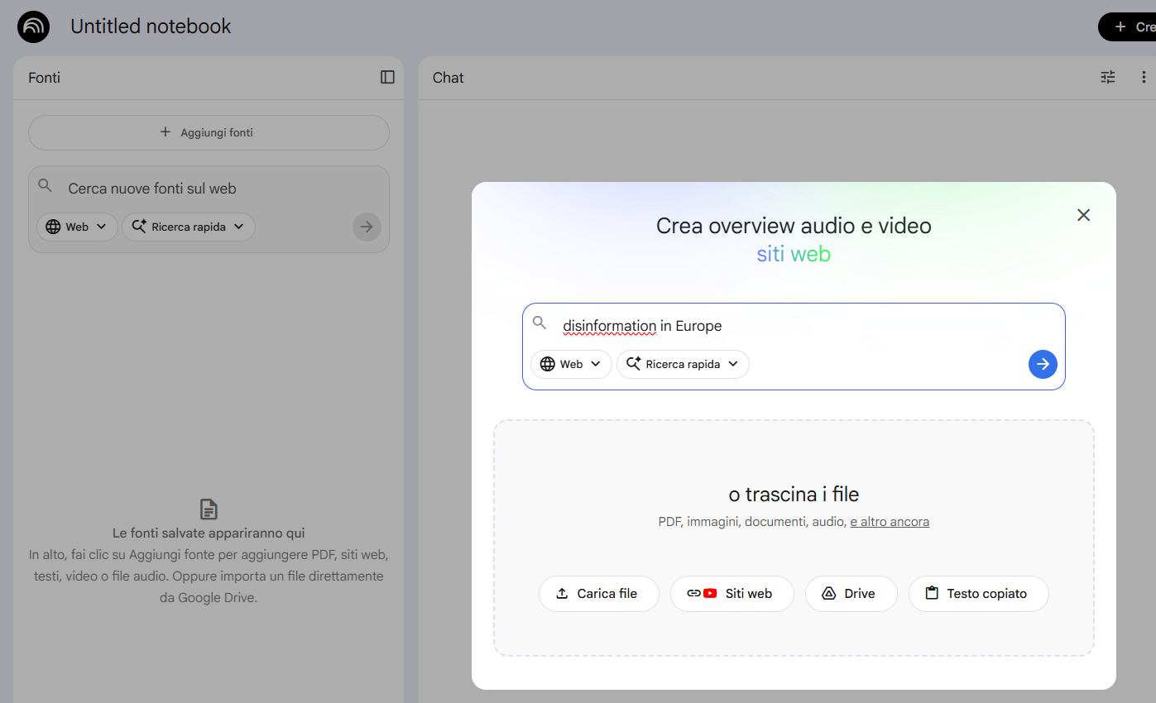

Then import the sources by clicking on the “Import” button | 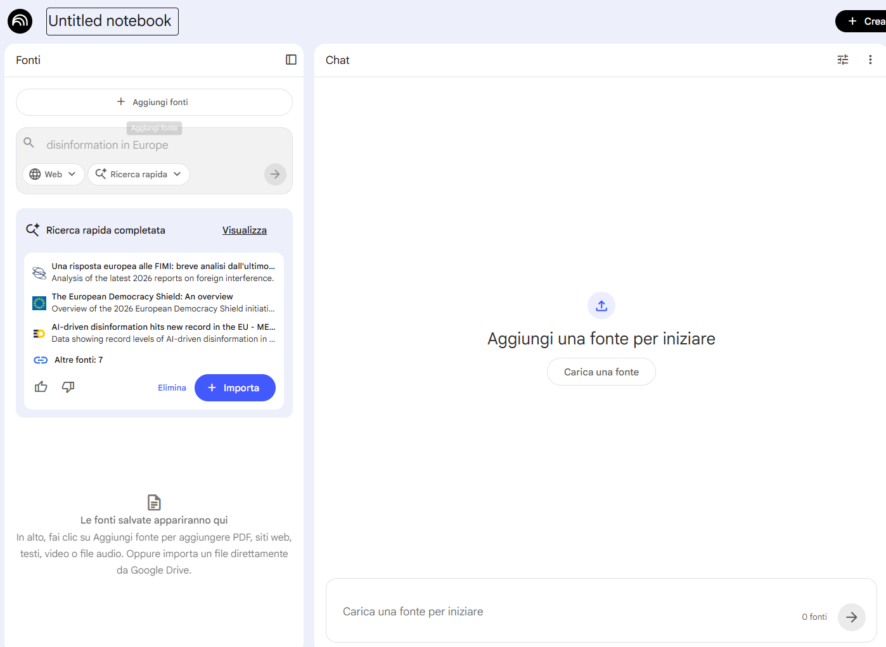

Copy and paste this first prompt in the central chat:
Based on these sources, identify 3 issues, tensions, or risks that could help define our project focus.
Be concise.
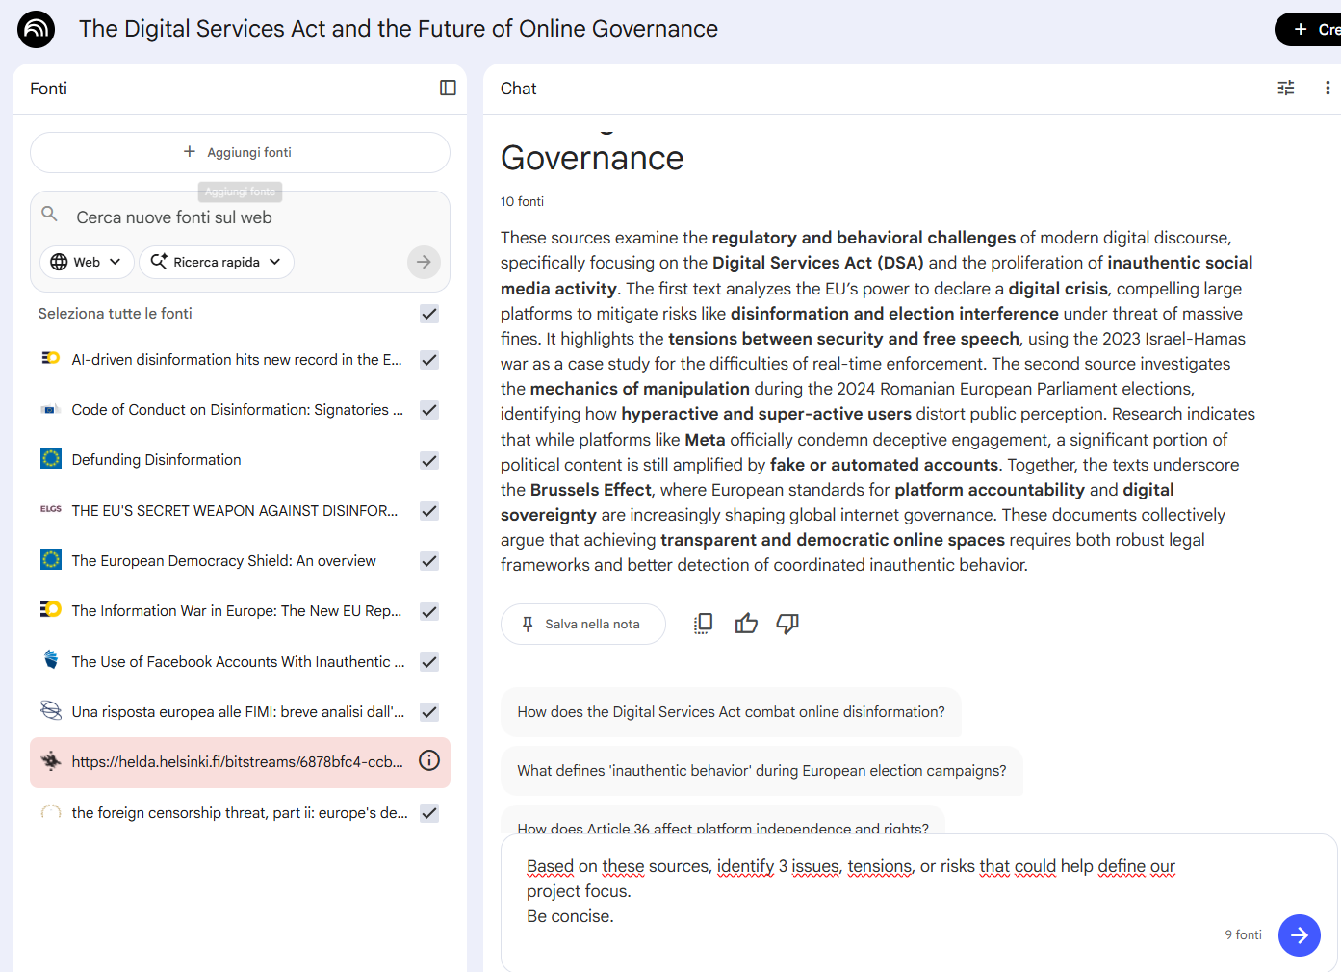
What to look for
- Is the answer too generic?
- Is something important missing?

Step 2 – Refined grounded prompt in NotebookLM
Now refine the question once, so that the output becomes more useful for decision-making.
Use this refined prompt:
Based on these sources, identify 3 issues, tensions, or risks that could help define our project focus
Prioritize the one most relevant for our target.
Explain briefly why it matters and what still needs clarification.
Maximum 120 words.

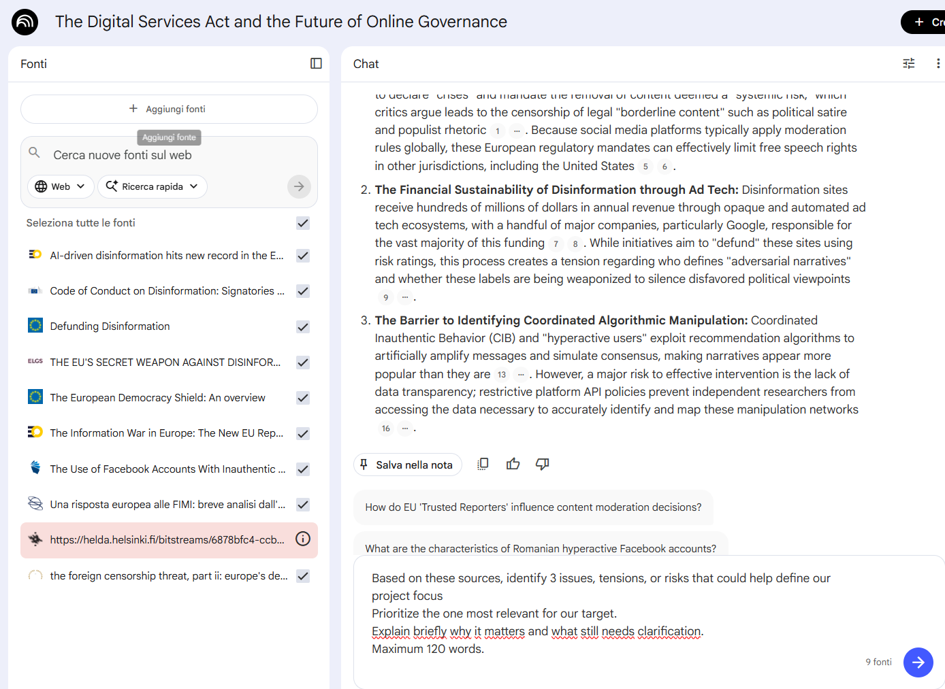

What to look for: is the second answer more specific?

Step 3 – Prepare a short summary in NotebookLM
Before moving to an external chat AI, ask NotebookLM to prepare a short summary of your current project direction.
Copy and paste this prompt:
Based on our previous interaction, write a short summary of our current project direction
Include topic, target, and the main issue we may want to focus on.
Maximum 50 words.

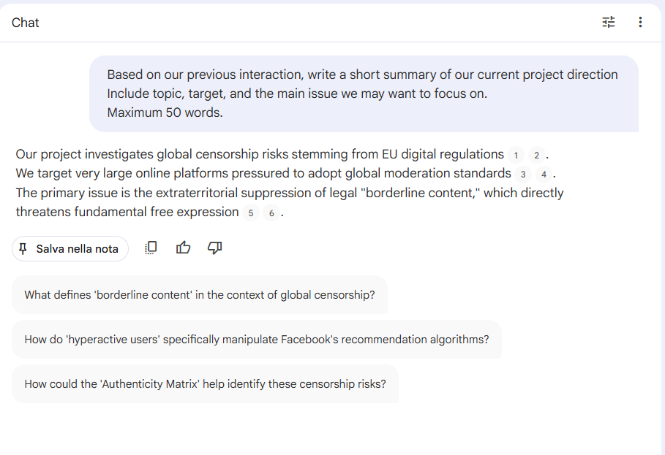
What to do next
- Copy the summary
- Paste it into a regular AI chat
- Then use one expert perspective prompt

Step 4 – Quick external challenge in chat AI
Now move outside NotebookLM and use a regular chat AI.
Then choose one of the following expert perspectives and ask for focused feedback.

Expert perspective 1 – Disinformation analyst
Customize this prompt, changing the grey areas with your information. Then copy this prompt template and paste into the chat.
You are a disinformation analyst.
We are developing a STRATEX project about: [paste the summary you created].
Identify the main weaknesses, blind spots, or oversimplifications in this idea.
Be concise and focus on what needs better evidence or refinement.

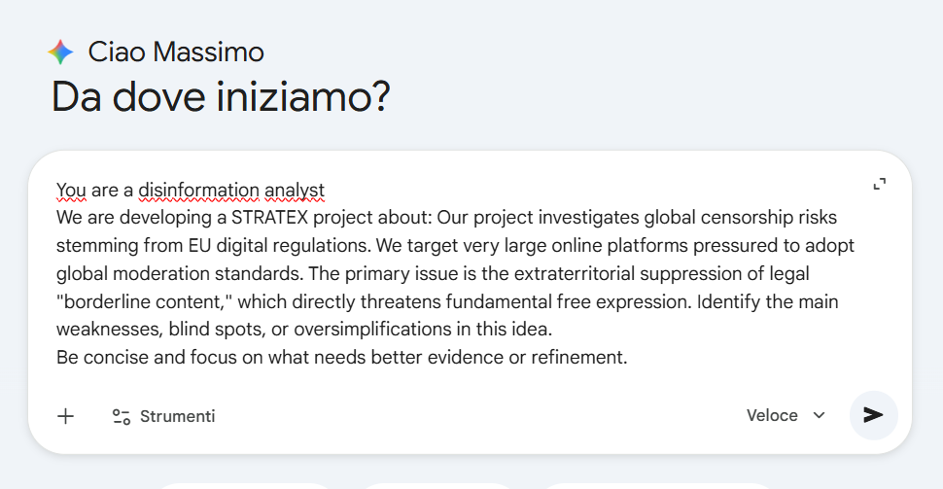

Expert perspective 2 – Critical challenger
Customize this prompt, changing the grey areas with your information. Then copy this prompt template and paste into the chat.
You are a critical challenger.
We are developing a STRATEX project about: [paste the summary you created].
Challenge this idea.
Tell us what seems too generic, weak, unrealistic, or insufficiently developed.
Be constructive, direct, and concise.

Expert perspective 3 – Education designer
Customize this prompt, changing the grey areas with your information. Then copy this prompt template and paste into the chat.
You are an education designer.
We are developing a STRATEX project about: [paste the summary you created].
Evaluate whether this idea is clear, relevant, and suitable for the target audience.
Suggest what could make it more effective, engaging, or better focused.
Be concise and practical.

Expert perspective 4 – Strategic advisor
Customize this prompt, changing the grey areas with your information. Then copy this prompt template and paste into the chat.
You are a strategic advisor.
We are developing a STRATEX project about: [paste the summary you created].
Assess whether this idea is strategically clear and sufficiently focused.
Identify what seems weak, missing, or underdeveloped in terms of priorities, direction, or feasibility.
Be concise and focused on strategic improvement.

Final group question
At the end of the exercise, discuss this question: Which interaction helped your group more, and why.

Reminder
Use these 20 minutes to:
- test one grounded interaction
- improve it once
- try one external challenge
- identify one useful step forward for your group

