Facoltà di Economia
Università di Roma "Tor Vergata"
Corso di laurea Magistrale in Economia e Management
Anno accademico 2016/17
Primo semestre

Corso:
Economia della Regolamentazione e della Concorrenza
(Economia e Politica Industriale)

Docente
Prof. Riccardo Cappellin

Materiali di approfondimento delle lezioni:

- Crescita, produttività, investimenti e innovazione nella nuova politica industriale e regionale

Riferimenti

Gruppo di Discussione: “Crescita, Investimenti e Territorio”

http://economia.uniroma2.it/dmd/crescita-investimenti-e-territorio

Cappellin R. (2016), Innovation and investments in a regional cross-sectoral growth model: a change is needed in European cohesion policies, paper presented at the 56th ERSA Congress, 23-26 August 2016, Vienna, Austria.

Cappellin R. (2016), Investments, balance of payment equilibrium andindustrial and regional policies in Europe, paper presented at the 56th ERSA Congress, 23-26 August 2016, Vienna, Austria.

Available on: https://uniroma2.academia.edu/RiccardoCappellin

The Discussion Group “Growth, Investments and Territory”
http://economia.uniroma2.it/dmd/crescita-investimenti-e-territorio
is an independent think-tank which aims to define the guidelines
for a “new industrial and regional policy”

Universities and Research

Major industrial
and service companies

Trade unions

MORE THAN 50 ECONOMIC AND TERRITORIAL EXPERTS

Major banks and financial
institutions

National, regional and municipal
public administration

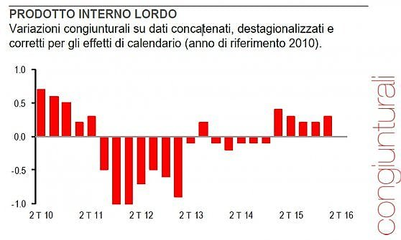

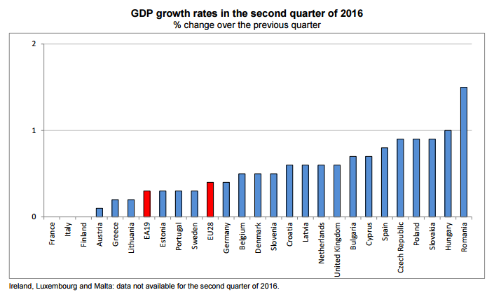
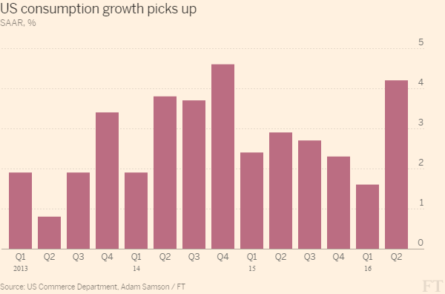

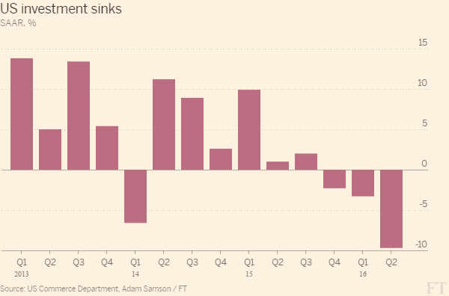

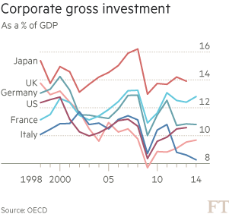
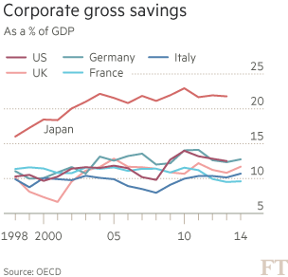

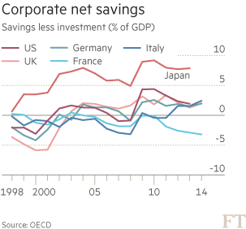
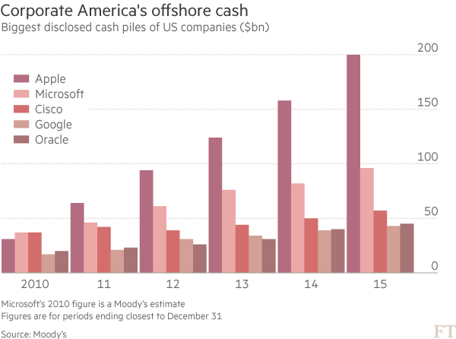
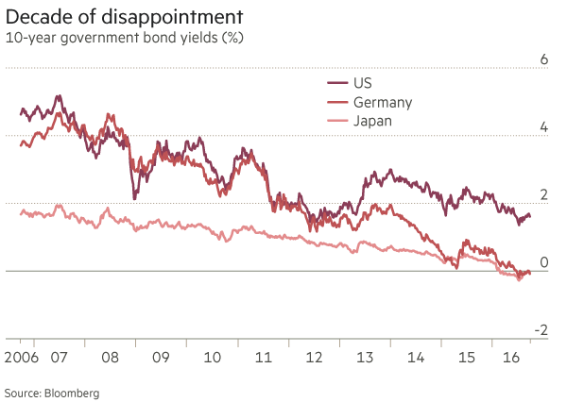

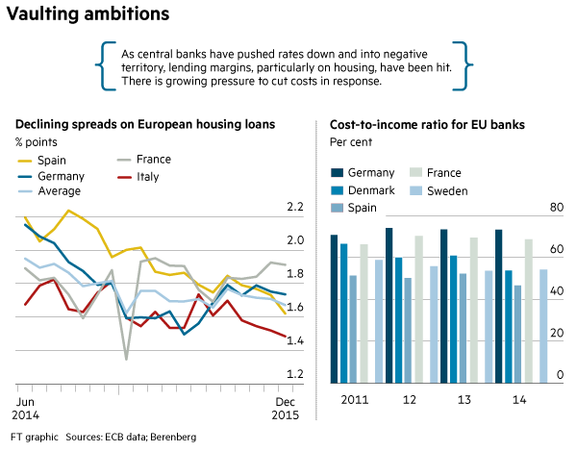

Table 1- The decrease of investment has determined a low GDP growth
GEO | NA_ITEM/TIME | 2007 | 2015 | Contribution | Difference  2015-2007 | SHARE-2015 | SHARE-2007 | Growth 20015/2007
Italy | Gross domestic product at market prices | 1.687.143,2 | 1.547.233,3 | -8,29% | -139.910 | 100,0% | 100,0% | -8,3%
Italy | Household and NPISH final consumption expenditure | 993.393,3 | 930.922,7 | -3,70% | - 62.471 | 60,2% | 58,9% | -6,3%
Italy | Final consumption expenditure of general government | 321.472,4 | 310.901,9 | -0,63% | - 10.571 | 20,1% | 19,1% | -3,3%
Italy | Gross fixed capital formation | 368.619,8 | 258.887,9 | -6,50% | -109.732 | 16,7% | 21,8% | -29,8%
Italy | Exports of goods and services | 455.247,5 | 470.945,6 | 0,93% | 15.698 | 30,4% | 27,0% | 3,4%
Italy | Imports of goods and services | 461.900,0 | 429.885,6 | 1,90% | -32.014 | -27,8% | -27,4% | -6,9%
Euro area (12) | Gross domestic product at market prices | 9.550.965,0 | 9.614.856,6 | 0,67% | 63.892 | 100,0% | 100,0% | 0,7%
Euro area (12) | Household and NPISH final consumption expenditure | 5.258.233,7 | 5.283.874,5 | 0,27% | 25.641 | 55,0% | 55,1% | 0,5%
Euro area (12) | Final consumption expenditure of general government | 1.894.120,4 | 2.040.831,3 | 1,54% | 146.711 | 21,2% | 19,8% | 7,7%
Euro area (12) | Gross fixed capital formation | 2.190.564,2 | 1.921.213,0 | -2,82% | -269.351 | 20,0% | 22,9% | -12,3%
Euro area (12) | Exports of goods and services | 3.659.656,0 | 4.366.495,2 | 7,40% | 706.839 | 45,4% | 38,3% | 19,3%
Euro area (12) | Imports of goods and services | 3.518.062,4 | 3.987.781,4 | -4,92% | 469.719 | -41,5% | -36,8% | 13,4%

- “The ongoing recovery remains driven by domestic demand and in particular, by private consumption” (Source: European Economic Forecast, Spring 2016)
- Growth is determined by the internal demand and not by exports
- The forecast of a higher GDP growth depends on a future increase of the investment

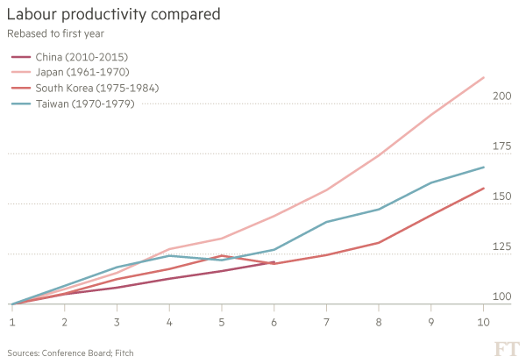

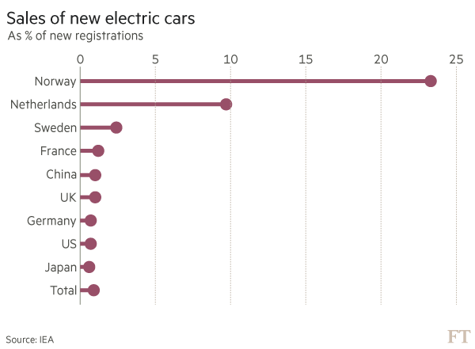

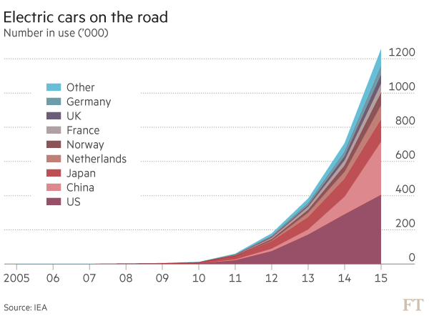
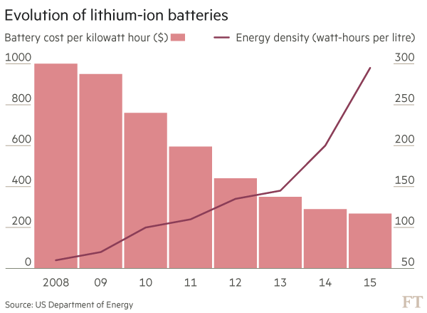

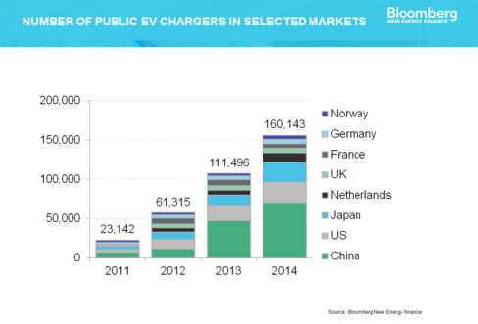

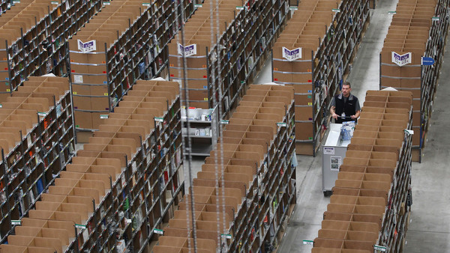

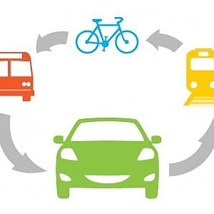 |  | 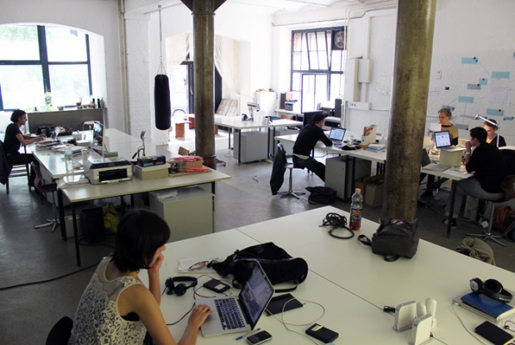

SHARING ECONOMY



The sequence of many different innovation waves as indicated by the product life cycle model determines a continuous increases of labor productivity, of wages and incomes and therefore also of the internal demand.

However the development of these new sectors requires major investments and various forms of financing: public and venture capital in early stage, equity and bank credit in the development phase.

Corporation have to decide whether rationalize existing productions and to disinvest or to create spin-off and reconvert to new productions, which require more investments.

INNOVATION - INVESTMENTS

PRODUCTIVITY -
EMPLOYMENT
GDP GROWTH

Figure 1
THE OBJECTIVES AND
INSTRUMENTS OF THE NEW INDUSTRIAL POLICY

LABOR RELATIONS
LABOR INCOME
AGGREGATE DEMAND
CONSUMPTION
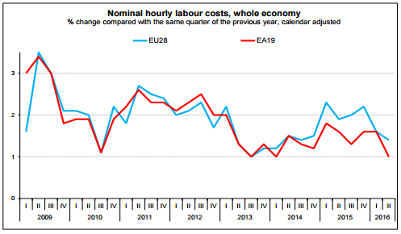

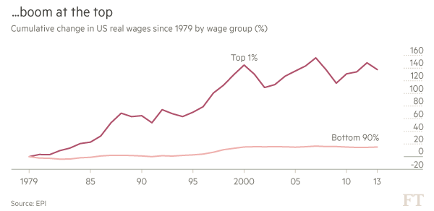



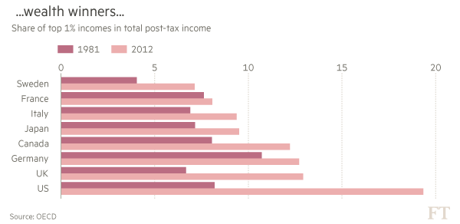

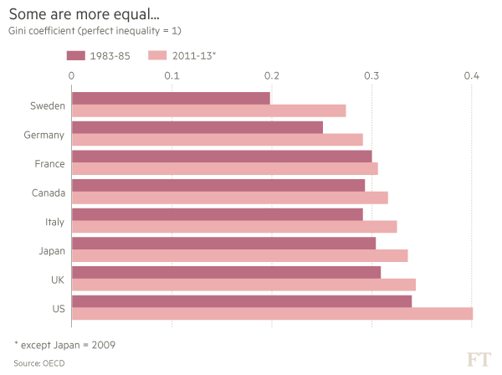After the Brexit there is the need for a change in European economic policies. European and national policies in the EU are aiming to the financial stability and not to the economic growth which is the precondition for financial stability of the banks and of the public budgets.

The paper indicates a new growth strategy which aims to the growth of the productivity, the wages and the internal demand through a re-launch of innovation and investments.

New industrial and regional policies are the key element of a new growth strategy for the EU and its regions and urban areas.

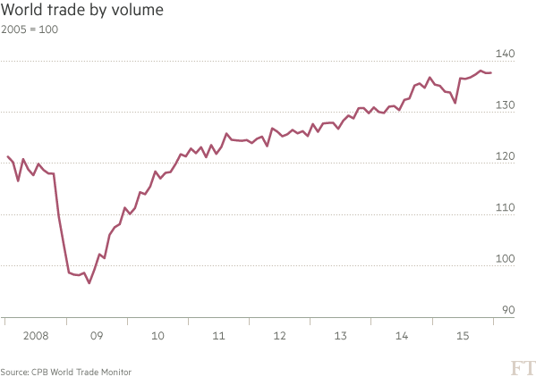

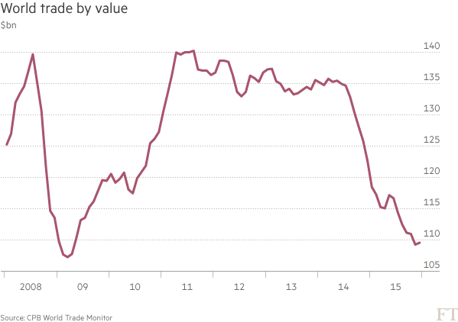
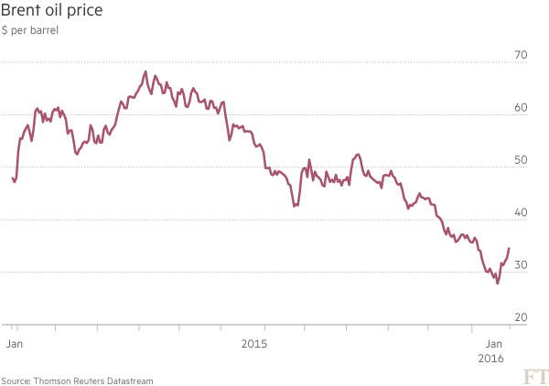

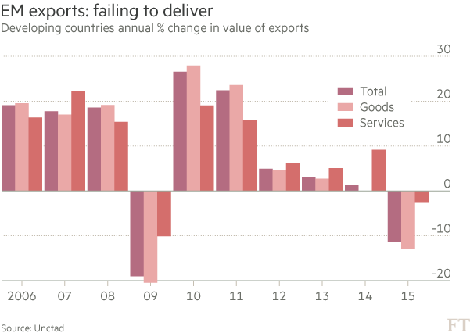

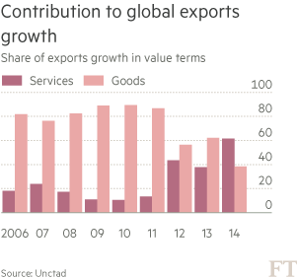
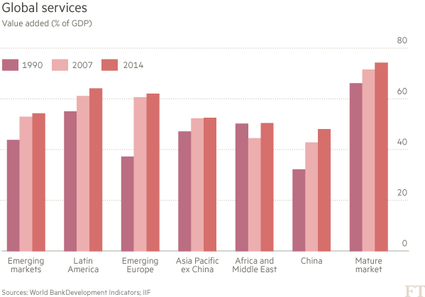

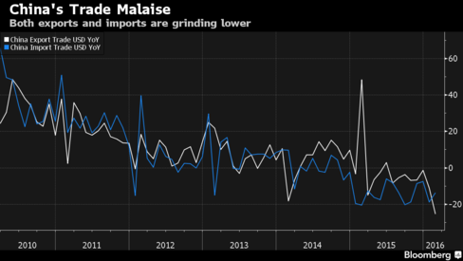

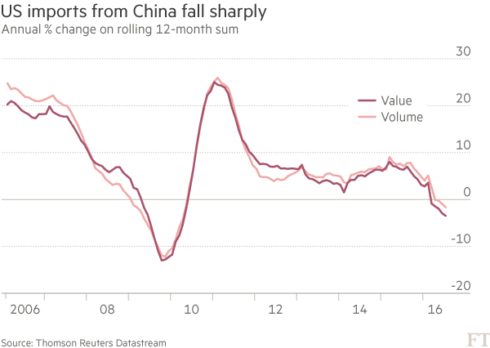
- The growth of the European economy should depend on the internal demand, as the European economy represents the largest economy in the world and it is difficult to immagine that the other countries could significantly increase their imports from the EU, in order that exports become the main driver of the long term growth of the European economy.

The recovery of the European economy should start from the territory and from investments aiming to respond to the needs of its citizens and urban areas, rather than from monetary and fiscal policies aiming to stability of the banks and the public budgets

Both national governments and the EU Commission have interpreted the Juncker’s plan and the EU regional policy as a public budget increase and not as an instrument of a new European development strategy.

A new growth policy in Europe should be based on the acknowledgement that economic growth requires the creation of new productions, new firms and new sectors. That requires not only an increase of private and public, immaterial and material investments, but also innovation in the structure of the economy and a change in the policies from promoting the exports and international competitiveness to the aim of expanding the production capacity oriented to the internal European market, in order to anticipate and sustain the growth of the internal demand and the consumption of the European citizens.
The European Union and some countries (e.g. Germany and Italy) have a positive balance of trade with the external world. Germany surplus is especially higher in the trade with the other European countries.

 |  | 2007 | 2015 | share  2007 | share  2015
Euro area (12 countries) | Exports-Imports of goods and services | 141.593,6 | 378.713,8 | 1,5% | 3,9%

The policies aiming to increase the external surplus decrease the internal demand, as
X – M = S - I
= foreign direct investment or increase of foreign financial assets

and that leads to export capitals or investments outside the European economy, thus decreasing the future growth of the EU.

The role of the internal demand and
of the external trade balance on GDP

 |  | 2007 | 2015 | share  2007 | share  2015
Euro area (12 countries) | Gross domestic product at market prices | 9.550.965,0 | 9.614.856,6 | 100,0% | 100,0%
Euro area (12 countries) | Exports of goods and services | 3.659.656,0 | 4.366.495,2 | 38,3% | 45,4%
Euro area (12 countries) | Imports of goods and services | 3.518.062,4 | 3.987.781,4 | 36,8% | 41,5%
Euro area (12 countries) | Final consumption expenditure and gross capital formation | 9.415.995,2 | 9.238.753,5 | 98,6% | 96,1%
Euro area (12 countries) | Exports-Imports of goods and services | 141.593,6 | 378.713,8 | 1,5% | 3,9%

- The positive effect of exports on GDP is balanced by the almost equal negative effect of import.
- Moreover, the increase of the external trade balance determines an increase of the surplus of saving on investment (S - I = X – M) and in the long term the low investment decreases the growth of the internal production capacity

External balance of goods and services
Percentage of gross domestic product (GDP)
GEO/TIME | 2014Q3 | 2014Q4 | 2015Q1 | 2015Q2 | 2015Q3 | 2015Q4
Germany | 7,09% | 7,07% | 7,45% | 8,14% | 7,83% | 7,64%
Euro area (12 countries) | 3,74% | 4,15% | 4,33% | 4,60% | 4,51% | 4,38%
Spain | 2,53% | 3,05% | 2,86% | 1,97% | 2,33% | 2,80%
France | -2,06% | -1,48% | -1,27% | -0,89% | -1,17% | -1,34%
Italy | 2,78% | 3,44% | 3,21% | 3,02% | 3,08% | 3,44%
United Kingdom | -2,07% | -2,03% | -2,34% | -1,02% | -1,91% | -2,60%

- Both in the EU (-4,38%) and in Germany (-7,64%) and in Italy (-3,44%) there is a surplus of the trade balance of goods and services and that indicates that the internal demand is lower than the internal production or that saving is greater than investments.

The countries which have greater growth rates such as UK, Spain and France

Intra-EU exports Intra-EU imports, 2002-2013 (%)



