Readings
in Economics of Innovation n. 1
Course 2014

March 17, 2014 12:11 pm

Wall Street set for tech IPO let-down
By Richard Waters in San Francisco
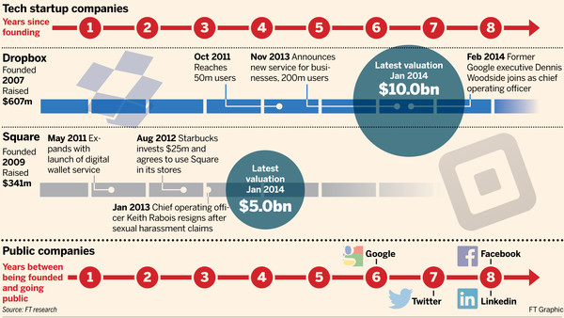
Evernote, a service for organising personal information across multiple devices, is among the companies that had been tipped to lead a long-awaited revival of tech initial public offerings in the US this year. But it seems Wall Street will have to be patient a little longer.
“I don’t think we’re ready for it right now,” says Phil Libin, the company’s chief executive. “Our revenue is not predictable enough yet, we don’t have enough history of it, the team isn’t at a point where we know how everything should be structured. These are all things that we should figure out before we go public.”
If Mr Libin does not feel any burning need to come to Wall Street, then the fact that he has plenty of cash in the bank has much to do with it. Contemplating the two or three years he expects to take to prepare the 10-year-old company for an IPO, he says: “We have the money to do it so there’s no reason to rush.”

Hot prospects

For a closer look at some of the groups most coveted by Wall Street for possible listings
See below
Evernote is not alone. Wall Street investors are getting impatient to get their hands on the next group of hot internet stocks. But some of the best-known names are flush with cash and showing no rush to list their shares.
Brian Chesky, founder of Airbnb, the site for homeowners to rent out their spare rooms, has ruled out taking his company public this year. Meanwhile, Square, a payments company whose private market valuation hit $5bn earlier this year, has also backed away from any immediate plan to list. Industry sources familiar with the group say it is focused on lifting revenues and finding new business lines, making it highly unlikely to come to market in 2014.
The availability of late-stage funds has created a lot of breathing room for some of these successful companies
- Lise Buyer, an adviser who worked on Google’s IPO a decade ago
Also, while Facebook’s planned $19bn purchase of WhatsApp has whetted investors’ appetites for a new generation of messaging and social media stars, the hottest prospects are a long way from an IPO. Like WhatsApp, they have put all their effort into the race to build large audiences, putting off the job of trying to make serious money for another day.
Pinterest, a social media site organised around pictures, has only recently begun testing an advertising service, despite approaching its fifth birthday – a point at which Google was already preparing its IPO. And Snapchat, which rejected a $3bn offer from Facebook last year, is even further back in the revenue stakes.
Many on Wall Street had been hoping that companies like these would lead a long-awaited revival of US tech IPOs in 2014. Instead, Chinese internet companies Alibaba and Sina Weibo look set to steal the IPO headlines.
Not that the IPO pipeline is not starting to look busy. A batch of US tech companies that sell to businesses are waiting in the wings, promising one of the most active years for fundraising since the end of the 1990s tech boom.
“This clearly is shaping up to be the best year for IPOs in a decade,” said Steve Case, the former head of online service America Online and now head of his own private investment firm, Revolution.
Rightly or wrongly, however, it is the next budding consumer internet giants that excite Wall Street’s anticipation the most – particularly in the wake of Twitter’s stock price surge following its October IPO and the sky-high price paid for WhatsApp.
Many of these companies feel no need to rush – particularly as they try to turn their early stabs at generating revenue into durable business models. Mutual and hedge fund investors have been competing to pour money into mature private companies in the hopes of picking up bargains ahead of an IPO. That has pushed up valuations and reduced the pressure to go public.
“The availability of late-stage funds has created a lot of breathing room for some of these successful companies,” says Lise Buyer, an IPO adviser who worked on Google’s stock market debut a decade ago.
However, the companies that delay their IPOs put themselves at a serious disadvantage for when the next wave of consolidation sweeps across the industry, said Mr Case. AOL pursued a number of acquisitions after its own 1992 stock market listing, helping to cement its position in the run-up to the dotcom boom. “It’s better to position yourself as a consolidator than a consolidatee,” Mr Case said.
Companies that have taken the money to extend their lives as private concerns include Credit Karma, a free site for US consumers to check their credit scores, which last week raised $85m from investors that included Google Capital.
With revenues forecast to reach $200m this year, “we have the financials” to go public, said Kenneth Lin, Credit Karma’s chief executive. He added, however: “We think it will take us a solid 18 months to be in that position.” Given the higher level of regulatory scrutiny public companies operate under, Mr Lin said: “You want to be tidied up for multiple quarters before you even consider it.”
Some fast-expanding internet companies, meanwhile, have shown signs of outgrowing their management teams. Dropbox, the online storage company whose private market value has already risen to $10bn, is only now showing signs of putting in place the senior management group it is likely to need as a public company. That included the appointment as chief operating officer last month of Dennis Woodside, who had previously run Google’s Motorola subsidiary. Dropbox has also yet to appoint a chief financial officer – something that could well put its IPO on hold until next year, according to some experts.
A CFO “is taking on big personal liability” by signing off on a company’s accounts that they were not involved in preparing, said Ms Buyer, making it undesirable to carry out an IPO within a year of naming a finance chief.
That has not stopped other companies moving more quickly: camera maker GoPro appointed a CFO only last month, days before revealing it had filed for an IPO. Yet for those able to attract the highest valuations in the late-stage private markets, the pressure to go public fast is off – no matter how impatient Wall Street is becoming.
Additional reporting by Tim Bradshaw and Sarah Mishkin
Hot Prospects: coveted possible listings for Wall Street

Dropbox
What it does: Online storage company
Founded: 2007
Amount raised: $607m
Latest valuation: $10bn, Jan 2014
Key dates: October 2011: Reaches 50m users
Nov 2013: Announces new service for businesses, 200m users
Feb 2014: Former Google executive Dennis Woodside joins as chief operating officer

Square
What it does: Payments company led by Twitter co-founder Jack Dorsey
Founded: 2009
Raised: $341m
Latest valuation: $5bn, Jan 2014
Key dates: May 2011: Expands with launch of digital wallet service
Aug 2012: Starbucks, pictured, invests $25m and agrees to use Square in its stores
Jan 2013: Chief operating officer Keith Rabois resigns after sexual harassment claims

Airbnb
What it does: Allows homeowners to rent out spare rooms
Founded: 2008
Raised: $326m
Latest valuation: $2.5bn, Oct 2012
Key dates: Jul 2011: Homeowner brings bad publicity after claiming vandalism by an Airbnb guest
May 2012: Offers homeowners up to $1m insurance protection
April 2013: Begins to require users to verify their real identities

Uber
What it does: A popular taxi-hailing app
Founded: 2009
Raised: $307m
Latest valuation: $3.5bn, Aug 2013
Key dates: Jul 2012: Extends car service with the lower-cost UberX
Oct 2012: Pressure mounts from taxi unions, including a lawsuit from taxi drivers in Chicago
Nov 2013: Offers financing plan for Uber drivers to lease their vehicles

Spotify
Founded: 2006
Raised: $538m
Latest valuation: $4bn, Nov 2013
Key dates: Mar 2011: Reaches 1m paying subscribers in Europe
Jul 2011: Long-delayed US launch after reaching a rights deal with music labels
Mar 2014: Secures $200m credit line as it moves closer to an IPO

March 17, 2014 6:17 pm

Start-ups box clever with home furniture to tap ecommerce growth
By Sarah Mishkin in San Francisco
A growing number of well-funded start-ups are betting on high-end furniture and home goods as a way to ride the growth of ecommerce.
They see packaging up large, unusually shaped and fragile goods as a route to becoming billion-dollar ventures without getting shunted aside by the dominance of Amazon, the Seattle-based ecommerce king, as so many other start-ups have before them.
Amazon, they reckon, is unlikely to get into the tricky business of boxing up delicate lamps or second-hand designer couches and shipping them across the US.
Start-ups including Wayfair, One Kings Lane and 1stdibs have all raised substantial new funds or gained investors recently, while British white goods retailer AO has seen its shares jump since listing in London in February.
Successful ecommerce companies now “have to have a specific focus area so they can offer a deeper selection, something really special”, said Anders Gustafsson, chief executives of Zebra Technologies, which sells systems to help online and offline retailers, including Amazon, track their inventory.
Goldman Sachs estimates that the US ecommerce market will grow 16 per cent this year to $241bn, with some of that growth coming from sites such as One Kings Lane and Zulily, a site for mothers and babies.
Unlike broader platforms such as Amazon or eBay that sell everything from used books to spatulas, the sites choose, or “curate” in Silicon Valley parlance, their merchandise carefully for a specific audience. They bring together in one marketplace what are now fragmented networks of small vendors and brands.
The second-hand furniture start-ups also springing up are equally selective, picking and choosing the best of the furniture their users want to sell, and then themselves perking up the pictures and text used in the listings.
Furniture is a particularly promising area, argues one investor, as it is one of many fields where online retailers – which despite their growth make up only 6 per cent of total retail spending in the US – have made only modest headway. The industry is dominated in the US by Ikea, national chains such as Crate & Barrel, local consignment shops, and interior designers with industry connections.
“There are still big shifts to take place in ecommerce in certain sectors, such as home goods, which have been traditionally offline,” said Michael Brown, a partner with one of Wayfair’s investors, Battery Ventures.
Wayfair, which sells a relatively wide range of goods, announced last week it had raised $157m. That values it at about $2bn, with sales last year up 55 per cent year on year to $915m, according to people familiar with the fundraising. Wayfair has filed confidentially to go public, say people familiar with the company.
One Kings Lane sells slightly more expensive items and features a photo-heavy layout to give shoppers ideas, much like a design magazine would. Earlier this year it raised $112m, valuing it near $1bn, about double its valuation in an earlier round.
Ambitious foreign investors have also taken note, and Chinese ecommerce group Alibaba in January invested $15m in 1stdibs, an eclectic high end home goods retailer inspired by a Parisian flea market.
Furniture companies are in a particularly strong position, says second-hand site Chairish’s co-founder Eric Grosse, because Amazon’s competitive edge as a marketplace lies largely in its massive warehouse network.
That lets it stock and quickly ship a wide range of items, but it is a strength that is hard to replicate in a field such as furniture, where items are often unique and bulky.
“When you expand you expand relative to your core strengths, and this is something that is so on the opposite end of [Amazon’s] fulfilment structure,” said Mr Grosse, who also founded travel site Hotwire.
Timing is also helping the growth of the online furniture market, said Paco Underhill, chief executive of retail consultancy Envirosell. The young adults known as Millennials do more online shopping than many older people, and are now settling down and wealthy enough to invest in home furnishing. In the US, they also favour small city apartments, unlike the spacious surbuban homes their parents might live in.
“One of the first places that [Millennials] start doing their research is online,” said Mr Underhill.
Yet building up the sites has not been without their hiccups for the start-ups trying to push quickly into the increasingly crowded space.
When Chairish, which sells only high-end used furniture, launched last year, its initial listings came in part from co-founder Gregg Brockway, who put much of his own furniture up for sale on the marketplace. Somewhat to his annoyance, his house emptied out quickly.
Additional reporting by Arash Massoudi in New York

February 20, 2014 12:02 am

Europe loses ground in global high-tech race
By Sarah Gordon, Europe business editor
Just nine of the world’s top 100 high-tech companies have their headquarters in Europe, generating only a tenth of the industry’s global revenues, according to a study that highlights the long-term dangers to the region’s economy if the sector is allowed to wither.
The study, by the consulting company AT Kearney, points to deals such as the purchase of the UK’s Autonomy by America’s Hewlett-Packard as examples of how European businesses are losing ground to their faster-growing Asian and US rivals.

High-tech, low performance
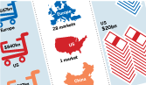

“A healthy high-tech sector is an engine for innovation that is a prerequisite for giving European companies a leg-up in a highly competitive environment,” said Axel Freyberg, one of the authors of the report.
“We can’t compete on labour costs, but we do in knowledge-intensive industries. If you lose these companies you lose the knowledge clusters which are necessary for innovation and growth.”
Mr Freyberg added there were particular industries where the loss of Europe-based expertise would be particularly painful. “By 2025, a car’s embedded software and electronics will account for up to 65 per cent of its total value. That Europe needs ICT to compete in sectors such as automotive, industrial engineering and others, is undisputed.”
One of the nine European groups in the list of the top 100 high-tech companies, measured by sales by sector, will drop out when Microsoft officially acquires Nokia’s devices and services division this spring – a move that will leave Europe with none of the world’s top 10 handset makers.
AT Kearney’s report, based on industry data and interviews with executives and researchers, suggests Europe is losing ground for a variety of reasons, including a shortage of skilled engineers, fragmented markets and a lack of strategic foresight.
Philip Greenish, who heads the UK’s Royal Academy of Engineering, recently wrote to the Financial Times, suggesting that by 2020 there would be a shortage of about 1.25m science, engineering and technology professionals and technicians in the UK alone.
According to the US National Science Board, only 17 per cent of EU students take engineering, mathematics and computer science courses, compared with 29 per cent in South Korea and 31 per cent in China and Taiwan.
Mr Freyberg said the loss of Europe-based high-tech companies would contribute to this gap, with fewer young people aspiring to join them. Another reason for Europe losing ground was a shortage of funding. “Companies lack financing to grow and gain scale,” he said.
According to the European Commission, Europe invests almost one percentage point less of gross domestic product in research and development than the US and 1.5 percentage points less than Japan.
Although Europe’s largest high-tech companies devote revenue to R&D, this is dwarfed by the size of some Asian and US companies. Last year, South Korea’s Samsung invested more than 6 per cent of its global revenues into R&D – equal to $13bn a year – and employed 65,000 staff in the department devoted to it.
The study’s authors urge Europe’s institutions and governments to do more to rejuvenate the high-tech industry. “Government bodies, ICT companies, investors and industry associations can work together for a long-term master plan,” said Hervé Collignon, a co-author of the study.
Mr Freyberg said there was a need for more strategic partnerships – as had happened, for example, in the development of GSM, the global system for mobile communications, which was developed in Europe for second-generation mobile phone networks.
“China and South Korea are doing this with the next generation of mobile networks, other regions are stepping up on this, so that their industry is moving ahead,” he warned.
“Although the European Commission has officially recognised technology’s importance to Europe’s future growth, competitiveness and mastery of upcoming social challenges, policy makers have still not done enough to stop the decline of the European high-tech sector.”
The commission is attempting to address some of these problems through its Horizon 2020 innovation and research strategy, which was commissioned in 2013 and aims to inject about €70bn into European technology-driven industries over the next seven years. But Mr Freyberg said these efforts fell short of what was required.
“A strategic master plan is missing in which the EU places major bets to grow promising ICT sectors, and in which an industrial policy is designed to help leading players expand,” he said.
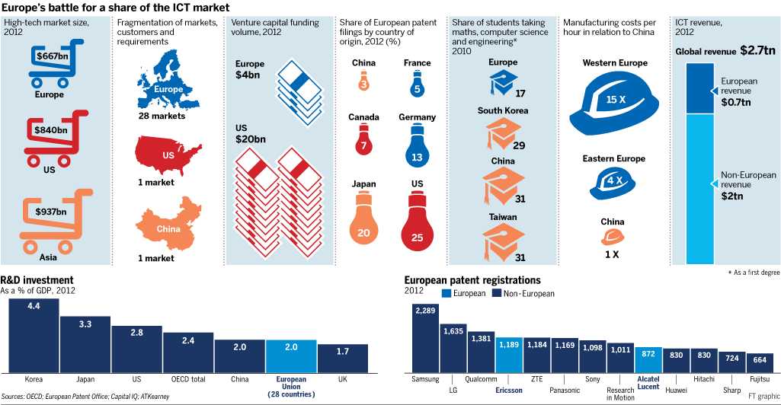
March 23, 2014 10:46 pm

Bosch applies expertise to innovation in consumer devices
By Chris Bryant
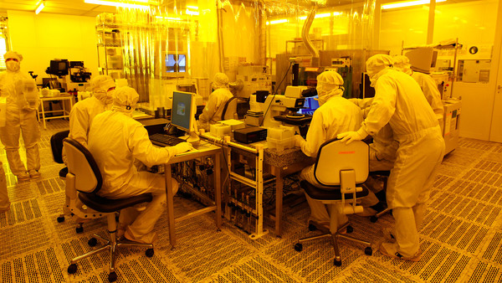©Reuters
Hands on: Bosch’s microsystem research lab
If you bashed your smartphone with a hammer there is a strong chance that, in the wreckage, you would find a micro-electromechanical sensor made by Bosch, the German technology conglomerate.
Without these sensors, known as MEMS, the phone would not know whether it was the right way up. Nor would it be able to measure acceleration, altitude, temperature or the earth’s magnetic field. In short, MEMS make a mobile phone “smart”. They are also the building blocks of other consumer electronic devices such as tablets and computer games controllers.
Best known for manufacturing car parts, including technology for self-driving cars, Bosch has quietly established itself as the leading manufacturer of MEMS, the smallest of which measures just 1.5mm x 1.2mm.
This has burnished Bosch’s reputation for innovation – the company invented anti-lock brakes, among a string of firsts. Furthermore, it has demonstrated that by working in novel ways a private company that is more than 125 years old can be as agile as any in Silicon Valley.
Last year Bosch produced more than 1bn MEMS, up from 600m in 2012. That number is expected to grow further as the trend for wearable electronics gathers pace and household appliances are networked in what has become known as the “internet of things”.
“If you had a humidity and temperature sensor in every room you could use this for your heating appliances,” says Stefan Finkbeiner, chief executive of Bosch Sensortec, the consumer-focused sensor unit. “If you had a microphone sensor in the room you could use that to switch on the light [via your voice].” The internet of things, he says, will bring us to “a completely different level”.
Bosch produces these delicate silicon structures at its high-tech wafer fabrication facility, or fab, in Reutlingen near Stuttgart, southwest Germany. Apart from specialising in such tiny components, the town’s claim to fame is that it has the world’s narrowest street – measuring a rather more generous 31cm across.
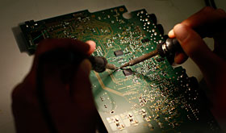©Reuters
Testing a car diagnostic system
Until recently the main customer for MEMS was the car industry, which uses them for all manner of safety-critical functions, from airbag sensors to vehicle antiskid systems.
Bosch used its automotive sensor experience to pivot into consumer electronics and founded Sensortec in 2005. The shift was not without risk: in the automotive industry, Bosch must be able to guarantee 100 per cent reliability for its sensors because of the potential for a malfunction to cause a lethal accident. Each sensor is tested to ensure it can survive a temperature range of -40C to 125C.
In consumer electronics, by contrast, small size, low cost and low power consumption are the priorities. Price varies according to volume, but an accelerometer sensor for a high-volume smartphone might sell for less than €0.50. The consumer business is volatile, as handset manufacturers are prone to change suppliers when they launch new models to guarantee the latest functionality.
Mobile phone companies roll out new models annually. In the car industry new car models are launched roughly every six years. Bosch has had to pay great attention to whether it can handle two such different markets. It requires “a different kind of thinking”, Finkbeiner says.
Privately-owned Bosch prides itself on financial prudence. In 2013 the company’s sales rose 3 per cent to €46.4bn and its return on sales was about 3 per cent. In 2009, however, the group made its first loss since the second world war. The demand slump that followed the financial crisis left it with production overcapacity in Europe. Its margins have since been under pressure from €3.7bn of losses linked to a failed solar power venture, which it is in the process of leaving.
It was, therefore, far from an easy time for Bosch to commit the €600m for its semiconductor fab in Reutlingen, which opened in 2010 and is the largest single capital investment in its history. It has paid off. Bosch’s sensors are installed in half the world’s smartphones and innovative new sensors are on the way. At the Consumer Electronics Show in January in Las Vegas, Bosch showed off an environmental sensor that can measure humidity, temperature and pressure in one unit measuring just 2.5mm square.
While Bosch’s automotive experience helped it get into the consumer electronics sector, now the latter is setting the pace of innovation. “New technologies are developed for consumer electronics applications and some of them are re-qualified for automotive products later on,” Finkbeiner says. “So in that sense, it was a win-win.”
Volkmar Denner, Bosch management board chairman, highlights the sensor business as an example of how the company is learning to work in new ways. In future, Denner says, the company will be on one of two speeds: the old Bosch in areas where absolute safety and reliability is required, and the new one where flexibility and agility are needed, particularly in relation to the internet.
“We also need a start-up culture but within the company,” he says. An example of that is Bosch’s eBike Systems unit. In just a short time, Bosch has become the market leader in Europe for power-assisted cycling, generating more than €100m in sales last year.
Ebikes, once considered clunky and only for the lazy or unfit, are catching on among commuters who want to save energy on long uphill climbs and not arrive at work in a sweaty shirt. Two young Bosch engineers came up with the idea in 2008 of combining existing Bosch expertise in lithium-ion batteries (from its power tools business) and sensor controls and electrical drives (from its automotive side) to build an ebike system. Bosch, incidentally, does not build the bicycles but rather sells the electronic system to bicycle manufacturers.
Bosch’s management board, having tried out a prototype model in the company car park, approved internal venture capital funding for a small team to pursue the project. “I don’t know how many banks in 2009 or 2010 would have granted a double-digit million-euro investment [to a hardware start-up],” says Claus Fleischer, head of eBike Systems. “It was a handful of people” who were given “enough freedom to define their own way”.
That said, the business is not allowed to let its standards slip. “We have very strict and disciplined board meetings where we have to show we are able to produce the products on time, on spec and on budget,” says Fleischer.
Although bankers tend to criticise conglomerates as inefficient, it appears that in innovation terms Bosch’s multi-division structure has advantages. “If we have an issue we can bring in experts from different areas,” Fleischer says.
The company continues to invest heavily in hybrid and electric motor vehicle systems. It is likely to take years for these to make a return, because at the moment sales volumes for electric vehicles remain low. But Bosch’s strategy of embracing other kinds of emobility has paid dividends. Ebikes are an opportunity to build volume more quickly and Bosch has been able to exploit its respected automotive brand to approach bicycle manufacturers.
Many potential buyers of electric vehicles are put off by concerns about how far the vehicles will travel before they run out of power. Ebikes do not have this problem because the option is always there to pedal. With electric bikes, says Fleischer, “you have more range and charging infrastructure is not an issue”.

March 12, 2014 2:48 pm

Aerospace and automotive are UK manufacturing’s star performers
By Tanya Powley, Manufacturing Correspondent
©Bloomberg
Britain’s manufacturers are using cutting-edge technology and gadgets to improve products and processes as the sector accelerates its recovery.
Significant growth of aerospace and carmaking during the past five years has led many to believe the future of UK manufacturing lies with so-called “advanced manufacturing” – companies that use innovative technology.
The strength of these two industries since the onset of the global financial crisis has been the most talked about evidence of a revival in manufacturing – a sector of the UK economy that has been in a state of decline for the past 30 years.
In spite of signs of a recovery, overall manufacturing output still remains about 9 per cent below pre-crisis levels. But this figure masks the wide divergence in the levels of growth seen by UK manufacturers during the downturn.
The UK’s aircraft and car industries have been two of the brightest spots for UK manufacturing growth, with output up 60 per cent and 40 per cent, respectively, compared with five years ago, according to an FT analysis of Office for National Statistics’ data.
In comparison, other industries have experienced a torrid time over the past five years, such as clothes manufacturing and petrochemicals, which have fallen 20 per cent and 26 per cent respectively.
Marcus Bryson, head of GKN’s aerospace division, an engineering company that makes components for planes, believes the UK excels at high-end technology, where a lot of innovative engineering resources and manufacturing processes are used.
The UK’s aerospace industry is unusual within the manufacturing sector as it was not particularly hit by the recession. It has instead benefited from the launch of an “unprecedented” number of new aircraft and engine programmes under development in the industry simultaneously. This includes the Airbus A380 and Boeing 787 over the past five years, while development work on the new Airbus A350 aircraft and the associated Rolls-Royce XWB engine has begun in the past two years.
“This has provided the industry with a major step change in volumes and has been a major contributing factor in the growth seen in the sector over the past five years,” says Darren Jukes, head of PwC’s industrial manufacturing sector.
GKN is one UK manufacturer that has taken advantage of this growth by making sure it is at the forefront of the latest wave of composite technologies that improve the efficiency, reliability and affordability of 21st century passenger jets. “Civil aerospace is going through a boom,” says Mr Bryson.
In 2012, GKN opened a new £170m wing factory near Bristol to make all-composite rear wing spars for the Airbus A350. It represents the FTSE 100 company’s largest ever investment in a single programme facility. The new site currently employs more than 300 people but GKN expects to increase this to 450 by 2016, following a ramp up in production rate by Airbus.

Nine out of 13 UK industry sectors recovering
Signs of a recovery in almost all UK industry sectors are beginning to show positive momentum.
Output rose in nine out of 13 sectors in January, according to figures published on Tuesday by the Office for National Statistics.
One industry showing strong growth is the non-metallic mineral sector, which covers materials such as glass, clay, porcelain, ceramic and stone. Manufacturing output was up 20 per cent at the end of 2013 compared with a year earlier, boosted by a pick-up in construction activity.
Continue reading
Although the UK’s aerospace industry may have avoided a sharp downturn, the same cannot be said for the country’s carmakers. Yet, an industry considered to be on its last legs just a decade ago has fast become the government’s shining beacon after focusing on high-end manufacturing and away from volume vehicles.
Michael Straughan, who heads Bentley’s manufacturing, believes the industry’s revival has been a product-led recovery, boosted by foreign investment and government support. Over the past year alone output is up 13 per cent.
“If you look at the UK car industry we are almost all entirely owned by a foreign company and each of those companies invested very heavily in product at a time when it was most difficult,” says Mr Straughan.
More than £2.6bn was invested into the British car industry in 2013, as foreign-owned manufacturers such as Jaguar Land Rover and Bentley increased investment in factories and the wider supply chain.
Tom Lawton, head of manufacturing at BDO, says many of his manufacturing clients are now using technologies used by the automotive industry to improve their production processes.
“Manufacturers today will look very hard to recruit somebody from the automotive sector just because they’ve got such fantastic knowledge and experience of how production processes should work,” says Mr Lawton.
GlaxoSmithKline, the drugs company, has for the past two years worked with McLaren’s Applied Technologies division to boost production, which has helped its Maidenhead toothpaste factory increase manufacturing capacity by more than 20m units.
This improvement comes at a time when output in the overall pharmaceutical industry has fallen 23 per cent compared with five years ago. Experts say this has largely been down to patent expirations and mergers and acquisition activity, forcing companies to rationalise their assets in the UK.
But with pharmaceutical manufacturing output rising 2 per cent over the past year, there are signs of recovery. “One of the main reasons the tide is turning is that the investment situation in the UK has changed quite positively over the last three to four years,” says Mike Murray, technical affairs manager at the Association of the British Pharmaceutical Industry.
The introduction of the “patent box” by the government in 2012 – designed to provide tax benefits for companies registering intellectual property in the UK – led GSK to invest more than £750m in UK manufacturing, which will create 1,000 jobs, including a new factory in Cumbria. Set to open in 2020, this will be GSK’s first new UK manufacturing factory in 40 years. Last year, AstraZeneca said it would invest £120m in a new factory in Macclesfield.
Roger Connor, head of manufacturing at GSK, says its investment will support the launch of several innovative new products and also increase capacity for some of its existing medicines. “This investment demonstrates our belief that the UK is a good place to invest,” he says.

February 25, 2014 12:07 am

Small businesses raise hopes of investment upturn
By Brian Groom, Business and Employment Editor
Almost nine out of 10 small and medium-sized manufacturers plan to invest in capital equipment in the coming year, raising hopes that a much-predicted upturn in business investment will finally happen.
Companies are looking to spend £121,000 on average, according to a survey of more than 850 SMEs by the government’s Manufacturing Advisory Service. This could equate to hundreds of millions of pounds across the industry.
Two-thirds of companies said they planned to buy plant and machinery, with just over half expecting to upgrade IT systems and almost a third to improve their premises.
Cab Automotive, a motor components manufacturer based in Tipton in the West Midlands, has spent £4m on a new production line and other equipment. It expects to double turnover to £40m this year compared with 2012 and expand its 240 staff by 80.
The company, which makes interior components including seats, arm rests, parcel trays and dashboard consoles, has tapped into the car industry boom by winning £7m of new contracts to supply parts for the BMW Mini and seat foams for the Renault van.
“The automotive sector is continually changing and you have to continue to offer added value and innovation to remain competitive and in a position to bid for new platforms and models,” said Richard McCulloch, finance director.
Across the economy, business investment remains almost a quarter below its pre-recession level. However, the Bank of England has predicted a rebound from a decline of 3.25 per cent in 2013 to growth of 11.5 per cent this year.
Steven Barr, head of the MAS, said: “Investment is crucial if we are going to take advantage of reshoring and predicted growth in markets such as offshore wind, renewables and low carbon vehicles.”
Wrightform, a Suffolk-based laser cutting specialist, has spent £300,000 on two machines to increase its capacity and speed of turnround, and expects to replace one of its laser machines this year.
Turnover has risen by a quarter to £2.5m over the past year and its workforce has grown by eight to 29, with four more likely to be hired in the summer. The company has won orders in the automotive, food processing and offshore oil and gas markets.
“It seemed there was just a bit more money about and a bit more confidence,” said Jane Everett-Page, deputy general manager. “It became quickly apparent that our existing manufacturing systems would not withstand the influx of new orders.”
The company produces anything from conveyor systems and aluminium parts for Formula 1 cars to plates used in the construction of oil rigs.
The survey found that 53 per cent of manufacturers expected to take on staff over the next six months, up 14 points from the previous quarter.
Mr Barr said: “The significant question now is do we have enough people to fill these positions or will it be a case of growing capability through apprenticeships and graduate recruitment?”
Only 19 per cent said they planned to approach banks to fund capital purchases, with 27 per cent hoping to secure grants and 21 per cent to win support from the government’s Regional Growth Fund.
Mr Barr said: “I’m encouraged that some firms (11 per cent) are also using their own in-house funds. This suggests manufacturers have been prudent through the recession and are trying to be more self-reliant when it comes to financing expansion.”
Recent data from the Office for National Statistics showed that manufacturing output unexpectedly stagnated between October and November, though business surveys have pointed to swelling output, orders and confidence.
The EEF manufacturers’ organisation has warned that some sectors will be forced to invest overseas unless the chancellor acts to check rising energy costs and green taxes in next month’s Budget.

March 16, 2014 2:34 pm

Lack of engineers threatens UK recovery, say industrialists
By Brian Groom, Business and Employment Editor
©Charlie Bibby/FT
Vince Cable
A growing shortage of engineering skills threatens to hold back industry’s nascent recovery and wreck efforts to rebalance the UK economy, industrialists and politicians have said.
Vince Cable, business secretary, told the Financial Times that skills shortages were “a massively serious problem” that could disrupt the recovery “unless we get this right”.
Four out of five manufacturers are experiencing recruitment difficulties and two-thirds of those say this is because candidates lack technical skills, according to the EEF industry organisation. It warned that shortages threatened to stifle companies’ growth plans.
Industry faces added competition because demand for engineering and maths graduates is rising in the financial services sector for the first time since the recession, though the numbers so far are modest.
The government is trying to tackle the problem by funding more apprenticeships, offering schemes to encourage more young people and women to choose a career in industry and investing £385m in university facilities and teaching. But employers are demanding further action.
The CBI, the UK’s largest business lobby, wants university fees reduced for some science, technology, engineering and maths (Stem) courses, while other groups are pressing the chancellor in this week’s Budget for more grants to encourage small companies to hire apprentices.
Recruiters are calling for the government’s “shortage occupation list”, under which work permits can be fast-tracked in areas of skill shortage, to be widened to include more technology categories.
Migrants are filling a fifth of jobs in industries such as oil and gas extraction, aerospace manufacturing and computer, electronic and optical engineering because of a lack of skilled British graduates.

Boatyard training scheme pays off
Berthon Boat Company in Lymington, Hampshire, has 30 apprentices among its 100 boatyard workers, evidence of a dedication to training that has paid off in a difficult economic climate.
“We have doubled the size of the boatyard in the past five years or so during the recession and we have been able to do that largely because of the apprentice training programme,” said Brian May, managing director.
The company was founded in 1877 in Romsey by the Rev Edward Berthon, who invented the screw propeller and collapsible lifeboat. It moved to its present site, reputedly used as a shipyard since Roman times, in 1918 when Mr May’s great-grandfather bought it.
Mr May said industry had “a lot of waking up to do” about the need to train more apprentices. “The big problem is convincing small and medium-sized enterprises in all manufacturing businesses that if they do not take on apprentices, they will have a skills gap in a couple of years’ time.”
Berthon recently ran a government-sponsored pilot scheme to place 60 apprentices with 15 local marine businesses. Now it is leading a national programme for the Worshipful Company of Shipwrights, a charity, to fund the first year of apprentices’ wages for marine SMEs new to training.
Mr May said that a decade ago it was hard to find the right trainees or get help from colleges because the national focus was on getting young people into university rather than into apprenticeships, but attitudes had changed.
Will Butler-Adams, managing director of Brompton Bicycle, the foldaway bike maker, said his company had a “permanent shortage” of mechanical and design engineers.
Brompton has more than doubled turnover to £28m over the past five years and increased staff from 125 to more than 200, but it could grow faster if it could find the right employees.
“We need to innovate . . . if we don’t have people with the right experience and education to do that, it slows us down,” Mr Butler-Adams said.
Hays and Morgan McKinley, the recruitment companies, said finance businesses in the City had started hiring more engineers and mathematicians as risk analysts and quantitative analysts, but not in large numbers.
The City may be an exaggerated threat. According to the Higher Education Statistics Agency, before the crash a little more than 3 per cent of engineering graduates a year went to work for a financial services company. This has since fallen to 2 per cent.
Overall, more than a third of engineering and technology graduates take jobs in non-Stem sectors. The retail trade is the biggest user with 8 per cent.
Much of the increased demand is coming from within engineering. Mr Butler-Adams said he faced stiff competition from Dyson, maker of bagless vacuum cleaners, which plans to hire up to 3,000 UK-based engineers over the next 10 years, and carmaker Jaguar Land Rover, which is rapidly expanding its workforce.
The average starting salary for engineering and technology graduates is £25,762, nearly 16 per cent more than the average for all graduates, but Mr Butler-Adams said some companies were offering £30,000.
Sir James Dyson, founder of Dyson, said his company had tripled the number of engineers in its UK headquarters in the past three years but had “hit a wall”, leaving 120 posts unfilled last year.
The UK Commission for Employment and Skills said “skills shortage vacancies” across the economy, where businesses cannot find recruits with the right qualifications and experience, had returned to 2007 levels. Manufacturing, with 30 per cent of this type of vacancies, topped the list.
The main problem is that, while the number of young people taking Stem subjects at GCSE and A-level is slowly rising, there is a “missing generation” because too few engineers were trained over the past 20 years.
Mr Cable said: “To encourage a young person to take up an engineering career starts at age 10 or 12 and it takes a decade or more to produce a professional engineer.”
Verity O’Keefe, employment and skills adviser at the EEF, said more companies were going into schools to give talks about manufacturing, or bringing teachers in to show them the practical application of the subjects they teach. But, she added: “We need to see more of that happening, at an accelerated rate.”

March 13, 2014 12:01 am

Technology research centres face entrepreneurial scrutiny
By Tanya Powley, Manufacturing Correspondent
©Dan Lynch
The business secretary has asked a serial entrepreneur to examine government-backed technology centres that were launched in 2011 to solve the difficulty Britain has long had in commercialising scientific breakthroughs.
Vince Cable has commissioned Hermann Hauser, co-founder of Acorn Computer, to look at how so-called “catapult” centres might be further developed.
The government has said it will create nine of them over five years with £1.4bn of public and private investment. However, Mr Cable would like to see their scale eventually rivalling overseas examples such as Germany’s Fraunhofer Society, which was founded in 1949 and employs more than 22,000 people in 66 research hubs.
“We need to get away from the stereotype of Britain that we’re full of clever boffins that aren’t very good at business,” Mr Cable told the Financial Times.
It is early days for the UK network, which employs 1,400 scientists and engineers in seven hubs, where universities and businesses work together. There have been some notable successes, however.
Aerospace giant Rolls-Royce will open a factory this year in Rotherham that will make high-tech single crystal turbine blades that were developed at the High Value Manufacturing Catapult.
The factory, which will be one of the most advanced blade casting factories in the world, will create 150 jobs and manufacture about 100,000 castings a year for aircraft such as the Airbus A380 and the Boeing 787.
The HVM centre is also working with Applied Graphene Materials, a Durham University spinout, in the international race to commercialise the so-called “wonder material” graphene.

Feb 21, 2014 : While Britain is often portrayed as a country that does not make anything any more, UK manufacturing output is actually on the rise. The Advanced Manufacturing Research Park outside Sheffield is one of the centres of excellence helping to take innovation out of the laboratory and into the market place. Andrew Bounds reports.
It is this centre that has made the most progress of the UK’s seven. Over the past 12 months, it has worked with 1,087 companies on 857 projects and it employs 1,100 of the 1,400 people working across the network. It has a £218m order book.
Mr Cable will announce the review on Thursday, during a visit to the most recently opened research hub – the Offshore Renewable Energy Catapult based in Glasgow.
The ORE centre aims to reduce the cost and make better use of offshore renewable energy. It estimates this could be worth up to £6.7bn a year to the economy by 2020, creating about 150,000 jobs.
The review will see Mr Hauser revisit the topic after first proposing the network of innovation and technology centres four years ago in a report commissioned by the Labour government.
Seven centres are now in operation; in high-value manufacturing, city infrastructure, cell therapies, offshore renewables, transport systems, the digital economy and satellite applications.
Two more centres – focused on energy systems and precision medicine – will open next year. For funding, they all rely on a mixture of contract income from industry, collaborative projects and state funding. They have also received £500m of government funding, meaning they could face scrutiny about how much they contribute to the economy.
According to Simon Edmonds, the Catapult programme director, a study will be published next year that aims to quantify economic benefits.
Ansty centre captures imagination
In a large white futuristic room sit rows of bulky machines that look like huge fridge freezers or props from a science fiction film, writes Tanya Powley.
They contain cutting-edge 3D printers, robotics, welding machines and other technology that scientists and politicians hope will propel Britain to the top of the league tables for high-value manufacturing.
The room is part of a factory in the Manufacturing Technology Centre in Ansty, near Coventry, one of the seven research centres that make up the government-backed High Value Manufacturing Catapult.
The success of the MTC, coming up to its third year in operation, has taken its chief executive by surprise. It has gone from just 35 employees to 290 and income of £50m, exceeding its original target of £10m by 2020.
“It’s really captured the imagination of industry,” says Dr Clive Hickman, who joined MTC from Tata Motors, where he was head of engineering in India.
The research centre, a collaboration between the universities of Birmingham, Nottingham and Loughborough and Rolls-Royce, Aero Engine Controls and Airbus UK, is working on more than 200 projects.
While it was set up as an aerospace centre, it now works for a range of sectors including medical, food and drink, power generation and automotive in technology areas, including robotics, 3D printing, machining and fabrication.
It is developing 3D printers that have already been used in a life-saving skull operation, helping to reduce the operating time from several hours to less than one.
The MTC is also involved in space technology. It is currently working on a project looking at ways of producing crash-resistant foams to protect the European Space Agency’s Mars Samples Return module from damage during re-entry into the Earth’s atmosphere.
But many of the most futuristic manufacturing processes being developed at the centre are kept firmly under wraps. Some are so commercially sensitive that mobile phones are taken away before visitors step into the factory area.

March 11, 2014 6:52 pm

‘Reshoring’ could create 200,000 jobs over next decade
By Tanya Powley, Manufacturing Correspondent
Companies bringing production back to the UK from overseas could create up to 200,000 jobs in Britain over the next decade, as a small but growing trend gains strength.
Manufacturing stands to benefit most from “reshoring”, particularly sectors such as textiles, electrical equipment and machinery.
The UK textiles industry, which has been hit hard by low-cost manufacturing in Asia, could see between 30,000 and 60,000 jobs return, according to research by PwC, the consultancy.
Separate data published on Tuesday showed that UK manufacturing started the year well, with month-on-month growth of 0.4 per cent in January. Output rose in nine of the 13 manufacturing subsectors, according to the Office for National Statistics.
The government hopes to boost output further by encouraging companies to bring back production. In January, it launched a service, Reshore UK, to help companies do so.
In recent years, more companies have brought production back to the UK: according to a recent study of almost 300 businesses by EEF, the manufacturers’ trade association, one in six British companies has reshored work in the past three years. The EEF found that a desire to improve quality, rather than rising wage costs overseas, lay behind the trend.
However, experts have warned that high energy costs and skills shortages remain big barriers and the number of companies that are reshoring is small. UK Trade and Investment, the trade promotion agency, estimates that 1,500 jobs have been brought back to the UK since 2011.
According to PwC’s research, the creation of 200,000 jobs could boost GDP by 0.4-0.8 per cent over the next 10 years – equating to about £6bn-£12bn in today’s values.
Reshoring could have a knock-on effect on other industries: PwC estimates 20,000 jobs could be created in areas such as business support services and telecommunications.
Job creation will depend on the level of reshoring that happens, with decisions impacted by a range of factors including the competitiveness of the UK business environment
- Felicity Burch, senior economist at EEF
In the US, reshoring has grown more quickly. An estimated 80,000 manufacturing jobs have been brought back in the past three and a half years, driven by the shale gas boom.
“[Reshoring] . . . is still at a very early stage, but our analysis suggests that the impact on jobs and output could build up gradually to material levels over the next decade or so,” said John Hawksworth, chief economist at PwC.
Mr Hawksworth admits jobs will continue to move offshore but says there should be more of a “two-way street” in future.
While job creation would be welcomed by the government and industry, the numbers pale compared to the drop in UK manufacturing employment over the past 30 years: from 6.4m in 1980 to 2.5m today.
The number of jobs in textiles has fallen from 800,000 in 1980 to about 100,000. Even if more production is reshored, much of the work is likely to be done by robots rather than people.
“Job creation will depend on the level of reshoring that happens, with decisions impacted by a range of factors including the competitiveness of the UK business environment,” said Felicity Burch, senior economist at EEF.
Economy just 1% below 2008 level

March 3, 2014 12:02 am

Reshoring driven by quality, not costs, say UK manufacturers
By Brian Groom and Tanya Powley
A desire to improve quality, rather than rising wage costs overseas, lies behind the trend towards bringing production back to the UK, manufacturers have said.
One in six British companies has “reshored” production in the past three years, according to a study of almost 300 businesses by the EEF manufacturers’ organisation and the law firm Squire Sanders.
That is a slight acceleration from one in seven in a 2009 survey. The EEF said the trend was set to continue, with 6 per cent saying they planned to “reshore” production in the next three years.
The EEF said the rise was “highly encouraging” and the survey showed benefits being felt down the supply chain – one in six said they had reshored sourcing to a UK-based supplier.
However, the numbers remain small and it is likely to be a struggle to turn the trickle into a flood. The government is introducing a service to help companies reshore.
Examples include Symington’s, a Leeds foods company, which moved noodle production from Guangzhou back to Yorkshire, and Hornby, the maker of model rail sets, which recently returned the making of aircraft kits from India to East Sussex.
UK Trade and Investment, the trade promotion agency, last month estimated that 1,500 jobs have been reshored since 2011. But this is tiny compared with the 80,000 manufacturing jobs reshored to the US in the past three years.
There are also examples of companies that are still offshoring. Dunlop is planning on moving tyre production from Birmingham to sites elsewhere in Europe in September, putting more than 240 jobs at risk.
The EEF survey found that 51 per cent of companies had some production overseas, up from 48 per cent 10 years ago, and the proportion of work carried out abroad had also risen.
The main reason given for reshoring was to improve the quality of products and components, cited by 35 per cent. This was closely followed by certainty and speed of delivery and the desire to cut transport costs. The risk of supply chain disruption was cited by 23 per cent.
Only 16 per cent said the erosion of labour cost benefits was a significant factor. Wages have been rising in countries such as China but a large gap remains. Manufacturing costs per hour in western Europe are about 15 times higher. China was the main area from which companies were reshoring, followed by eastern Europe. The main barriers cited to doing more manufacturing in the UK were high energy costs and skills shortages.
Among companies to benefit from reshoring – also known as “onshoring” – is Hull-based Hodgson Sealants, which makes products for construction and other industries. Last year it won £2m of business previously manufactured in Belgium.
“Our customer felt it was more cost-effective and convenient to make the product in the UK,” said chief executive Charles Hodgson.
Mr Hodgson said the onshoring trend had helped its growth, with turnover rising from £5.3m to £8m in two years. Its £2m contract win saw it employ an additional six people at its Hull factory.
Cipriano Beredo, partner at Squire Sanders, said the higher level of reshoring in the US had been helped by “the reduction in energy costs, driven by the boom in shale gas. In addition, the US also benefits from a more flexible labour market than the UK and Europe.”
Terry Scuoler, EEF chief executive, said: “While it will always be two-way traffic, the need to be closer to customers, to have ever greater control of quality and the continued erosion of low labour costs in some competitor countries means that in many cases it makes increasingly sound business sense.”
The EEF wants the government to keep the reshoring momentum going by pledging to keep UK energy costs at, or below, the EU average. It also wants to see further progress in reforming the skills and apprenticeship structure.
“It is now key that government policy supports the most competitive business environment possible so that we continue to see more high value innovative manufacturers invest in and sell from the UK,” Mr Scuoler said.
Time is money for festival brand
The team behind WedgeWelly, a Hull-based business that makes wellington boots aimed at music festival goers, took the decision last year to relocate manufacturing for Grace, its new clothing brand, from China to Leicester, writes Tanya Powley.
Co-founder Sarah Longthorn said the aim was to shorten lead times.
“Working with manufacturers in the UK we can launch products in approximately six weeks, whereas in the Far East it can take as much as five months,” she said. Ms Longthorn said this meant the company could miss out on opportunities.
“When a product is selling really well you want to be able to repeat it quickly and if you can’t then you are missing out on a lot of sales,” she added.
The growing popularity of UK-made clothing in overseas markets was another factor.
Several big UK retailers have said they plan to bring back production to Britain – but Ms Longthorn said WedgeWelly had decided to keep production of its wellington boots in China because the lead time was less of a problem compared with the clothing brand.

June 10, 2012 7:48 pm

Industry: Future factories
By Peter Marsh
High-cost nations are considering a return to manufacturing as innovation makes it cleaner and more competitive
A cavernous factory in Charlotte, North Carolina, is among the newest and shiniest in the empire of Siemens, the German engineering group. There is a palpable buzz as workers put the finishing touches to a new breed of 300-tonne gas turbines – workhorses of the global electricity industry.
The turbines cut production times by a third and costs by 15 per cent but their improved efficiency is not the most striking feature of what is happening in Charlotte. More fundamentally, the Siemens operations offer a microcosm of the factors behind a far-reaching new industrial revolution that is altering the global balance of power in goods production.
This new period has the potential to turn winners into losers and also-rans into champions. It provides high-cost nations with a way back into areas of manufacturing some of them thought they had lost to emerging economies such as China and India.
In many countries, policy makers are re-examining the potential of production industries to generate jobs and growth at a time of great economic uncertainty. “Everywhere I go, re-industrialisation is at the forefront of political thought,” says Peter Löscher, Siemens chief executive.
There are seven features that define this new era in which manufacturers, once dismissed as grimy and uncompetitive, can once again be seen as a powerful engines of growth.
First, “networked manufacturing” makes it easier for businesses to operate in dispersed locations, drawing on skills spread across their empires.
In the North Carolina unit, workers are connected with 350 global parts suppliers and about 3,000 engineers scattered around the world in other Siemens centres.
Through such ties, the Charlotte plant has gained access to new ideas in production and design, some of which are derived from industries as diverse as medical equipment and car production, helping the unit to be competitive despite the handicap of relatively high wage costs.
Joe Hogan, chief executive of ABB, the Swiss-Swedish engineering group, says new technologies are removing the incentives to relocate intricate manufacturing away from high-cost countries.
Second, manufacturers are harnessing advances in technology. The US factory uses an array of new ideas, from new types of surface coatings to advances in computer-aided design.
In the new era, says Omar Ishrak, chief executive of US medical equipment maker Medtronic, combining technologies – in anything from electronics to biotechnology – will prove crucial. “It’s not enough to know about different technologies, you have to be able to combine them,” he says.
A third factor is “industrial democracy”. More countries have a role in manufacturing, with China leading the way. This can be seen at Charlotte, which can take advantage of its 40 per cent stake in Shanghai Electric, a group offering Siemens insight into the latest Asian trends and production facilities.
“Personalised production” is illustrated in techniques to ensure that most of the gas turbines being made in the plant incorporate bespoke features for consumers.
The turbine plant also depends on ideas that have been produced in a number of “niche” industries – the fifth factor. Large manufacturing operations are creating more work for boutique operations. The North Carolina plant is a big user of machines for boring tiny holes in turbine blades produced by UK-based niche manufacturer Winbro.
While networked manufacturing widens the geographical options, companies also see a virtue in “cluster dynamics” – having groups of suppliers concentrated in small areas to help ideas flow more freely. The Charlotte unit has 15 local suppliers and managers are keen for a threefold increase in this number in five years.
Environmental imperatives are the final component of the new revolution. The turbines produced in the factory have higher standards of efficiency than previous generations, assisting in reducing emissions of carbon dioxide from power stations.
The new industrial revolution reduces the barriers for manufacturing, making it possible for more companies and countries to compete. But the new world of the new era will not be “flat”. Diversity will remain, with opportunities created by organisation and imagination. The rewards will go to those that boost their brainpower reserves and technology, while making the most of global connections.
“There’s a sense that we are seeing a global manufacturing renaissance,” says Jeff Immelt, chief executive of General Electric.
Peter Marsh is the author of ‘The New Industrial Revolution: Consumers,Globalization and the end of Mass Production’ (Yale University Press). For more on the seven ages of manufacturing, view our interactive graphic at: www.ft.com/industrialrevolution

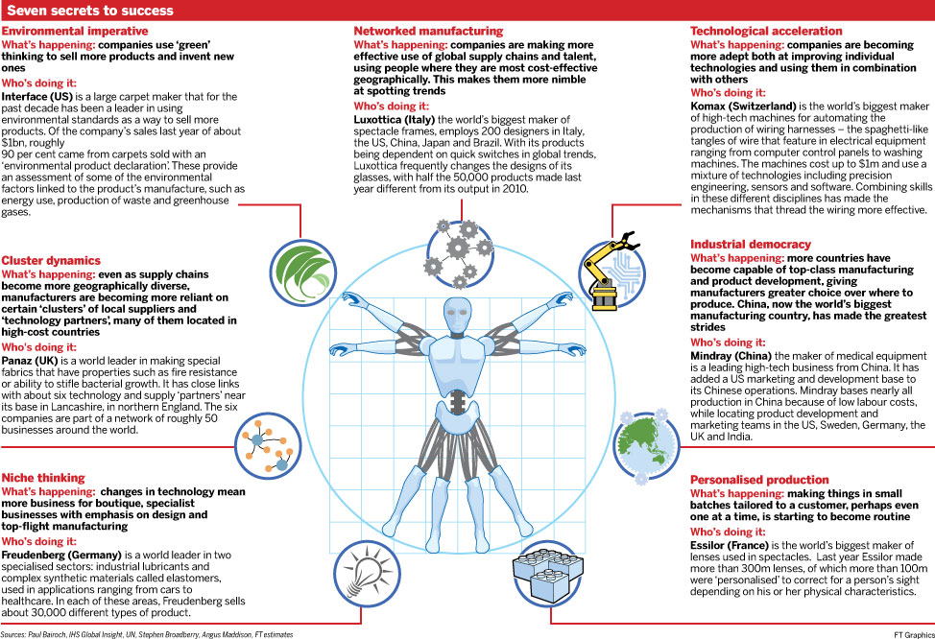

November 4, 2013 6:50 pm

The rise of the automotive tech wars
By Henry Foy
©AP
An electric car is connected into power supply
In 1911, Henry Ford won a patent battle that kick-started the US automotive industry, crushing a licensing cartel that had demanded royalties for every car he built.
Just over a century later, as green engines, self-driving cars and interactive vehicles pitch the industry into a period of feverish innovation not seen since its birth, Big Auto is nervously eyeing another intellectual property battle that could shape the winners and losers for the century to come.
The quest is on to find a successor to the venerable combustion engine, to make cars more autonomous and safe, and to provide drivers with all the connectivity and entertainment they expect from their mobile phone.
That has opened up a previously rather exclusive industry to the threat of the unknown outsider, the technological breakthrough or the crusading entrepreneur.
“We are definitely seeing other players enter the field that was previously reserved for car manufacturers,” says Felix Rummler, partner at IP law specialists Maucher Börjes Jenkins in Munich.
“New players from outside the industry are possibly more used to enforcing patent infringement. They may be more aggressive,” says Mr Rummler. “So this could certainly change the way the industry looks at IP.”

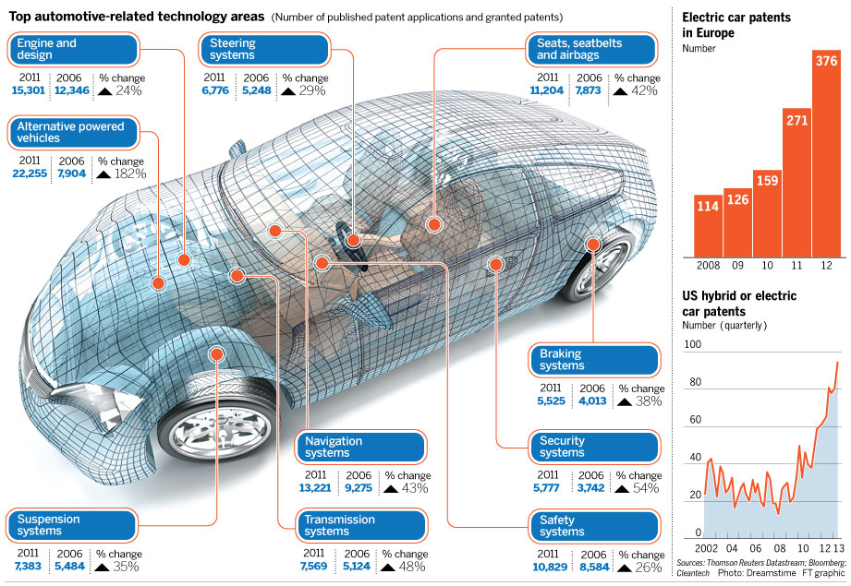
Sensing the danger, carmakers have ramped up patenting, particularly in areas such as electric vehicle systems, hybrid transmissions, safety features and connectivity. Granted patents in those areas were almost 80 per cent higher in 2011 than five years previously.
Patents for alternative engine technologies accounted for a fifth of all automotive patents last year, up from 14 per cent in 2009, and the rate of patenting for hybrid and electric car technologies in the US has doubled in the last three years.
When Henry Ford overturned the 1895 Selden patent in 1911, he was the upstart outsider who refused to play by the rules of the Association of Licensed Automotive Manufacturers – a licensing monopoly. Today, Ford’s company and its automotive rivals are on the other side of the fence: the incumbents looking warily at the upstarts.
Rocking the boat are smaller, more nimble innovators such as electric supercar manufacturer Tesla, or France’s Bolloré Group and its electric BlueCar urban vehicles, or traditional battery suppliers such as Panasonic and LG, which have become as important to the next generation of cars as the engine is in a standard petrol model. Technology giants such as Google or Microsoft are also beginning to encroach on the carmakers’ turf.
With far less moving parts and more focus on microchips than machinery, tomorrow’s cars will probably be far easier to assemble using a lower proportion of internally-built parts. Aside from the demands of brand building and customer perception, the barriers to entry will probably be lower.
Carmakers are worried that if technology advances faster than they can keep up, they could be forced to become simple assemblers of other companies’ products.
“So much more of the technology in electric cars today is coming from outside suppliers,” says Harald Hendrikse, head of automotive research at Nomura. “The worry for carmakers manufacturing them is that technically any of their rivals could put it together.”
The situation is similar to what happened in the smartphone industry around five years ago, when established brands such as Nokia and Motorola found themselves up against aggressive new players such as HTC and Apple, sparking a long and costly patent war that continues today.
“For the last 80 years, all the innovation was done either in-house or by their traditional tier-one suppliers,” says Nikolaus Lang, senior partner at The Boston Consulting Group. “Now they are suddenly confronted with a series of suppliers that they do not know . . . that they have never worked with before. That presents a big challenge.”
“The OEMs might get encircled in their car world,” adds Mr Lang.
That encircling is already starting to take place. Google shocked the industry with its prototype self-driving car back in 2010. Telecoms companies such as AT&T are taking the lead in the development of systems to connect cars to the internet, and component manufacturer Continental signed a deal with IBM in September to develop car networking systems.
“It is the emergence of disruptive technologies and new players who were previously not involved in the automotive industry that potentially threatens the relatively ‘peaceful’ status quo,” says Rebecca Lawrence, partner and IP law expert at Powell Gilbert LLP. “In this regard there are a number of parallels with the introduction of new technologies in the telecoms industry, and the resulting ‘Smartphone Wars’.”
Some litigation has already begun. Last month Daimler won a case brought by a company specialising in patent litigation that had argued a system that monitors drivers for drowsiness in Mercedes-Benz cars infringes a patent it had acquired.
“The cameras, the radar detection, all the new features that we are seeing in these cars, many of them are now subject to lawsuits,” says Scott Doyle, partner at Shearman & Sterling, the US law firm that represented Daimler in the case. “It has really opened the door.”
“There has been tremendous growth in these type of cases. It’s a really, really big concern in the industry right now,” adds Mr Doyle, referring to litigation filed by patent holders from outside the industry.
For the carmakers, the choice could be a stark one between allowing non-traditional rivals to increase their share of components and their slice of the profits, or a costly turn towards the courts.
“Where we could face the smartphone wars of the future is that Apple wants to get into everybody’s cars, Microsoft would, Google feels the same way . . . if it’s done poorly, we could be sucked up into that patent war,” says the head of innovation at a top 10 global carmaker. “The only ones who will win are the lawyers.”
December 10, 2013 6:31 pm

Auto industry: Hybrid carmakers
By Henry Foy
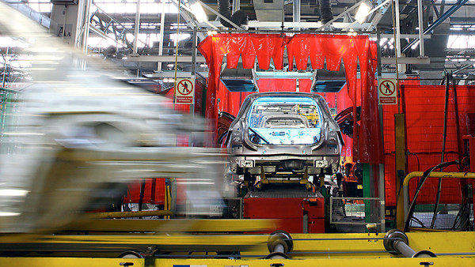©Bloomberg
Robots work on Renault vehicles on the production line at the Renault factory in Valladolid, Spain,
The power couple of the car industry, Carlos Ghosn and Dieter Zetsche, make for an odd pair. Mr Ghosn, an effervescent French Lebanese-Brazilian, is outspoken and animated. Mr Zetsche, a tall, slim, German with an immaculate but fulsome moustache, prefers to let his cars do the talking.
One sells millions of low-cost, entry-level hatchbacks every year. The other builds Mercedes-Benz saloons. But the blossoming relationship between the Renault-Nissan chief executive and Daimler’s chairman, they stress, is a meeting of equals.

Partners and rivals


On this story
- Insider takes the wheel at GM
- Renault-Nissan steers closer to Daimler
- Renault secures foothold in China
- JLR to spend £240m on Brazilian plant
- Car industry has poor history on alliances

IN Analysis
- Energy Forest fuels
- Emirates In a sweet spot
- Mandela – man on mission to bind a nation
- Wine The new bunch
“I do not know if this is a marriage, two fiancées or a casual encounter,” says Mr Ghosn, his eyes twinkling, as Mr Zetsche laughs. “[But] there is no limit. There is no taboo.”
“This is not just about drinking Bordeaux together, it is about eating together as well.” says Mr Zetsche, as they swivel on matching white chairs at a press conference.
Amid falling western demand, rising competition and pressure to spend big on costly new technologies, carmakers are turning to an increasing array of alliances, from full mergers to informally pooling of resources – pulling former rivals closer in order to save themselves.
Mr Zetsche, with research laboratories full of gas-guzzling V8 engines, needs expertise in small cars and low-emission, compact engines. Mr Ghosn, who has run Renault-Nissan as one company for more than a decade, could do with some secrets from Stuttgart for his luxury products.
The result is an alliance in which the two build sedans, trucks, engines and compact cars together.
Every one of the world’s 24 biggest carmakers by sales operates some form of alliance or joint venture with another large carmaker. Some work with as many as 10 of their rivals, while many own chunks of each other’s shares.
The approach is not without risk. After all the handshakes and champagne, the car industry has a patchy record for making these marriages work.
Failed romances litter the industry but the remnants of shared models, engines and research linger. The scrappy divorces leave a tangled web of co-operation that continues to benefit the separated parties.
For car buyers, the badges on the dealership forecourts look as distinct as ever. But under the bonnet, it is a different story, with engines shared between manufacturers. A diminishing number of platforms, the skeletons on which cars are built, means more and more models are made from the same DNA. Pooled design teams mean the difference between once starkly different brands is becoming harder to discern.
The logic for carmakers is simple. The cost of developing a new platform, a new engine family or building a factory can run to several billion dollars. Sharing that with another carmaker halves the investment while maintaining the benefits.
“No car company in the world right now is rich enough to go forward in every area and every market on its own,” says one senior executive at a carmaker. “Before, there was a fear that it would make brands seem weak. Now alliances are seen as a necessary evil.”
“It will not go away. It is only going to intensify. The investments to work on new projects are crazy,” says the executive, whose company works with several other carmakers. “It is not done because we love each other so much, it is done because it makes sense.”
Renault engines are used by Mercedes. Peugeot and Citroën’s electric-powered car is built by Mitsubishi. Fiat builds engines for Suzuki. Ford engines power Jaguars and Aston Martins. Dacia cars sell around the world with Renault or Nissan badges on them. General Motors and Peugeot’s forthcoming MPV will be the same car under the skin.
Volkswagen’s success at sharing its components across its brands and markets means the same engine can power a £20,000 Seat León and a £28,000 Audi TT. The average car buyer is none the wiser.
“To expand into new products and markets is expensive and time-consuming. Alliances are a way to accelerate the expansion strategy with affordable investments,” says Stefano Aversa, managing director at AlixPartners, a consultancy.
Sergio Marchionne, chief executive of Fiat and Chrysler, has said that to survive, a mainstream carmaker needs to build and sell about 6m cars a year. By that yardstick, accepted begrudgingly by the industry, only Toyota, General Motors, Volkswagen, Renault-Nissan and Hyundai are comfortable.
Toyota, the biggest of the national champions that dominate the industry, got there alone.
GM and Volkswagen bought their way to scale. GM snapped up companies in Europe, Britain, Australia and South Korea. VW swallowed Audi, Seat, Skoda, Lamborghini, Bentley and Porsche to build the most complete portfolio.
And Hyundai, through its shareholding and alliance with fellow South Korean carmaker Kia, and Mr Ghosn’s Renault-Nissan, found that by working together they were stronger than the sum of their parts.
Building a car factory can cost a billion dollars. Developing a new engine can cost three times as much. Building up a reliable supply chain network and a footprint of dealerships can take the best part of a decade.
“If you are big enough, you can afford it,” says Xavier Mosquet, partner at Boston Consulting Group. “But for everyone there are areas where you would like to reduce the risk.”
In 1999, Nissan was bankrupt and needed $5bn. Renault had cash but with a limited portfolio and very little market penetration outside Europe it was on shaky ground. A deal was struck in which the French carmaker sent a cheque and a team of executives to Yokohama for a slice of the Japanese company. One of those who made the journey was Mr Ghosn, who was to take charge of Nissan within two years.
. . .
The companies approached the developing alliance cautiously, swapping best practices and pooling some purchasing. But 10 years in, the financial crisis forced the long engagement into a shotgun wedding.
As GM and Chrysler went bankrupt, profits at Renault and Nissan collapsed and the car industry faced a bleak future. For the integration ideologues at the alliance, there was no better opportunity to make their case.
“There was a sudden wake-up due to the crisis. We had to jump to full sharing ... Survival mode and a sense of emergency hit us both,” says Christian Vandenhende, Renault-Nissan’s director overseeing all purchasing.
In 2001, Renault and Nissan conducted 30 per cent of their purchases together. Now they share everything, from exhaust pipe suppliers to joint factories in new markets such as India.
Cost savings from the alliance tripled to €1.5bn in that year and reached €2.7bn in 2012. That is more than Nissan’s profit last year and more than 20 times Renault’s.
“The first rule was that every decision taken for the alliance must be beneficial to both. It is not always 50-50 but always win-win,” says Christian Mardrus, managing director at the alliance. “It is easy to say but not easy to do.”
Many in the industry watch with envy. Much of the alliance’s success is attributed to Mr Ghosn, who maintains a gruelling schedule between Yokohama and Paris. The head of another global carmaker quips that Renault and Nissan are held together with “Ghosn tape”.
“Breaking up the alliance is a virtual impossibility,” says Harald Hendrikse, head automotive analyst at Nomura in London. “There are just too many shared products, plants and technologies.”
But Mr Zetsche has seen the other side of mergers. He was chairman of DaimlerChrysler when their $38bn, nine-year deal fell apart, rupturing what was at the time the world’s biggest cross-border accord.
VW and Suzuki are still fighting legal battles over their partnership that went sour more than two years ago. GM took a stake in Fiat in 2000 as part of a planned partnership, but that turned bad five years later and the US carmaker was forced to pay $2bn to sell options that could have seen it buy out the entire Italian company.
Most alliances fail, industry executives say, because of a lack of patience. Product cycles are typically more than five years long, meaning that companies can take the best part of a decade to align their model strategies in order to share designs, factories and parts.
But in spite of a history of failures in the industry, the rewards of getting it right are too great to ignore. And with new technologies such as electric and hybrid cars and self-driving vehicles needing huge, long-term investments, many see no alternative.
“That will be the main driver of future alliances; to share the huge costs of developing these megaplatforms that will be dominating the auto industry in the next decade,” says Mr Aversa. “If you go outside your core product area, you are almost obliged to find alliances.”
Mr Marchionne is determined to ram together a deal that would fully unite Chrysler and Fiat. Mitsubishi recently joined Renault-Nissan to share small car expertise.
Analysts expect more tie-ups, especially between mainstream carmakers and smaller, more nimble companies. “We have always seen focused alliances on a platform or a technology. But what we are seeing now is alliances that are broader, because if you want the full benefit of integrating engines and platforms, for instance, then you are making decisions for companies that are long-term decisions you cannot get out of two years later,” says Mr Mosquet of Boston Consulting.
“We’re going to see more integrated alliances like Chrysler-Fiat and Renault-Nissan,” he says. “Once you start sharing platforms ... you have tied the two companies very closely. And it is better to do that in a Renault-Nissan environment than a totally separate environment.”
-------------------------------------------
Unholy alliances
Aston Martin Cygnet
The world’s biggest carmaker teamed up with one of the industry’s most prestigious brands to build a luxury supermini. The Aston Martin Cygnet cost £32,000 but was little more than a dolled-up Toyota iQ, which cost two-thirds less. It sold abysmally and was killed off this year after just two years of production.
General Motors-Fiat
In 2000, the two national champions thought they had a winning formula. GM swapped 6 per cent of itself for 20 per cent of Fiat and the two agreed to work together. But things quickly went awry. Complicating the issue was an option for Fiat to sell out to GM completely. As the Italian company continued to lose money, the Americans balked at the possibility of having to rescue it and ended up paying $2bn to wash their hands of the deal.
DaimlerChrysler
The supreme car alliance disaster. It was supposed to be a “merger of equals” between Stuttgart and Detroit, but ended up as a bonfire of investment. Executives sparred and cultures clashed. People used to designing Mercedes sports cars struggled to get to grips with a Chrysler pick-up truck. Promised cost savings spluttered. In 2007 the companies separated. Chrysler was bankrupt within two years.
Jaguar X-Type
The X-Type is a textbook case in how not to share car designs and platforms. Under Ford’s ownership, Jaguar wanted to return to the compact car market. The result was a souped up Ford Mondeo with a Jaguar snout, designed in Detroit. Reviews were poor and sales flopped. The car was killed off soon after Ford sold the marque to Tata Motors in 2008.

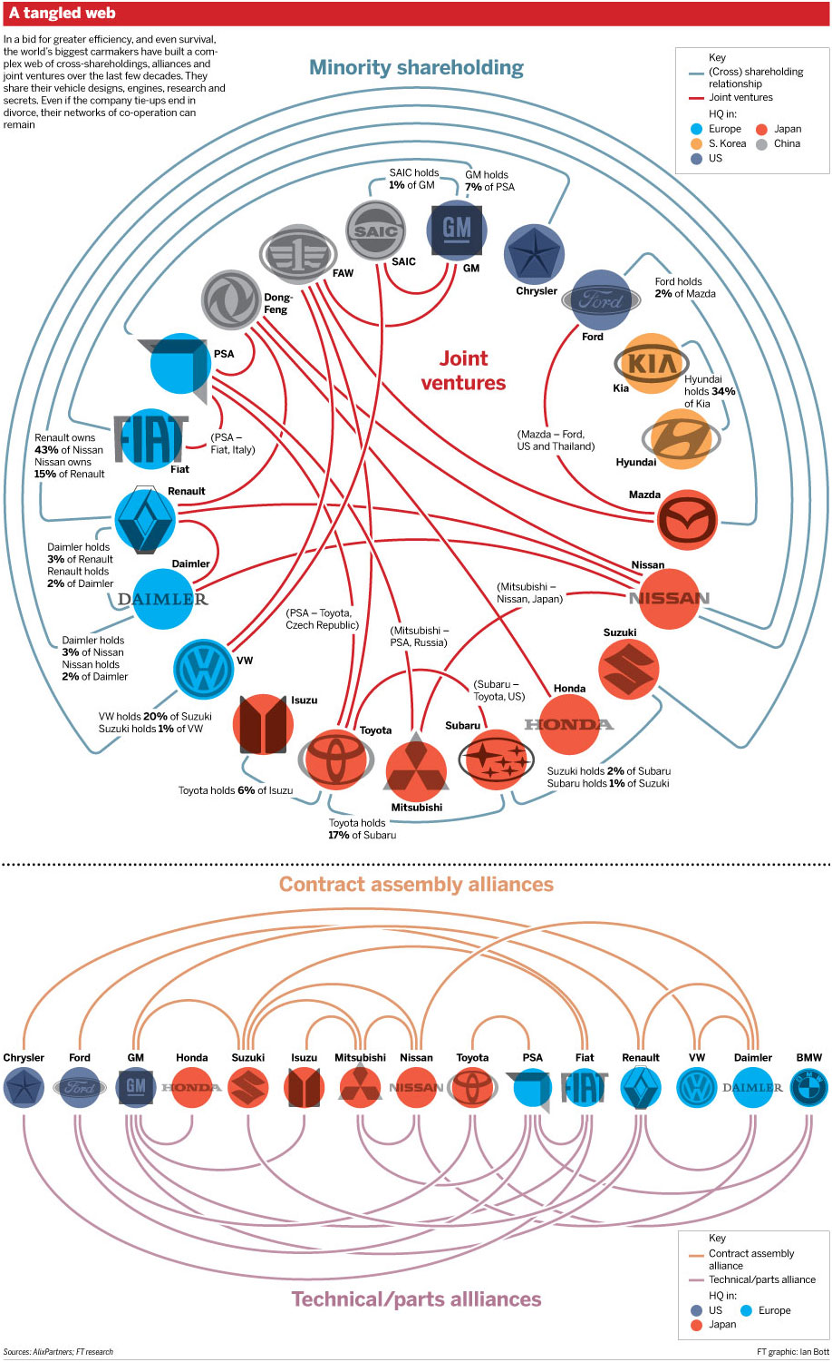
NEWS

Il gruppo VW investirà 84,2 miliardi in 5 anni
23 Novembre 2013
volkswagen
Una cifra “spaventosa” per ricerca, sviluppo e nuovi prodotti, nella convinzione che soltanto così si possa crescere.
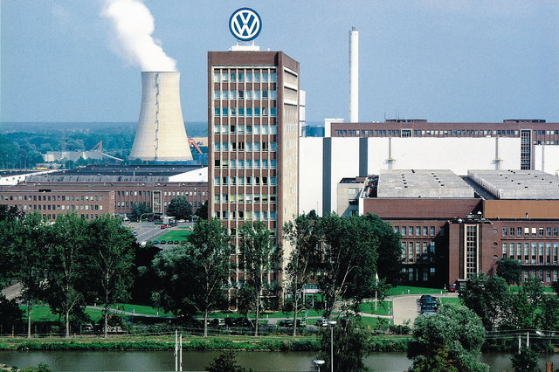
GRANDE IMPEGNO - Il consiglio di amministrazione del gruppo Volkswagen (nella foto sopra la sede di Wolfsburg) ha esaminato e approvato il nuovo piano programmatico per gli anni 2014-2018. Rispetto al quinquennio che sta terminando, gli investimenti sono leggermente inferiori ma quanto deciso resta sempre di dimensioni molto rilevanti: 84,2 miliardi di euro impegnati per i cinque anni in questione.
PER DIVENTARE IL NUMERO 1 - Le decisioni prese testimoniano la piena convinzione e determinazione del gruppo nel puntare alla leadership mondiale nel settore auto entro il 2018, a cui la Volkswagen ritiene si possa arrivare soltanto attraverso un continuo e ambizioso impegno di sviluppo, rinnovamento e crescita tecnologica. Tutto ciò è testimoniato dal fatto che oltre due terzi degli investimenti saranno destinati alla ricerca per migliorare tecnologicamente le auto, la loro efficienza, la guida e la loro sostenibilità ambientale.
UN PO’MENO MA SEMPRE TANTO - Gli interventi nel settore auto assorbiranno 63,4 miliardi di euro. Ciò significa che l’investimento medio annuo sarà inferiore di 0,5 miliardi rispetto ai cinque anni precedenti. Questo per la scelta fatta di rinviare alcuni progetti, in attesa del superamento della fase di crisi che colpisce soprattutto l’Europa. Ciò non intacca lo sforzo globale del gruppo nella ricerca per nuovi prodotti e nuove tecnologie: nel quinquennio 2014-2018 tali investimenti rappresenteranno una percentuale del 6-7% del fatturato.
GERMANIA SOPRATTUTTO - Da notare che circa il 60% degli investimenti riguarderanno la Germania. Per quanto riguarda le destinazioni, circa il 65% degli investimenti della divisione auto (41,2 miliardi) riguarderà la progettazione, gli stabilimenti e l’allestimento delle linee di produzione. La parte più rilevante degli investimenti riguarderà i nuovi modelli e lo sviluppo di quelli esistenti, basati sulla nuova piattaforma modulare della casa.
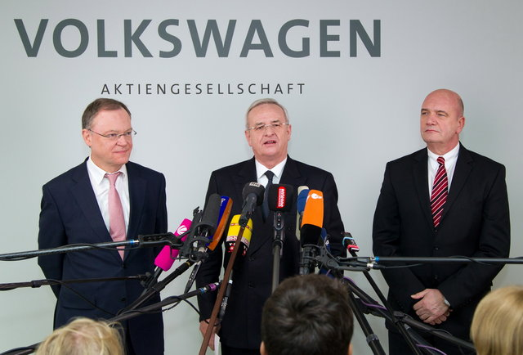
Da sinistra Stephan Weil, primo ministro della Bassa Sassonia, azionista della Volkswagen, Martin Winterkorn, presidente, Bernd Osterloh rappresentante dei lavoratori in occasione della conferenza seguita al consiglio di sorveglianza del gruppo tenutosi ieri.
NUOVI MOTORI - Tutto ciò con il primario obiettivo di rinnovamento dovuto alla necessità di avere una gamma omologata Euro 6. Tra gli obiettivi previsti nel piano quinquennale c’è infatti anche una nuova generazione di motori che offriranno elevati livelli di prestazioni a fronte di consumi contenuti.
MIGLIORAMENTI NELLE FABBRICHE - 22,2 miliardi di euro saranno destinati nei prossimi cinque ani per il potenziamento delle strutture per aumentarne le capacità produttive. Ci sarà poi un intervento importante per rinnovare gli impianti della verniciatura, con l’obiettivo di migliorare ulteriormente la qualità. Infine non mancheranno interventi per affinare la rete di vendita, i ricambi e il sistema informativa sugli aspetti tecnici delle vetture.
E IN PIÙ C’È LA CINA - In aggiunta a quanto deciso per il gruppo Volkswagen propriamente detto, in Germania e nel mondo, ci sono poi le joint ventures a cui il gruppo partecipa in Cina. In totale per queste attività nei prossimi cinque anni è previsto un impegno della Volkswagen di 18,2 miliardi di euro.
- See more at: http://www.alvolante.it/news/il-gruppo-vw-investira-84-miliardi-5-anni-332204#sthash.kRhTYoUe.dpuf

Non c'è crisi per Volkswagen:
gli utili sono record a 11,7 miliardi

Il colosso tedesco dell'auto non risente delle difficoltà che accomunano tutti gli altri produttori e chiude un nuovo esercizio con numeri in crescita. Il segreto? Introduzione di nuovi modelli, risparmi ai costi come mentalità aziendale a tutti i livelli, ma senza tagli all'occupazione, alle retribuzioni e alla qualità
dal nostro corrispondente ANDREA TARQUINI
- TAG
- Volkswagen, Bilanci 2013, case automobilistiche, auto
BERLINO - C'è chi può, o piuttosto diciamo: c'è chi sa fare meglio di altri, nel mondo dell'auto. Il gruppo Volkswagen ha raggiunto record storici nei suoi dati di bilancio appena presentati: aumenta utili, fatturato e vendite nonostante la crisi sul mercato europeo, e preannuncia enormi investimenti e un'offensiva su tutti i fronti e su tutti i mercati con il lancio imminente di decine di nuovi modelli di tutti i suoi undici marchi, dal primo all'ultimo.
Mentre Peugeot-Citroen cade in pasto alla Repubblica popolare cinese, mentre Fiat si sforza come meglio può di risollevarsi, mentre Renault resta in difficoltà e mentre persino Toyota affronta problemi col richiamo di 1,9 milioni di ibride Prius per gravi difetti, il colosso di Wolfsburg appare più forte che mai, e più vicino che mai al suo obiettivo strategico: diventare il numero uno mondiale dell'auto entro il 2018, sorpassando Toyota stessa e General Motors.
I dati definitivi 2013, resi noti stamane e rilanciati dai siti dei grandi media tedeschi, fanno impressione: gli utili al lordo delle tasse ammontano a 11,7 miliardi, quindi anche più delle ottimiste prognosi (11,5 miliardi) fatte dagli analisti del gruppo e attese dai mercati. E' un 1,5 per cento in più rispetto all'anno precedente, quindi un dato in totale controtendenza rispetto al pesantissimo calo generale delle vendite d'auto in quasi tutta l'Europa, con pochissime eccezioni come il Regno Unito, esterno all'Eurozona. E aumenta anche il fatturato di Vw: l'anno scorso ha raggiunto 197 miliardi, un record storico assoluto, e una crescita del 2,2 per cento.
Sono dati di cui gli altri costruttori generalisti, di massa o 'di volume' come si dice oggi, possono solo sognare. Frutto di una strategia accorta, lungimirante e basata su un mix: risparmi ai costi come mentalità aziendale a tutti i livelli, ma senza tagli all'occupazione, alle retribuzioni, alla qualità. Introduzione sistematica delle piattaforme comuni per classi di dimensioni analoghe dei modelli dei vari marchi (Golf, Seat Ibiza, Skoda Octavia, per esempio) ma poi ogni modello e ogni marchio conservano appieno la sua specificità. Non solo nello stile, anche nelle soluzioni tecniche e di design, nelle scelte ingegneristiche, nelle prestazioni. Standardizzazione sì, uniformizzazione appiattente no, insomma. Un altro fattore importantissimo del successo Volkswagen è la sua forza nel segmento premium. Soprattutto perché il 2013 da poco concluso è stato il primo anno di bilancio in cui Porsche, la casa delle supersportive in mano al gigante, pesa appieno, per 12 mesi, sul bilancio dell'intero gruppo. E Porsche vola di successo in successo: ha appena assunto 1500 operai solo per il nuovo modello di 'piccolo' Suv Macan, vola nelle vendite in tutto il mondo.
Il vertice Vw ha deciso un aumento di 50 cent dei dividendi agli azionisti, e per l'anno in corso prevede una rendita operativa tra il 5,5 e il 6,5 per cento. Nei grandi piani sono investimenti per quasi 85 miliardi nei prossimi cinque anni, negoziati anche con il potente sindacato IgMetall che in omaggio alla costituzione federale e alle leggi sulla Mitbestimmung (cogestione, cioè il modello originario di quello che noi chiamiamo concertazione) siede nel Consiglio di sorveglianza: più soldi nei modelli, risparmi sul 'superfluo' come il rinnovo degli edifici. Offensiva di nuovi modelli d'ogni segmento di gamma e d'ogni marchio, con la nuova Golf pienamente ibrida e la Up! Elettrica tra i punti di forza, una sfida pericolosissima anche per giapponesi e coreani. E intanto il gigante di Wolfsburg si rafforza anche nel settore veicoli pesanti: rileverà il restante del pacchetto del produttore svedese di autotreni e veicoli industriali Scania di cui è già azionista di maggioranza. Con Scania e Man (Maschinenfabrik Augsburg-Nurnberg) in pugno, il 'grande vecchio' Ferdinand Piech, potentissimo e ambizioso capo del casato e superstratega, e il ceo del gruppo Martin Winterkorn, sfidano i pochi altri global players nei veicoli pesanti, da Mercedes a Iveco agli asiatici.
(22 febbraio 2014) © Riproduzione riservata

Per l'industria un 2013 da -3,8 per cento.
Torna a scendere il fatturato a dicembre

Il fatturato è calato dello 0,6 per cento rispetto al 2012 nell'ultimo mese dell'anno. Nell'intero 2013, invece, la flessione è stata del 6,1 per cento sul mercato interno. Male anche gli ordinativi: -1,3 per cento nei dodici mesi. Il Pmi manifatturiero dell'Eurozona scende a 53 punti, ma continua a indicare espansione economica
MILANO - Il 2013 chiuso dall'Italia con un calo del Prodotto interno lordo dell'1,9%, ha registrato una nuova forte contrazione del fatturato dell'industria. Secondo i dati diffusi dall'Istat, infatti, l'indice ha segnato una flessione del 3,8 per cento rispetto al 2012. Ancora una volta, la statistica testimonia la doppia velocità tra mercato domestico ed estero: il calo complessivo è infatti frutto del -6,1 per cento sul mercato interno che abbatte il +1,5 per cento su quello estero. Il dato annuale arriva insieme a quello del solo dicembre scorso, quando il fatturato dell'industria, al netto della stagionalità, è diminuito dello 0,3% rispetto a novembre, registrando questa volta un aumento dello 0,3% sul mercato interno e un calo dell'1,4% su quello estero.

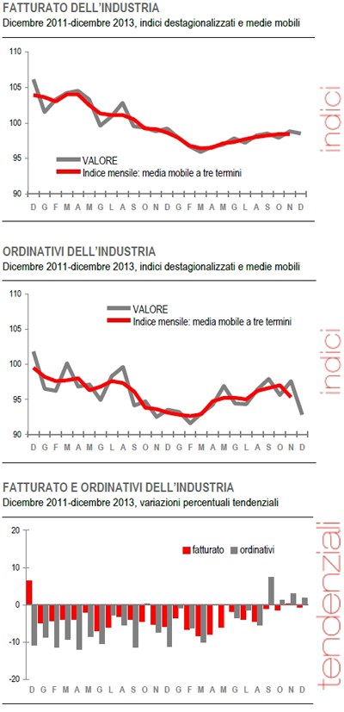

Si conferma quindi qulla dinamica di ripresa tricolore che ha visto il Pil finalmente rimbalzare dalla recessione nell'ultimo trimestre dello scorso anno. Nel complesso, però, è un passo indietro rispetto alla crescita che si era registrata a novembre. Corretto per gli effetti di calendario (i giorni lavorativi sono stati 20 contro i 19 di dicembre 2012), a dicembre il fatturato totale diminuisce in termini tendenziali dello 0,6%, con un calo del 2,1% sul mercato interno ed un incremento del 2,8% su quello estero.
Per quanto riguarda gli ordinativi totali, a dicembre si registra un calo congiunturale del 4,9%, con diminuzioni del 6,4% degli ordinativi interni e del 2,6% di quelli esteri. Nell'intero anno 2013, rispetto al 2012, gli ordinativi registrano una flessione dell'1,3% (-3,5% sul mercato interno e +2,0% sul quello estero). L'Istat spiega ancora che nel confronto con il mese di dicembre 2012, l'indice grezzo degli ordinativi segna un aumento dell'1,9%. L'incremento più rilevante si registra nella produzione di prodotti farmaceutici (+17,1%), mentre la flessione maggiore si osserva nella fabbricazione di apparecchiature elettriche e apparecchiature per uso domestico non elettriche (-17,2%).
L'Istat aggiunge poi, tornando invece al fatturato, che gli indici destagionalizzati del fatturato segnano incrementi congiunturali per i beni di consumo (+0,4%) e per i beni intermedi (+0,1%) mentre registrano una flessione i beni strumentali (-1,8%) e l'energia (-0,2%). L'indice grezzo del fatturato cresce, in termini tendenziali, del 2,6%: il contributo più ampio a tale incremento viene dalla componente estera dei beni di consumo non durevoli. Per il fatturato l'incremento tendenziale più rilevante si registra nella produzione di prodotti farmaceutici (+18,4%), mentre la maggiore diminuzione nell'industria manifatturiera riguarda la fabbricazione di coke e prodotti petroliferi raffinati (-12,4%).
Alzando lo sguardo dall'Italia all'Eurozona, l'indice Pmi manifatturiero dell'Eurozona è sceso a febbraio a 53 punti da 54 di gennaio e contro le attese per un valore a 54 punti. Lo segnala Markit nella stima flash precisando che è il valore minimo da due mesi. Calo anche per l'indice composito (che comprende manifatturiero e servizi) sceso a 52,7 da 52,9 del mese precedente, ai minimi da due mesi. In progresso, invece, il pmi delle attività terziarie a 51,7 (51,6 a gennaio), ai massimi da 5 mesi. Markit ricorda però che i dati Pmi, bene al di sopra della soglia 50 che indica espansione dell'attività, indicano il persistere di una forte ripresa visto l'aumento maggiore dei nuovi ordini dalla metà del 2011.

