

Course on “External Audit and

its grounds”

MSc in Business Administration - Control & Auditing



Contents

1 Deloitte 3

2 Course on External Audit and its grounds 4

3 Our CVs 5

1. Deloitte
   1. Global Facts and Figures

Deloitte has more than 286,000 professionals at member firms delivering services in audit, tax, consulting, financial advisory, risk management, and related services in more than 150 countries and territories. Revenues for fiscal year 2018 were US$43.2 billion.

Deloitte has long been a purpose-led organization. In 2018, we put that Purpose into words to inspire Deloitte professionals and help us achieve our global strategy of being the undisputed global leader in professional services.

Our Purpose statement is a clear and compelling declaration of why we exist. It says:

**Deloitte makes an impact that matters.**

Our desire to make a positive, enduring impact every day for our organization and its stakeholders requires that:

* We serve clients with quality and distinction, making a measurable and attributable impact.

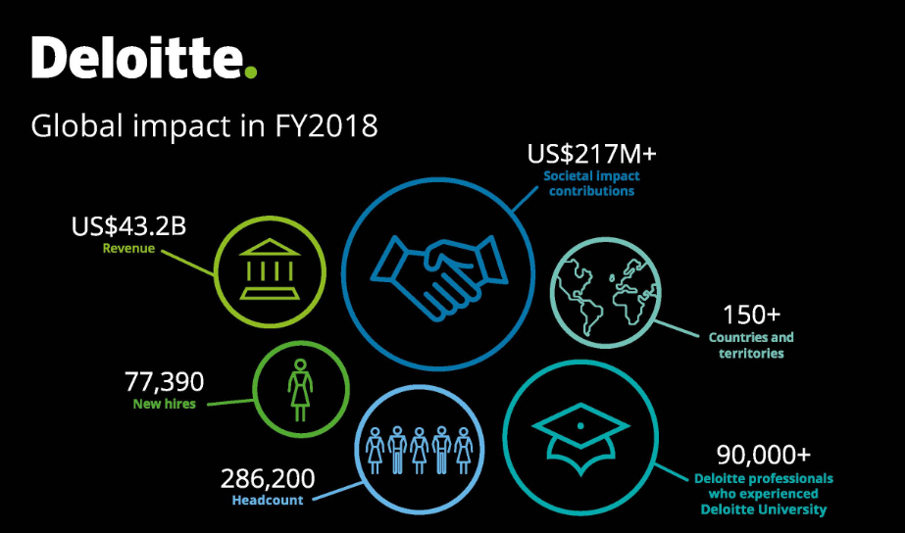

* We inspire our people to deliver value—mentoring and developing future leaders and colleagues for life.
* We contribute to society, building confidence and trust, upholding integrity, and supporting the community.
* We lead the profession by challenging ourselves to do what matters most, delivering innovative ideas that reflect our unique capabilities.

These Purpose-driven behaviors are guided by our network’s shared values-integrity, outstanding value to markets and clients, commitment to each other, and strength from cultural diversity.

* 1. Deloitte Luxembourg:

With more than 2.000 employees, Deloitte is one of Luxembourg's largest, strongest and oldest professional services firms. Our talented teams serve clients in various industries and we take great pride in our ability to provide quality services in audit, accountancy, tax, financial advisory & consulting.

1. Course on External Audit and its grounds
   1. Scope of the course

We would like to give our students the opportunity to experience a simulation of an external audit of a commercial company and help them to apply the knowledge cumulated during the Audit Course to a real-life scenario.

They will have the chance

- to see how the requirements of the ISAs are implemented in the day to day work of an external auditor,

- to get the full picture of how an external audit is planned and executed and

- to work in team in building an audit file that will hopefully lead to an unqualified audit report on the financial statements.

* 1. Structure program

We would propose to organize the simulation in the form of a workshop organized in a 3 days lectures detailed as follow:

* Day 1: Theoretical lecture
* Day 2: Practical application (Audit simulation)
* Day 3: Practical application, Deloitte presentation and final test

The students will work in teams. They will be assigned a case study describing a scenario and including the financial statements to be submitted to the external auditor.

We are enthusiastic about the idea of working with you and help our students to experience a real-life public audit simulation.

With our assistance, the teams

- will gain basic knowledge of the principle ISAs and the overall audit process

- will go through the necessary audit procedures to get an assurance over the material account balances, classes of transactions and disclosures,

- will evaluate the result of the tests carried out and

- will conclude and on the findings and evaluate their impact on the audit report.

* 1. Takeaways

A wrap up session at the end of the workshop will highlight and emphasise the link between the procedure performed and the content discussed by the Professor in charge of the course during the lectures delivered before the simulation.

* 1. Opportunities

Present Deloitte Luxembourg and its job opportunities for the attendees of the workshop. Sharing tips, experiences and take aways.

1. Our CVs

|  |  |  |
| --- | --- | --- |
| Alberto Meriggio  Partner ¦ Audit +352 451 454 771 ameriggio@deloitte.lu |  | CONSORTI SANTINO (8169)  Santino Consorti  Senior ¦ Audit  +352 451 454 751 sconsorti@deloitte.lu |
| Alberto is an audit Partner in the Luxembourg office with more than 12 years of public accounting experience at Deloitte, principally serving clients in the Private Equity Industries and Group Audits. He has broad experience with the accounting and reporting requirements of public and private companies, regulated and unregulated partnerships adopting IFRS, Lux GAAP and US GAAP.  He is a member of the Association of Chartered Certified Accountants (ACCA) and he holds an MBA from the Hong Kong University of Science and Technology.  His former and current clients include: AC Milan, Cairo Communication, Prada, Ferrero Group, Apollo Global Management, CVC Capital Partners, Mittal Investments Group, 2020 European fund for Energy, Climate and Infrastructure (“Marguerite Fund”), Ikano Group, Novenergia Group, AZ Electronics Materials Group, Keurig Group, Dsquared2 Group.  Within Deloitte Audit, Alberto is also Audit Talent Leader. |  | Santino is a Senior auditor in the Luxembourg office principally serving clients in the Industrial and Private Equity Industries and as well as in Group Audits. He has experience with the accounting and reporting requirements of public and private companies under IFRS and Lux GAAP.  His former and current clients include: ArcelorMittal Group, Ferrero Group, Cirque Du Soleil, Cinven Group and Mittal Investments Group. |

Elisabeth Adant

Junior ¦ Audit  
+352 451 452 663  
[eadant@deloitte.lu](mailto:eadant@deloitte.lu)

Elisabeth is a Junior auditor in the Luxembourg office principally serving clients in the Private Equity Industries and as well as in Group Audits. She has experience with the accounting and reporting requirements of public and private companies Lux GAAP.

Her clients include: Quilvest Strategic Fund, CVC Capital Partner Group, Groupe Bruxelles Lambert and Mittal Investments Group.